Class Discussion: “V-25.1B: “The Cycle of the Great Depression”
01) What do you think is going on in this picture?
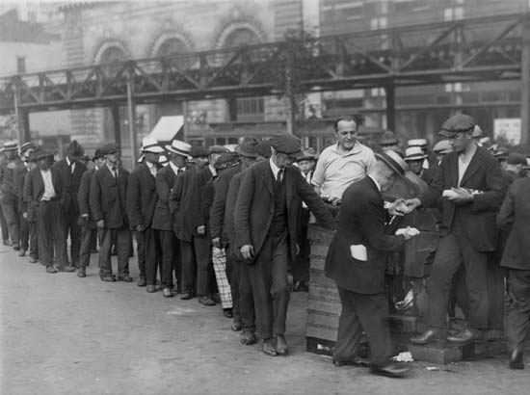

02) List five types of “cycles” that your group can brainstorm.
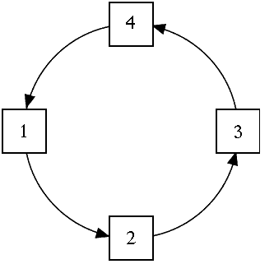

03) Come up with two types of “vicious cycles” that your group can brainstorm.
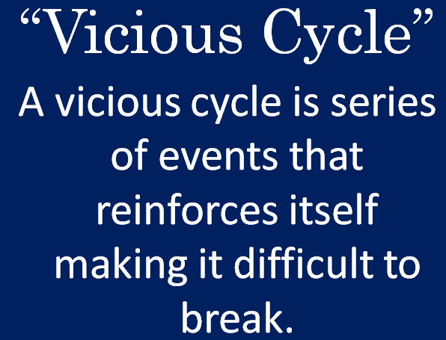

04) What is the main idea of the line graph?

05) What is the main idea of the bar graph?

06) If the Great Depression was an example of a “vicious cycle,” what approach would you take as the President of the United States to fix it?
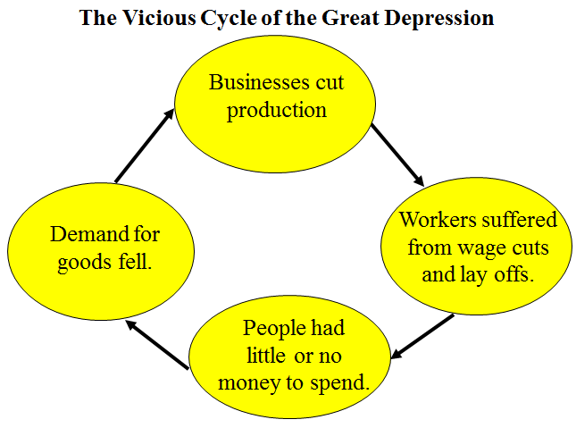

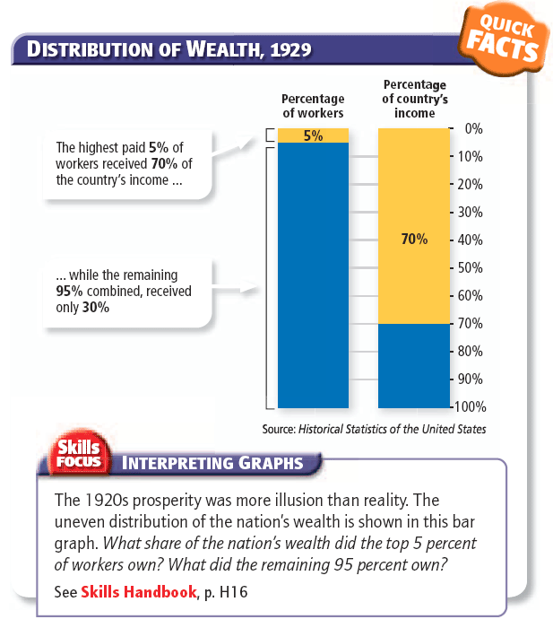
07) What is the main idea of the bar graph?

08) What do you think is the main idea of this bar graph?
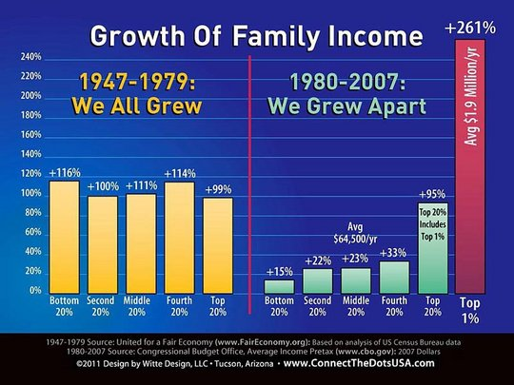

09) Do you think “income disparity” [the gap between the rich and most Americans] is something Americans should care about or do you think it is perfectly acceptable in a capitalistic economy, such as ours? Explain.

10) What do you think is the main idea of the line graph here?
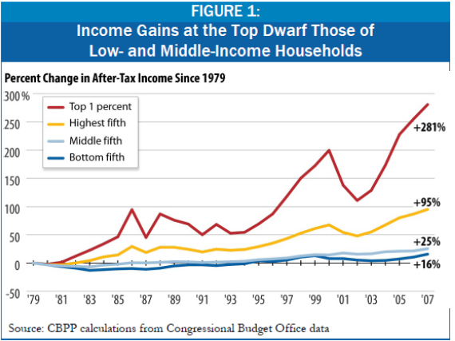

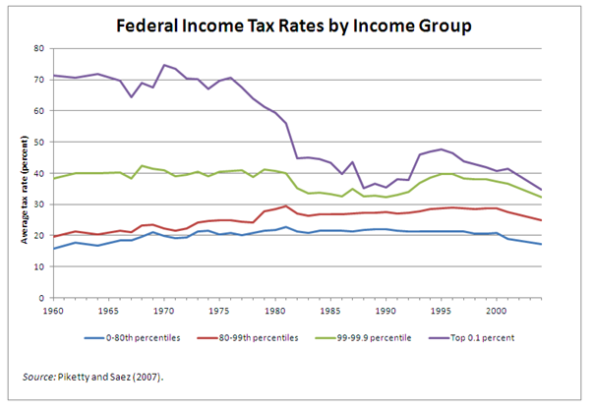
11) What do you think is the main idea of the line graph here?

12) What do you think was the main idea of this passage?
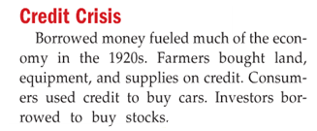

13) What would you think if Mr. Mo lost all of your first semester’s scores and you received an “F” for both quarters? Would you lose your faith and confidence in Mr. Mo for the rest of the year? Would you lose your faith and confidence in R.B.M.S. for the rest of the year? Explain.

14) How do you think the American people felt about banks between 1930 – 1933 based on the following passage?
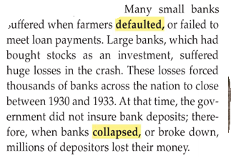

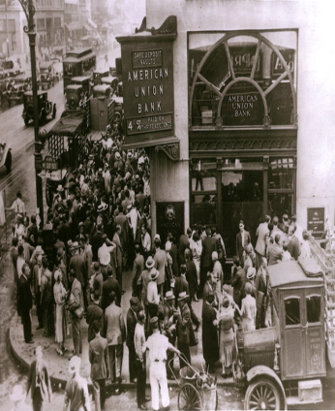
15) Explain how the closing of some banks could begin a “vicious cycle” of more banks closing in the future?

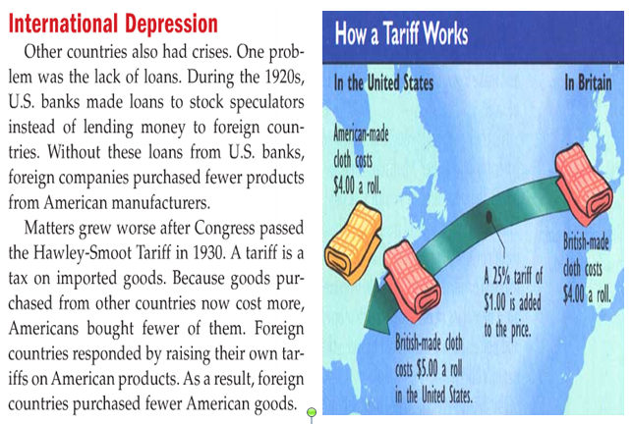
16) Explain why you think Congress thought that passing the Hawley-Smoot Tariff of 1930 would help the country’s economy. Then, explain how the plan actually backfired and hurt the economy more.

