Class Discussion: V-“The Grasshopper and the Ants” Name_________________________
01) At the beginning of the story, how was the grasshopper like America during the “Roarin’ 20’s?”
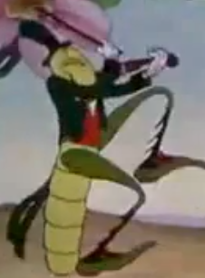

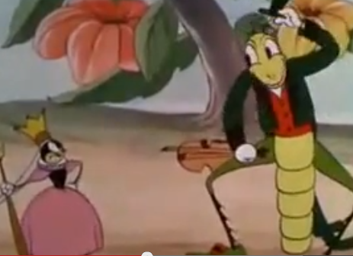
02) Why do you think the Queen Ant is so grumpy towards the Grasshopper?

03) Why do you think the grasshopper changes the verse “Oh, the world owes us a living” from the beginning of the story to “I owe the world a living”?
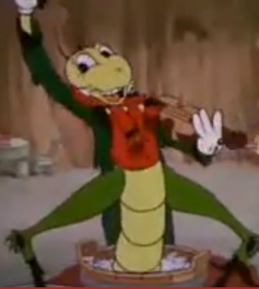

04) Mr. Mo grabbed some comments of this movie off of YouTube. Each comment represents the person’s critique of what they believe is the message of the movie. Which one of the following best describes your views on the meaning of the movie? Explain your answer.
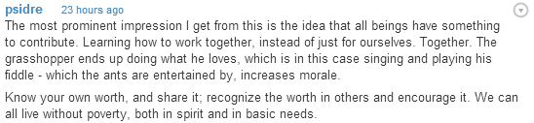
A

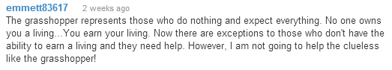
B

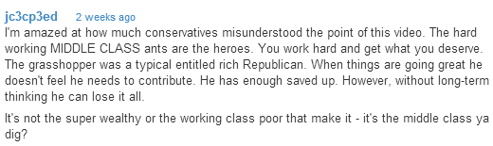
C

