Class Discussion: “V-25.2A: “The New Deal”
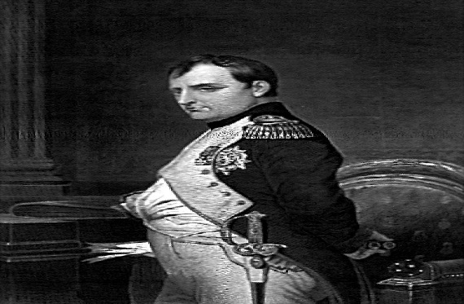
01) What does this quote mean, and why did Mr. Mo select it for today’s lesson?
“A leader is a dealer in hope.”
Napoleon
Bonaparte

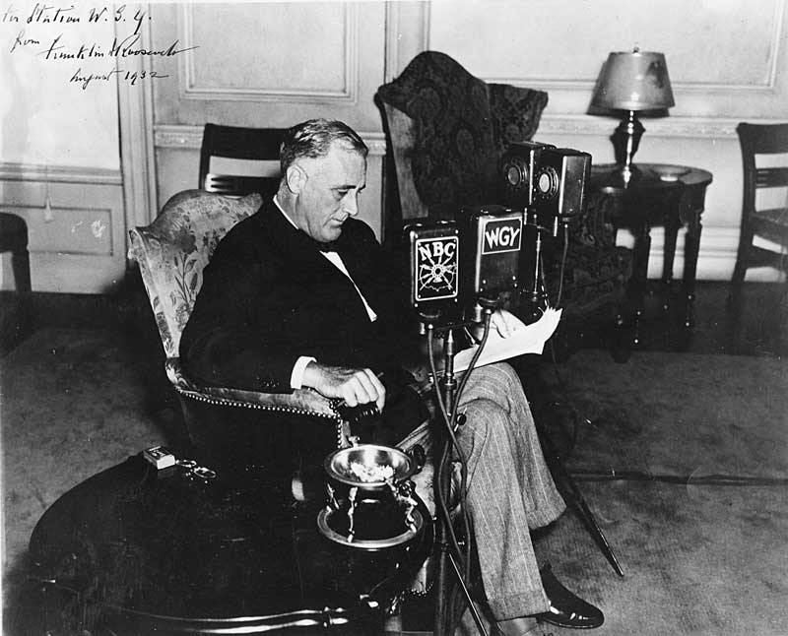
02) How did FDR’s first “fireside chat” show he was different from Herbert Hoover?

03) Why might the slogan “For A New Deal” work well with 1932 voters?
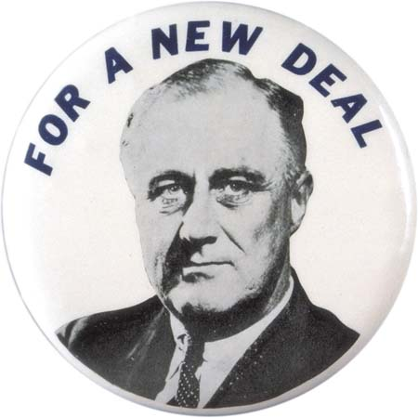

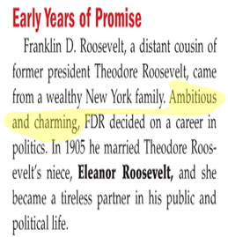
04) Do you think the character traits of “ambitious” and “charming” are in most politicians or are those rare traits for politicians to have?

05) FDR and Eleanor were fifth cousins. Did the diagram shown here help you understand how they were related better? Explain.
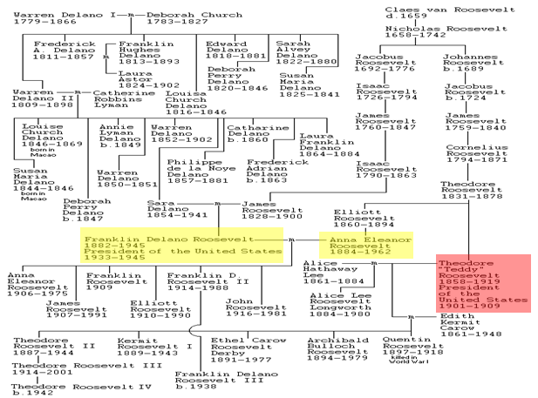

06) What did you think about FDR after reading this passage? Explain.
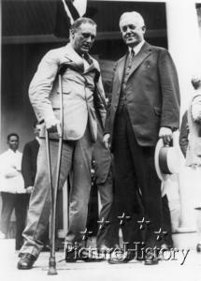

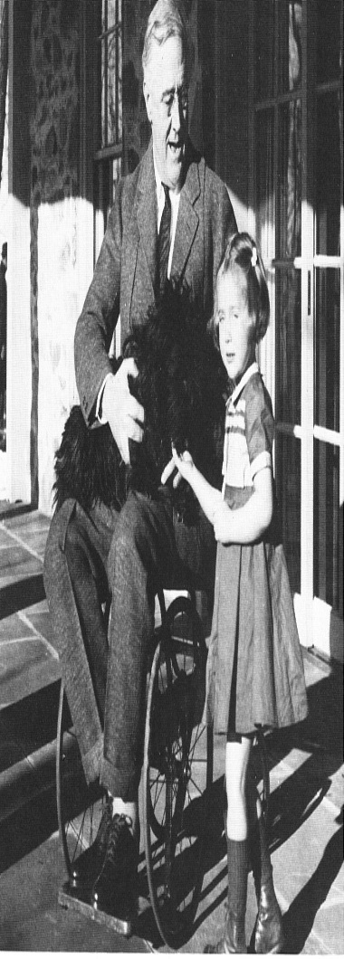
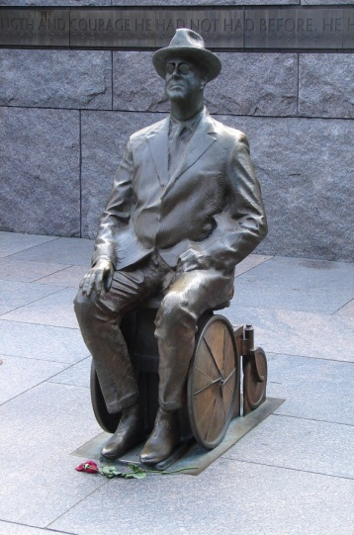
07) Why do you think FDR kept journalists from photographing him with his wheelchair or leg braces? What technologies did not exist back when FDR was President that would help him “keep his secret” about his paralysis?

08) What is the main idea of the political cartoon?
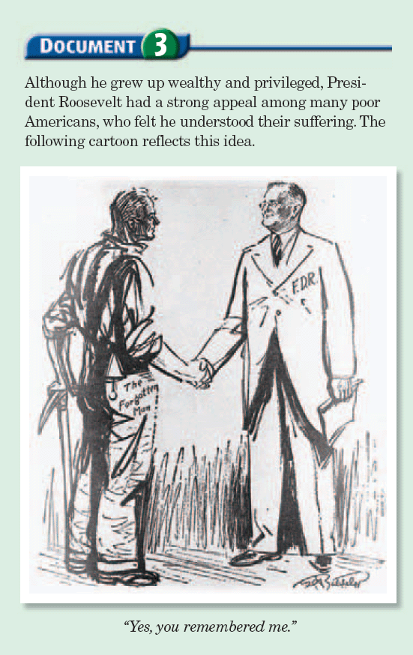

09) What do you think FDR meant by the following quote, and why do you think it would be a winning political quote for the Presidential Election of 1932?

10) What do the following items show about the Presidential Election of 1932, and what do you think was the message/theme of the telegram sent to President Hoover?
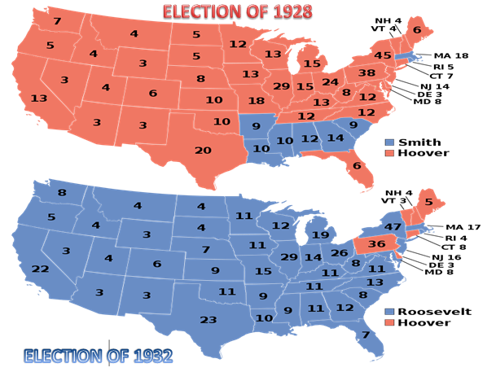

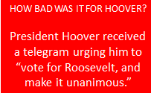
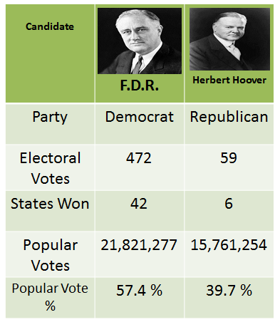

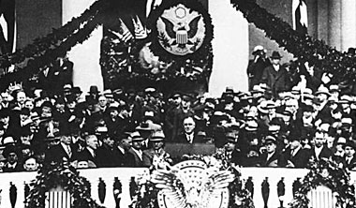
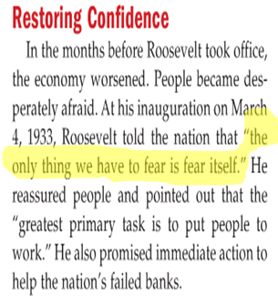
11) What do you think FDR meant by “the only thing we have to fear is fear itself?”

12) Considering the wide range of problems facing FDR, why do you think FDR started with the banks?

13) Why do you think the “fireside chats” were so effective for FDR?

14) Why do you think FDR started all thirty of his fireside chats with the expression, “Good evening, friends.”?
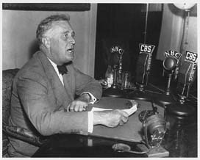

15) Why do you think 80% of the words used in FDR’s fireside chats were in the one thousand most commonly used words in the English dictionary?
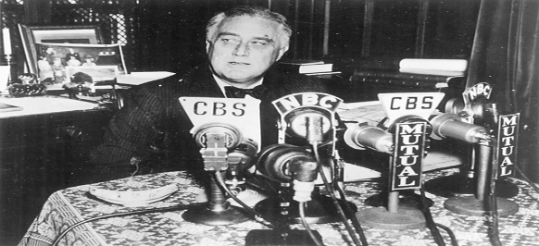

16) Summarize the main idea of this passage.

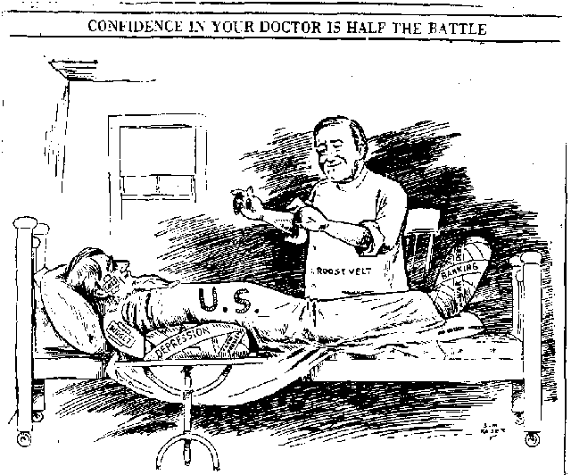
17) What is the title of this political cartoon trying to get Americans to believe? Have we seen a political cartoon before when a President was a “doctor?” Explain.

18) What is the main idea of this political cartoon? Can you remember another President who symbolically was the “captain of the ship?” Explain.
