Class Discussion: “V-25.1D: “Hoover Gets The Blame”
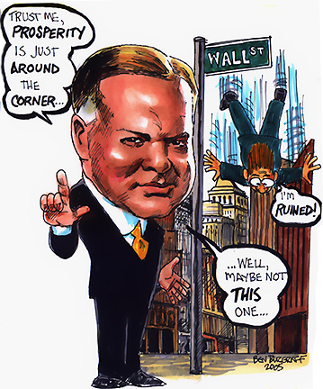
01) This image was found under “Hoover Caricature” using Google Image Search. What do you think is the main idea behind this caricature?

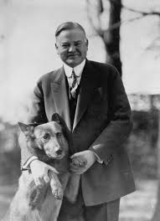
02) Why do you think modern day Democrats love to use Herbert Hoover’s Presidency to defend many of their positions/beliefs on how/what government should do for its citizens?

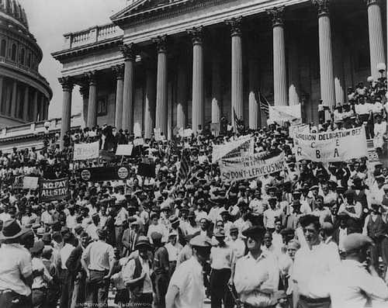
03) What 1st Amendment freedoms are the “Bonus Army” using in this picture?

04) Role-play: You are a member of Congress in 1932. Explain why you voted in favor of paying the Bonus Army in 1932 instead of 1945.
05) Role-play: You are a member of Congress in 1932. Explain why you voted against paying the Bonus Army in 1932 instead of 1945.

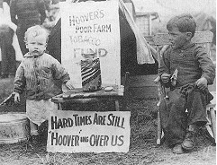
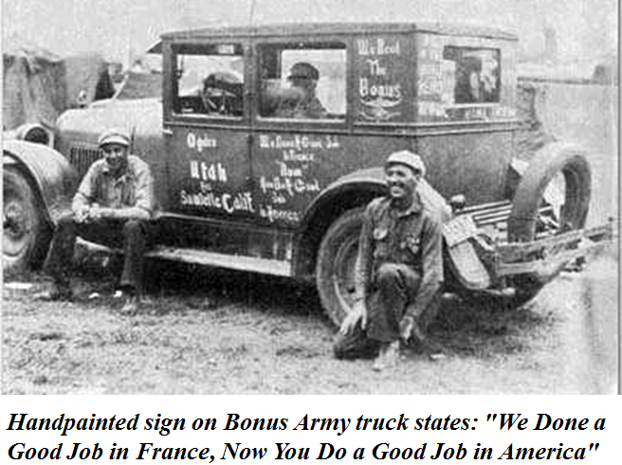
06) Describe what these two pictures show about the freedoms we have as Americans?

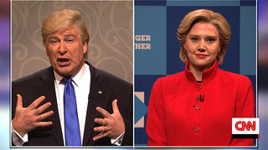
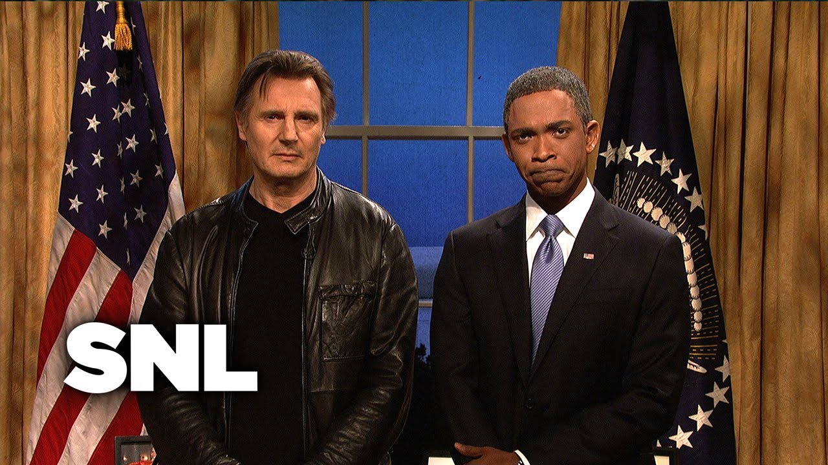
07) Do you think our comedic approach to our Presidents makes our country stronger, weaker, or has no impact on our country’s strength?

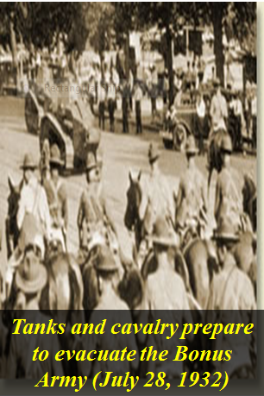
08) Role-play: You are President Hoover’s P.R. person (Public Relations.) Explain to him why you think it is a bad idea to send in tanks and cavalry to clear out the Bonus Army.

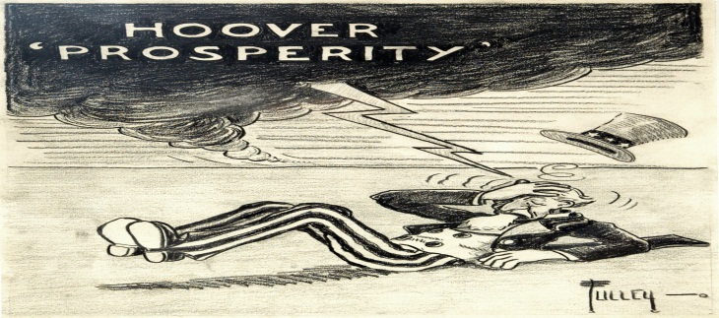
09) What do you think is the main idea of this political cartoon?

10) Write a five-sentence summary of what you think the main idea(s) was/were of this article.
President Hoover has gone down in history as a totally uncaring chief executive who, while he
presided over economic disaster, cared little about his fellow citizens, accepted the Great Depression as
inevitable and something to simply be endured regardless of the level of suffering it caused, and who
refused to do absolutely anything to alleviate the incredible suffering all around him for three and one-
half long years. While this image was particularly widespread during the 1930s and persists even to this
day, it is totally fallacious, misleading, and unjustified.
______________________________________________________________
Herbert Hoover was in the right place at the wrong time. He could well have been a good - if not
great - president had he served at another time. His ideological beliefs were such that he could well
have launched the country in a more progressive direction than his predecessors in the 1920s had not
the Great Depression intervened. He was far more committed to active government than either Calvin
Coolidge or Warren Harding. However, as the presiding chief executive when the Depression began, he
has received the blame for the Depression from his fellow countrymen both at the time and from
subsequent generations. While he really was a "progressive" in his own way and probably did more to
end the Depression than any preceding president in previous economic collapses, what he did failed to
alleviate the situation and therefore he gained a reputation that was only partially deserved.
______________________________________________________________
Orphaned at an early age, Hoover had made a success out of himself - according to his pre-
Depression legend and hype - by dent of his own hard work. Working his way through Stanford
University to a degree in mining engineering, he went on to found his own business and became a
multimillionaire.
Escaping any involvement in the Teapot Dome scandal and receiving a great deal of positive
publicity - much of it self-generated - for his supposed role in engineering the economic boom of the
1920s, Hoover entered the presidency in 1929 with a great deal of ballyhoo. During the 1928
presidential campaign his political handlers built this reputation up to phenomenal heights. Thus, when
the Depression began and Hoover's efforts to deal with it were unsuccessful, his fall from grace was that
much more spectacular because the publicity had built expectations up to a totally unrealistic level.
______________________________________________________________
Herbert Hoover once told his old friend Julius Barnes: "No president must ever admit he has
been wrong". During the last two years of his presidency as it became more and more apparent that the
Depression was worsening and his program of confidence, voluntarism, and business support wasn't
working, President Hoover set his feet in concrete. He refused to recognize that his philosophy and
programs weren't working. Rather than try something different, he clung rigidly to his program, became
more and more defensive, tried to convince himself and Americans that things were getting better, and
lost the support of the nation.
______________________________________________________________
At the depth of the national catastrophe in 1932, two incidents forever fixed Hooverís public
image. In the summer of that year, Movietone News crews filmed the president feeding his dog T-bone
steak in the Rose Garden at the White House. This footage played over and over again in movie theaters
across the country and was disastrous for a chief executive up for reelection who claimed that federal
relief would destroy the American character. On top of this came the government’s treatment of the
Bonus Army. General Douglas MacArthur violated a direct presidential directive from Hoover not to
attack the veterans of the Great War encamped at Anacostia Flats in the nation’s capital. Hoover,
however, took the blame for this public relations nightmare.
In the seventy years since his administration ended in failure, Hoover’s ratings and reputation
have improved little. In part this was because he was the incumbent when disaster struck. Like all
incumbents, his reputation was in many ways simply a reflection of events. Incumbents get the credit
when things go well, whether they had anything to do with it or not. Conversely, incumbents get the
blame when things go bad whether or not they were truly responsible. Hoover’s historical reputation,
however, has remained so fixed because he suffered from the extreme contrast in personality with his
successor, Franklin D. Roosevelt. Hoover seemed so much more of a failure because Roosevelt
convinced millions of Americans that things were getting better once he assumed office and launched
the New Deal program. Finally, the Democratic party ran against Hoover for a half century. At election
time, every Republican candidate was likened to Herbert Hoover. It was an effective partisan technique
for attracting votes but it converted the "forgotten progressive" into a caricature of his true self.

