Class Discussion: “We All Fall Down”
01) Reread the introduction paragraph to “We All Fall Down”. How do you think the Great Depression affected America’s confidence in our “way of life” (democracy, capitalism, etc.)?
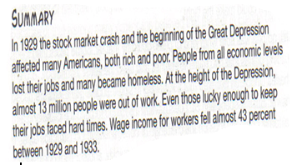

02) Roleplay… You are President Herbert Hoover. Explain why early on in the Great Depression, you do not think that the federal government should provide direct aid for the unemployed.

03) Why do you think many Americans believed that economic recovery was “right around the corner” when the Great Depression was in its early stages?

04) Brainstorm…. Why might Mr. Grasshopper have his head buried in the newspaper at the beginning of the story (before he knows anything about the crash)?

05) At this point in the story, how do you think Mr. Grasshopper felt about his life? Explain.

06) Based on this picture, which member of your group is most similar to Mr. Grasshopper? Explain. Which member is most dissimilar to Mr. Grasshopper? Explain.

07) This portion of the story does not have any speech bubbles. Create two separate bubbles for two different characters.
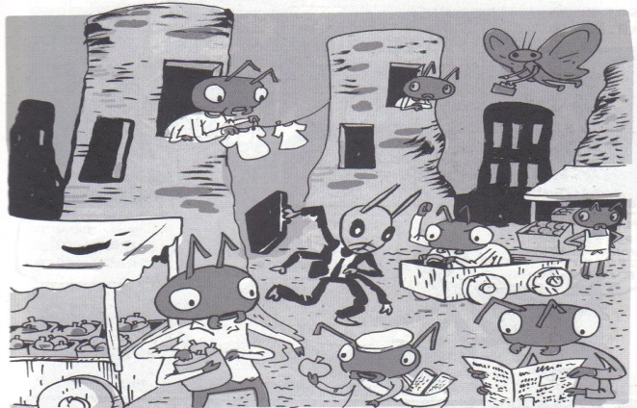

08) This portion of the story does not have any speech bubbles. Create two separate bubbles for two different characters.

09) At this point in the story, what are two clues that Mr. Mandible’s day is not going well.

10) In this portion, what do we learn about Mr. Grasshopper?

11) Describe 3 emotions that Mr. Mandible is feeling in these two panels of the story.

12) This panel does not have any speech bubbles in response to Mr. Banks’s bad news. Create two separate bubbles for two different characters.

13) Describe the major life stresses that have occurred to Mr. Grasshopper in this panel.

14) What valuable life lesson do you get out of this panel?

15) Come up with 3 adjectives that capture this panel.

16) Roleplay… You are Mr. Grasshopper. Whom or what do you blame for you current situation at the end of the story? Explain.

