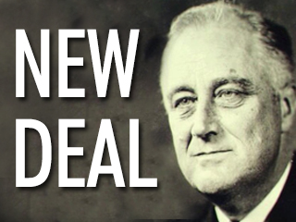
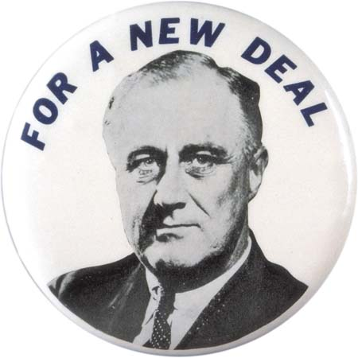
F.D.R.’s New Deal Project
Overview
F.D.R. stated he would deliver a “New Deal” to America. With the help of the United States Congress, President Roosevelt advanced a variety of programs to offer immediate relief to the jobless and hungry, promote recovery to the industries, and make long-term reforms to America’s future. For this project, we are going to focus on eight of the programs.
Each Mario Kart Group will “draft” two of the programs. We will hold that draft today. Once each Group has selected two programs, each Group will split into their Stock Market Groups. Each smaller Stock Market Group will be responsible for one of the programs. In each smaller group, the members should fairly divide up the work among the members, research the assigned programs, and create two Google Presentations. Your group will have the rest of class today, homework for the next two days, and all of class time Tuesday to create your Presentations.
Presentation
To make things easy, have your “Stock Leader” create the two Google Presentations. Then, share the presentations with each member of the group. Also, share the presentations with Mr. Morris (Mrs. Hoffman for appropriate 8A students and Mrs. Cobert for appropriate 8C students.) Your presentations will consist of seven slides.
Slide #1 will be your Title Slide. On this slide, you should have the name of the program and the names of your group members.
Slide #2 will be your Explanation Slide. Using ten sentences, your group will summarize the program (what was its purpose, how did it achieve that purpose, was it successful, etc.) You will also explain if the program was a “relief,” “recovery,” or “reform” program. Describe the program in 8th Grade terms that students can relate to. If you copy sentences from the Internet, you will receive a zero for plagiarism!
Slide #3 will be your Propaganda Slide. You need to create a piece of propaganda that persuades the American people that your program is worthwhile and necessary. You need to also include the type(s) of propaganda that you utilized. NOTE: This needs to be an original piece of propaganda. If you copy propaganda from the Internet, you will receive a zero for plagiarism!
Slide #4 will be your Haiku Slide. Remember, a haiku has a title and three lines. The syllable pattern is 5-7-5 (meaning the first line has 5 syllables, the second line has 7 syllables, and the third line has five syllables.) The haiku should summarize the program. Rhyming is not required.
Slide #5 will be your Black-Out Poetry Slide. You will create a “Black-Out” poem from pages Mr. Morris will provide. The Black-Out poem should capture the essence of the program you have been assigned. Once you create your poem, use your Chromebook to take a picture of it. Add the picture to your slide, and make sure the picture is big enough so that everyone can read it.
Slide #6 will be your Lyrics Slide. You will select lyrics from a song that portrays the substance of your program. Explain how the lyrics connect to your program. You will not be playing the song. You will be connecting the spoken lyrics to the program you have been assigned. The lyrics must be school appropriate.
Slide #7 will be your Forced Food Analogy Slide. Merriam-Webster.com defines an analogy as “a comparison of two things based on their being alike in some way.” For example, in the movie, “Forrest Gump,” the expression “Life is like a box of chocolates” is used. For this slide, you will put forth a food analogy/simile/metaphor that you believe summarizes what your program will do. Explain how the analogy is appropriate. If you need more help with analogies, YouTube has many clips, such as https://www.youtube.com/watch?v=DQHh40xQ6f0 to help you grasp the concept of analogies.
Division of Labor
Each group member will be fairly assigned portions of the presentations. Your team will fill out a form that details what has been assigned to each member. This form will be turned in to Mr. Morris. After the presentations have been given, each group member will have a chance to evaluate the performance of each member. Each member will be scored out of 100 possible points (based on effort, completion, attitude, and time-on-task.) Note: Plagiarism will result in an automatic zero!
Presentation Days
On Wednesday and Thursday, your group will compete against another group. For the six categories, Explanation, Propaganda, Haiku, Black-Out Poem, Lyrics, and Analogy, a “panel of experts” will judge the two presentations in each category. The first group will present their Explanation Slide, and then the second group will present their Explanation Slide. The two slides will be judged, and the process will continue for the remaining slides.
For each category your group wins, your Mario Kart team will gain 2 rolls for next week’s race.
New Deal Draft
Mr. Morris will give each group a minute or two to brainstorm the program(s) they would like to select in the “draft.” For the first round, Group #1 will select first and Group #8 will select last. For the second round, we will select in reverse order. Two teams from the same Mario Kart Team are not allowed to face each other.
NEW DEAL PROGRAM NAME | INITIALS | FIRST GROUP | SECOND GROUP
Federal Emergency Relief Administration | F.E.R.A.
Civilian Conservation Corps | C.C.C.
Agricultural Adjustment Act | A.A.A.
Tennessee Valley Authority | T.V.A.
National Recovery Administration | N.R.A.
Public Works Administration | P.W.A.
Federal Deposit Insurance Corporation | F.D.I.C.
Securities and Exchange Commission | S.E.C.

