Class Discussion: “V-25.4A: “The Second New Deal: Part I”
01) What is the main idea of Ellen Woodward’s speech here?

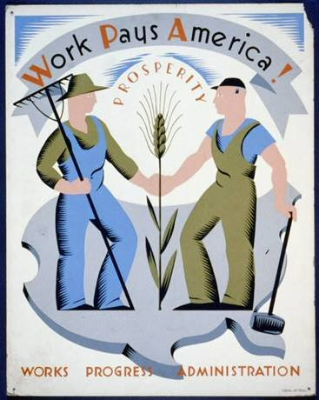
02) What is the main idea of this political poster?

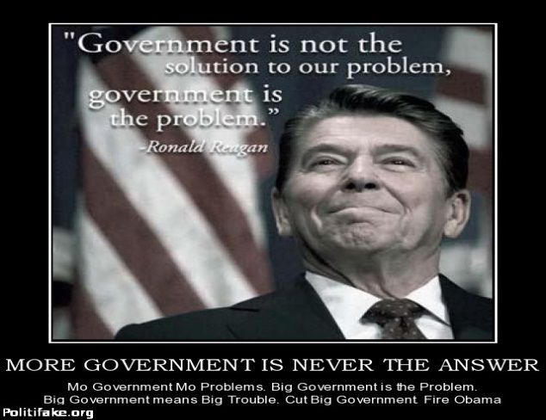
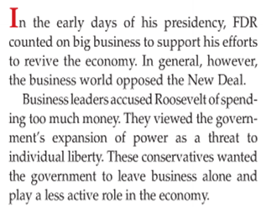
03) Which modern day political party would agree with this poster, and why?

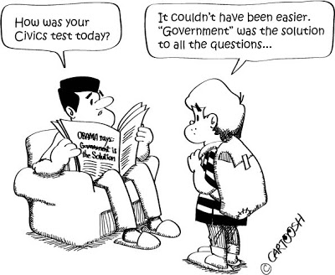
04) What do you think is the main idea of this political cartoon?

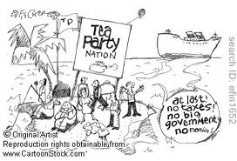
05) What do you think is the main idea of this political cartoon?

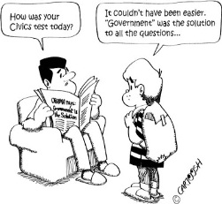
06) If you could be a dictator of America for just one day and force America to pick the level of involvement that are government should have in our lives using the scale below, which number would you pick and why would you pick that number?

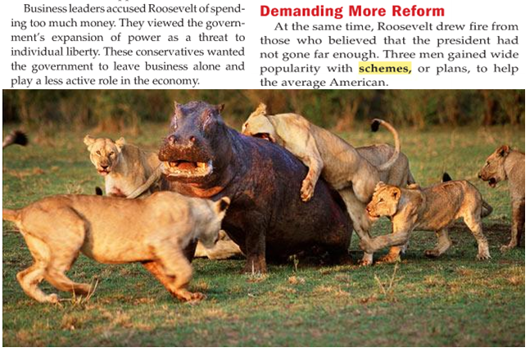
07) How was FDR like the hippopotamus in this picture?

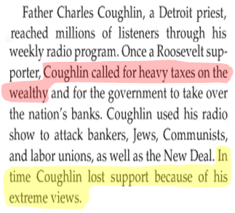
08) Why do you think it is easy for a politician to get popular support for the first highlighted sentence in this passage?

09) What lesson(s) do you think politicians should learn from the last highlighted sentence of this passage?

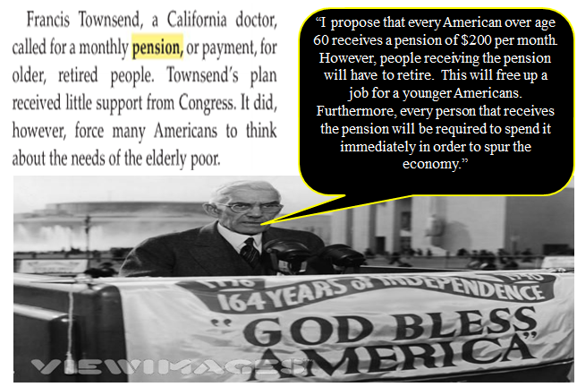
10) Role-play: You are Francis Townsend’s “teacher”. Give him a letter grade on his “pension” idea and explain why you gave him that grade.

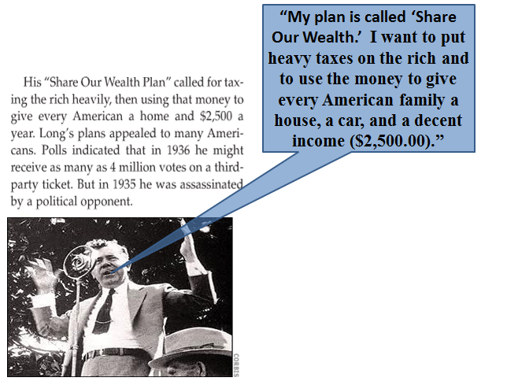
11) Role-play: You are Senator Huey Long’s “teacher”. Give him a letter grade on his “Share Our Wealth” idea and explain why you gave him that grade.

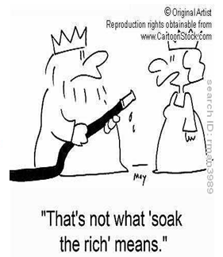
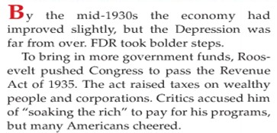
12) Why do you think the last sentence of the second paragraph is common in America?

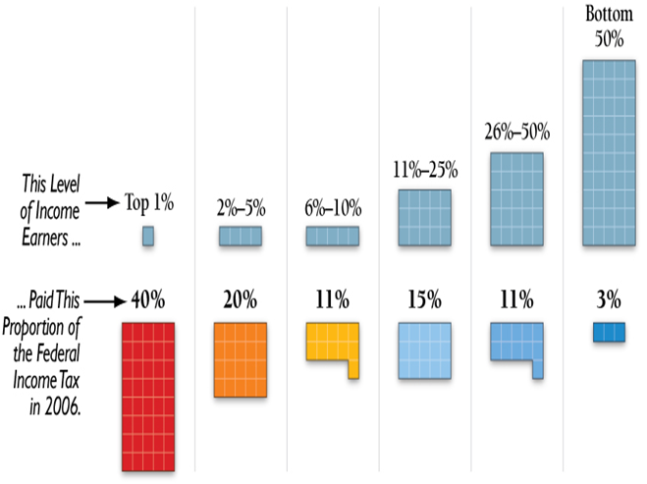
13) What is the main idea of this chart?

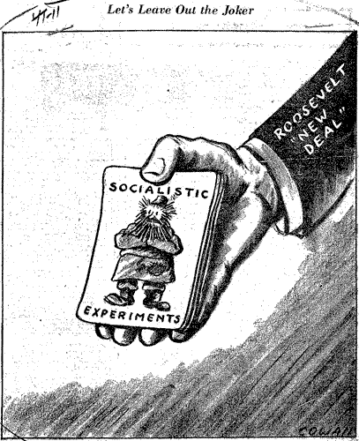
14) What do you think is the main idea of this political cartoon?

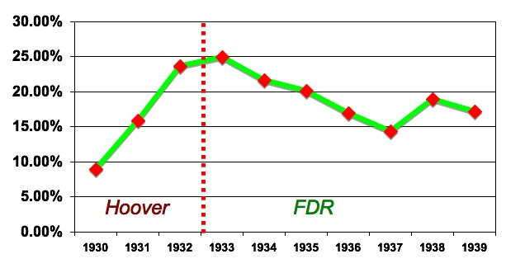
15) Based on the line graph below, what grade would you give FDR in the subject, “Lowering Unemployment?” Explain.

16) Of the WPA projects listed below, which one do you think was the “most beneficial” to society? Explain.
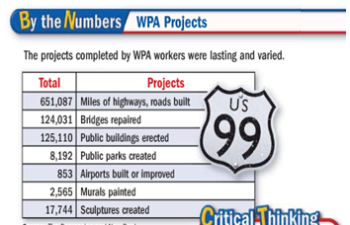
17) Of the WPA projects listed below, which one do you think was the “least beneficial” to society? Explain.

18) Why do you think prior to 1935, America was the only advanced industrial nation without a national government program to help the needy?

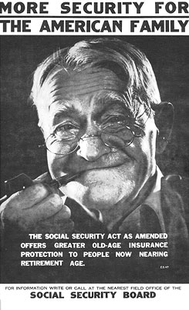
19) What type of propaganda is being used in the picture above?

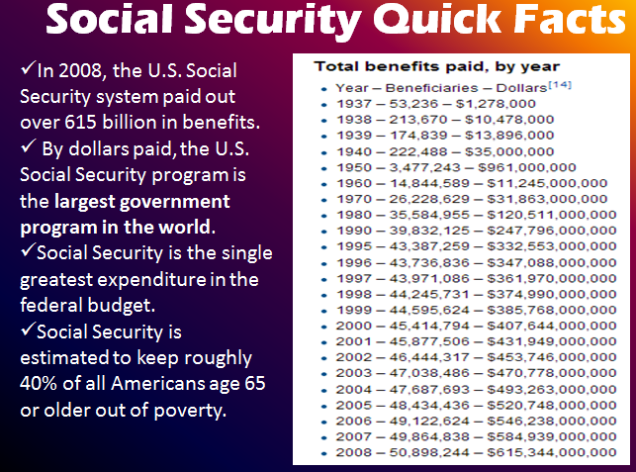
20) What did you find interesting about this particular part of Mr. Mo’s video on Social Security?

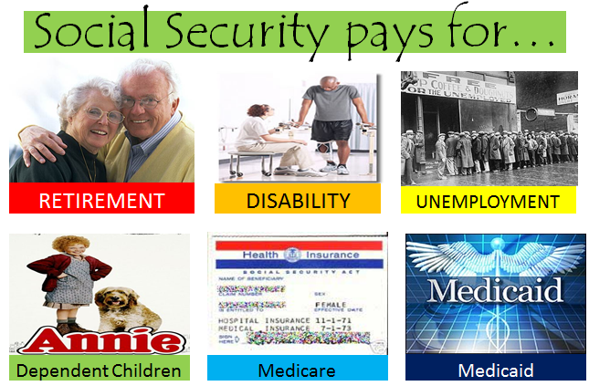
21) If you were a member of Congress and you were looking to reduce spending, which one of these six programs would you cut? Explain.

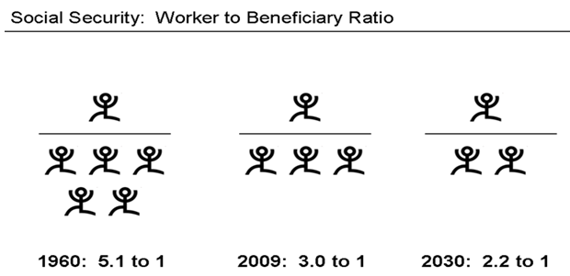
22) What is the main idea of this picture about Social Security?

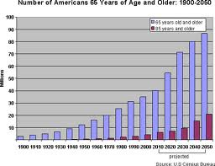
23) What is the main idea of bar graph?

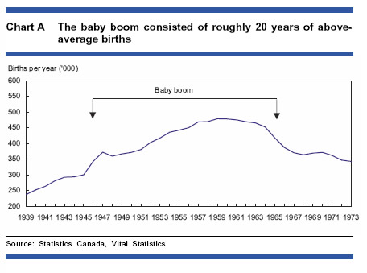
24) What is the main idea of line graph?

