Class Discussion: “V-25.4B: Social Security & The Budget”
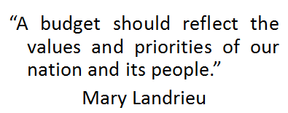
01) What does this quote mean to you?

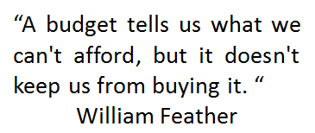
02) What does this quote mean to you?

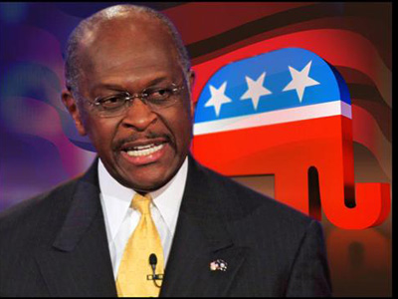
03) What are your thoughts on this quote by former Republican Presidential hopeful, Herman Cain…?
“I'm not a professional politician. I'm a professional problem solver, and I believe we should cut the salaries of senators and congressmen 10 percent until they balance the budget. I call that conservative common sense.”

04) What did you find to be the most interesting or surprising part about the 2015 United States Federal Budget?
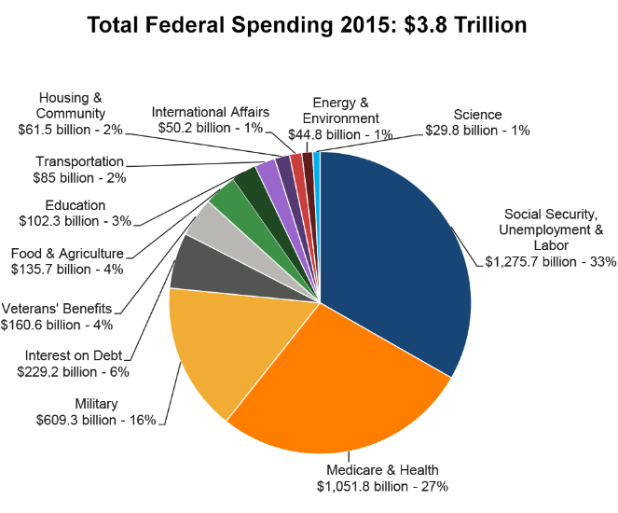
05) What did you find to be the most interesting or surprising part about the screenshot from www.usdebtclock.org captured on March 8, 2017?
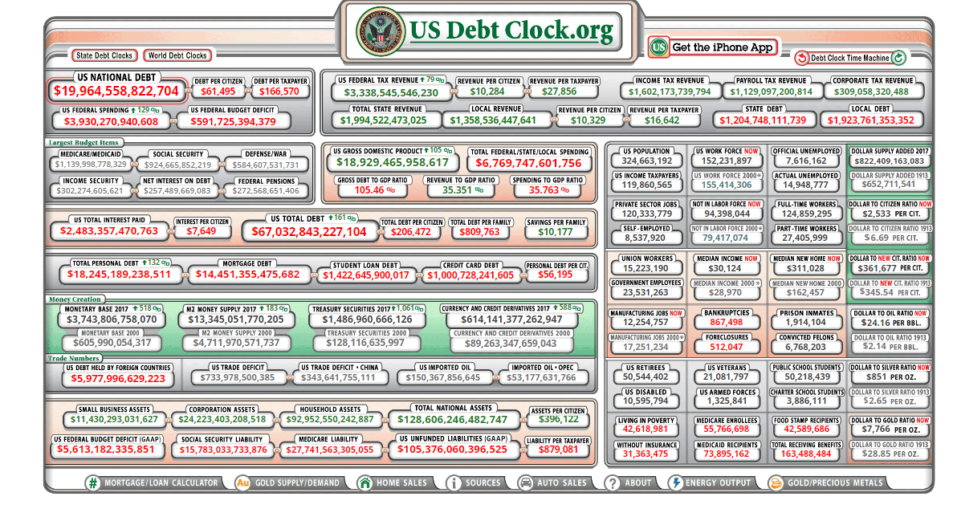

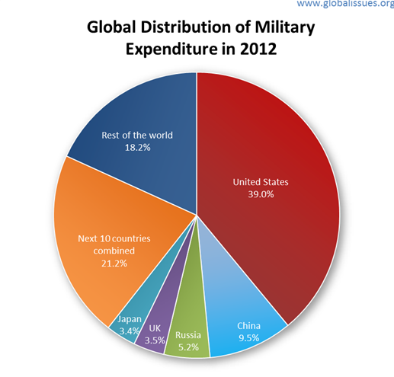
06) What is the main idea of this pie graph?

07) What do you think is the main idea of this picture?

08) Why do you think it is challenging for our country to pass a responsible, balanced budget?

