Class Discussion: “V-25.4D: “FDR Tries To Pack The Court”
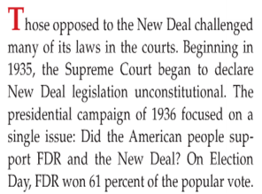
01) How do you think FDR felt about the Supreme Court in 1935 – 1936?

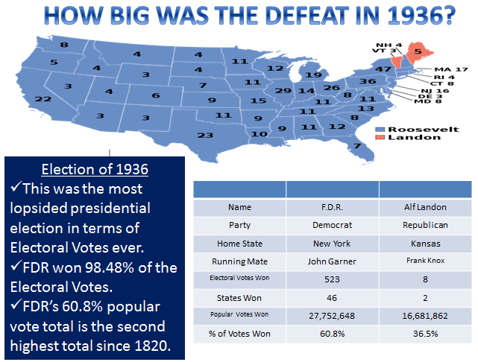
02) How do you think the outcome of this election affected FDR’s outlook on his Presidency?

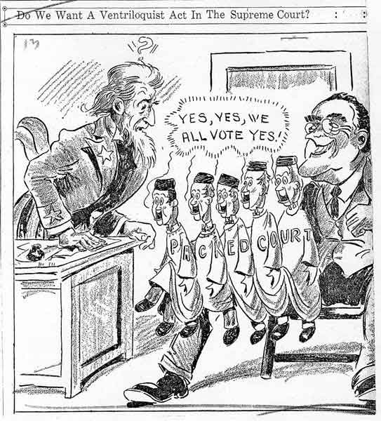
03) What is the main point of the political cartoon?

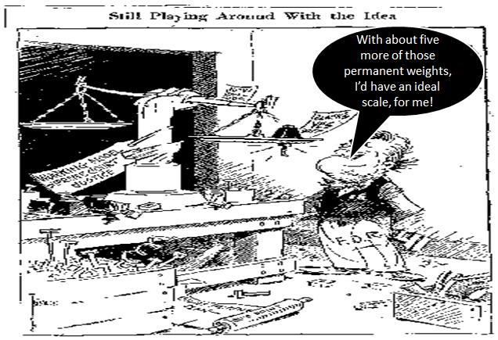
04) What is the main point of the political cartoon?

05) What is the main point of the political cartoon?
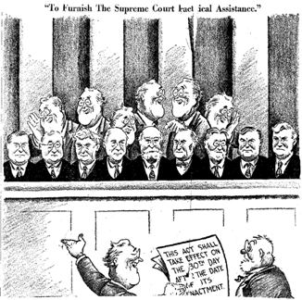

06) What is the main point of the political cartoon?
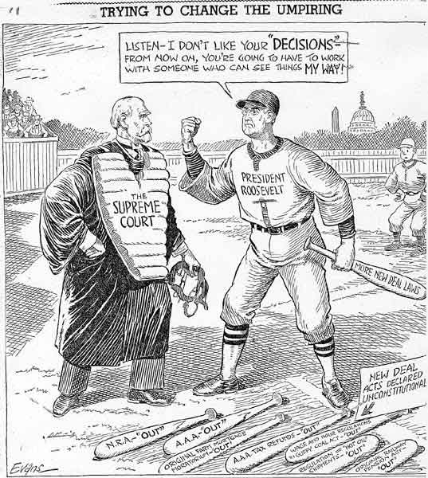

07) What is the main point of the political cartoon?
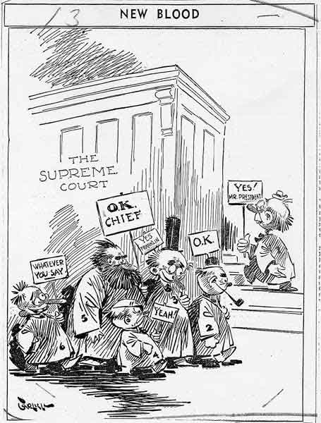

08) What is the main point of the political cartoon?
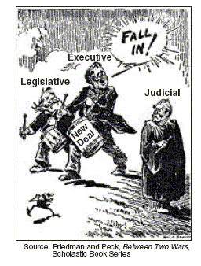

09) What is the main point of the political cartoon?
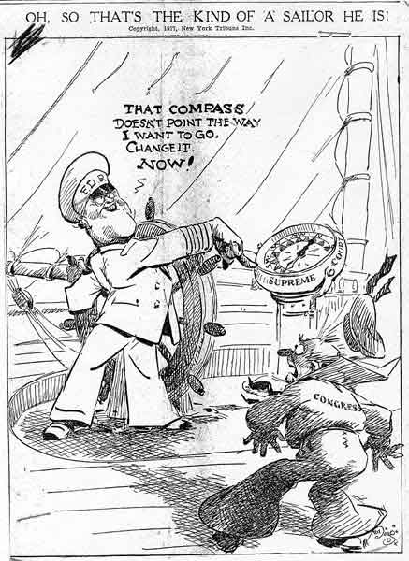

10) What is the main point of the political cartoon?
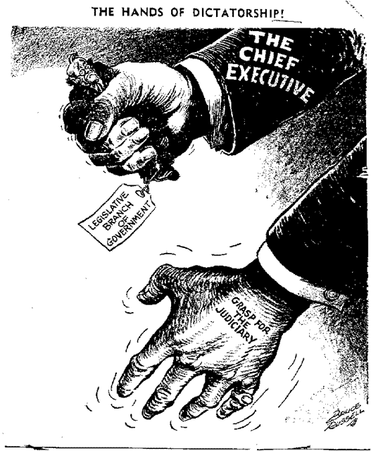

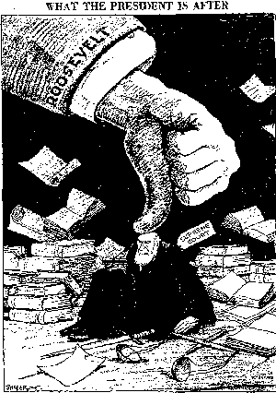
11) What is the main point of the political cartoon?

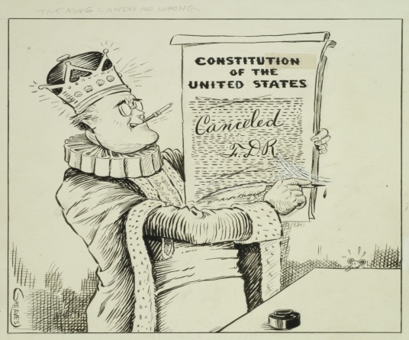
12) Is the creator of this political cartoon a supporter or a critic of FDR? Explain.

13) Is the creator of this political cartoon a supporter or a critic of FDR? Explain.
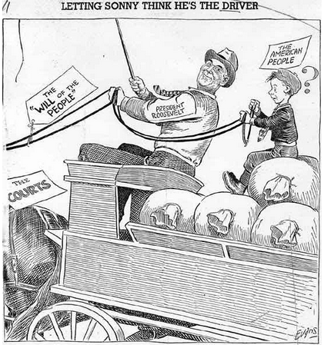

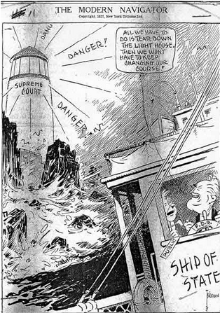
14) Is the creator of this political cartoon a supporter or a critic of FDR? Explain.

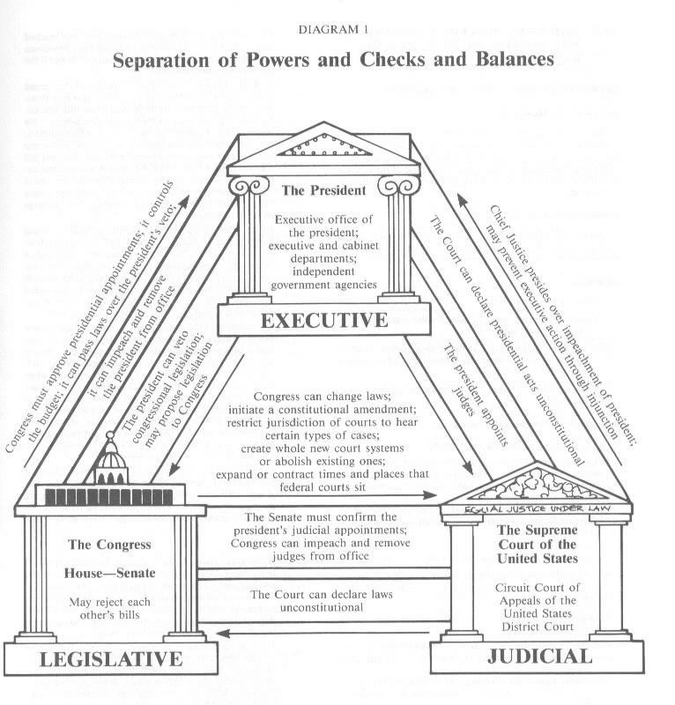
15) Why is it important in American history that FDR’s plan to “pack the Court” failed?

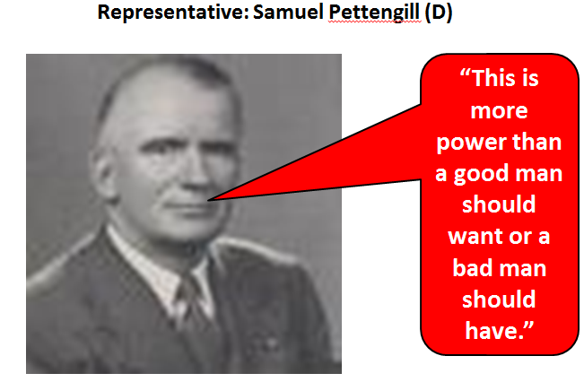
16) What does this quote mean to you?

