Class Discussion: V-25.3A: “Tough Times”
01) Why do you think the textbook included this story in the “American Diary?”

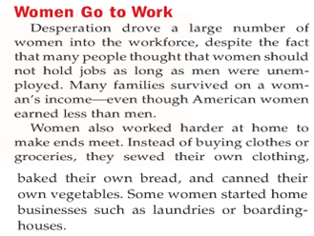
02) If a second Great Depression hit today, what would be three expenses you think your family would “cut back on?”

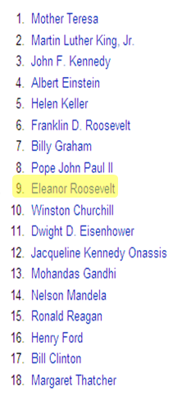
03) On the right, there is the Gallup's List of Widely Admired People of the 20th Century. What were your thoughts on this list? Would you have any additions or “corrections” to make to this list?

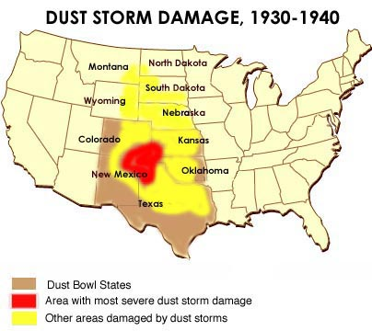
04) What are two examples of how we try to prevent another Dust Bowl in America today?

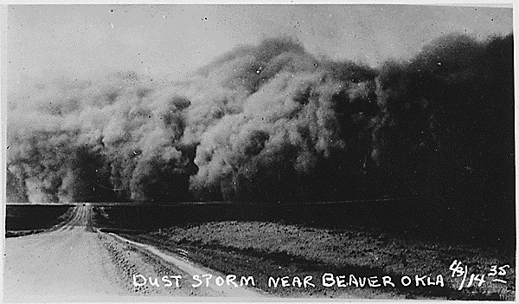
05) What were your thoughts when you looked at pictures of the Dust Bowl, such as this one?

06) Fill in the thought bubble of this migrant person.
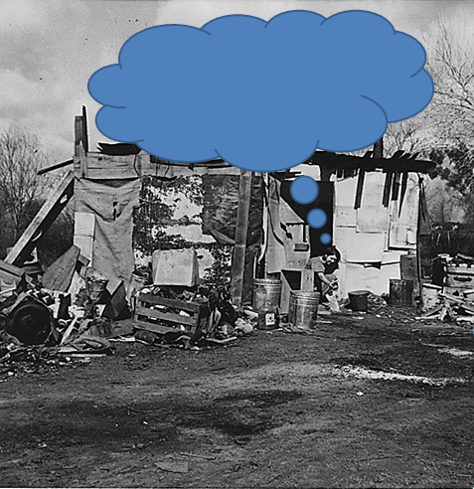

07) Fill in the thought bubble of this migrant person.
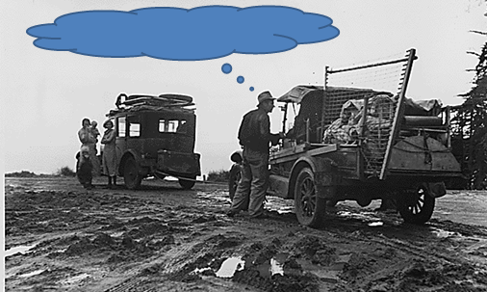

08) Why do you think this Dorothea Lange picture entitled, “Migrant Mother” is considered a classic photograph of the 1930’s time period?
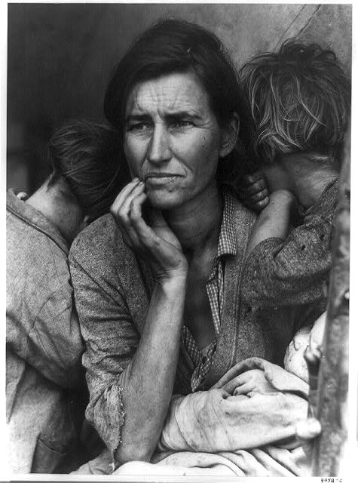

09) Of the hobo symbols shown here, which one do you think would be the most important to a
hobo? Explain.
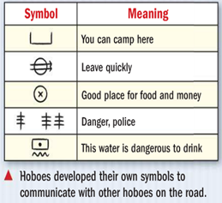

10) Draw a sixth symbol (to the right) for an important hobo message, and explain why you think that would be an important message for hoboes at that time.

11) Why do you think minorities were the “first ones fired and the last ones hired” during the Great Depression?
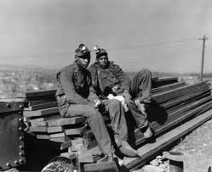

12) Why do you think this passage was important and significant for the Democratic Party? (Hint: Think about a war we studied last year.)
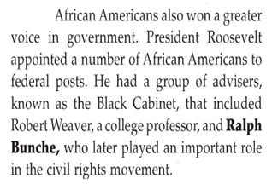

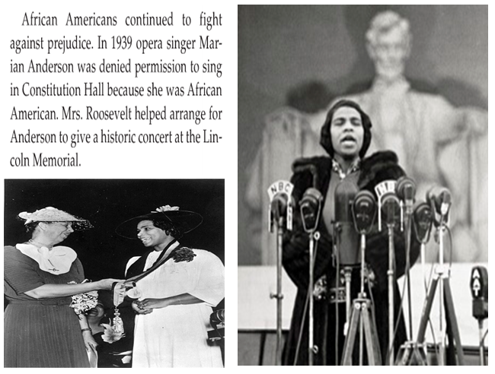
13) what did you find interesting and/or important about this passage?

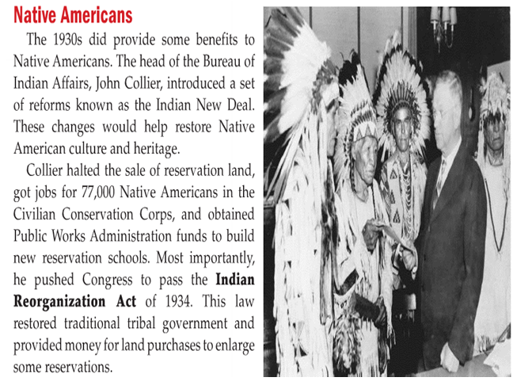
14) Based on what you have learned over the last couple of years, which group of Americans do you think were treated more poorly in our history… African Americans or Native Americans? Explain.

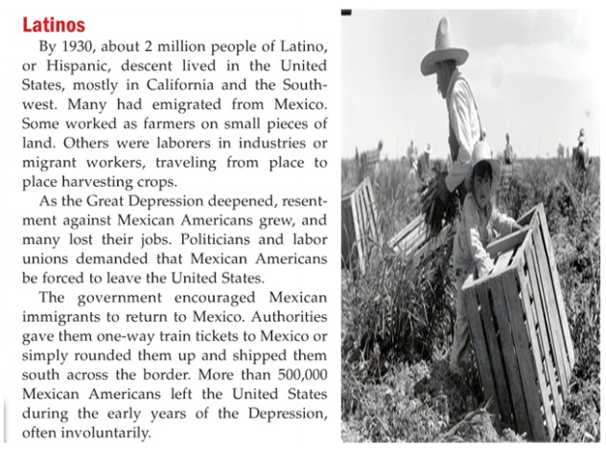
15) Role-Play: You are a Mexican American. During World War I, you were asked to come to America to work to help fill in the void of the men fighting in Europe. Now, it is less than twenty years later. You are being “pressured” to leave America. How does this make you feel?

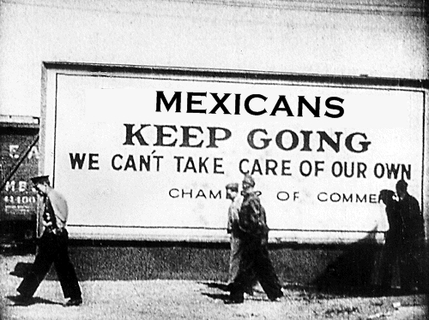
16) What does this sign show about America during the Great Depression?

