Class Discussion V-26.2A: “Blitzkrieg, Britain, & Backstabbing”
01) Why do you think the textbook used this story for the “American Diary?”

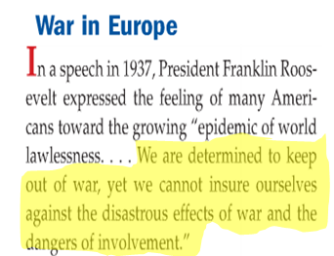
02) What did FDR mean by this quote, and why do you think he said it?

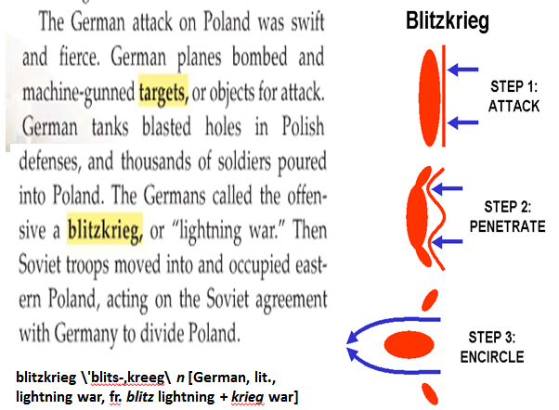
03) Contrast the difference(s) between the tactics used in World War I and the tactics used by Germany with “blitzkrieg.”

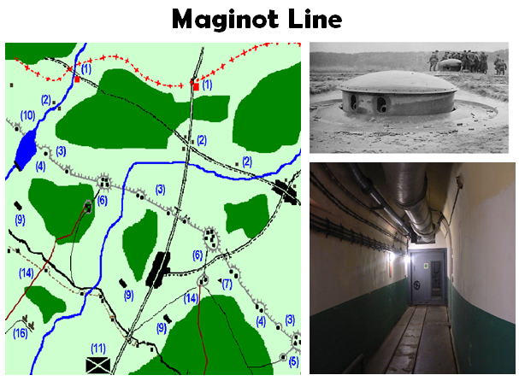
04) What were your thoughts on the “Maginot Line?”
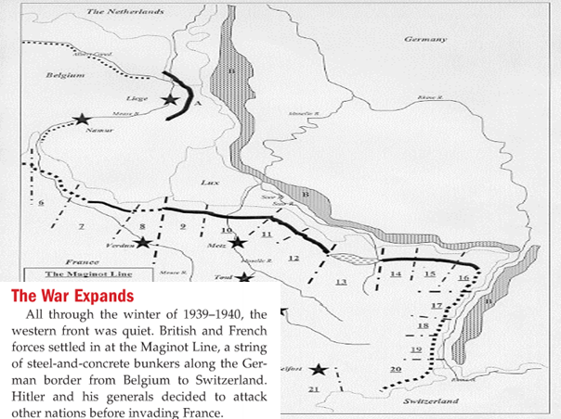

05) Based on the map on the right, how do you think Hitler planned to neutralize the effectiveness of the “Maginot Line?”

06) Why do you think the “Miracle at Dunkirk” was an important event for the Allied cause in World War II?
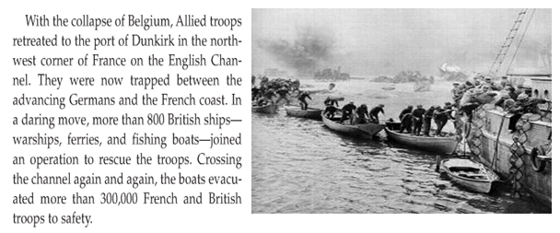

07) Why do you think Hitler would want this picture taken?
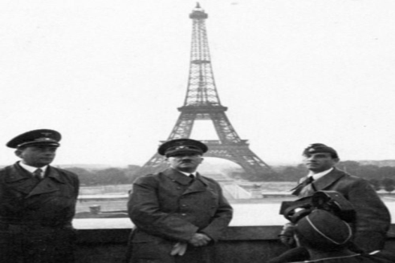

08) With France knocked out of the war, what was the only major European enemy left for Hitler to defeat?

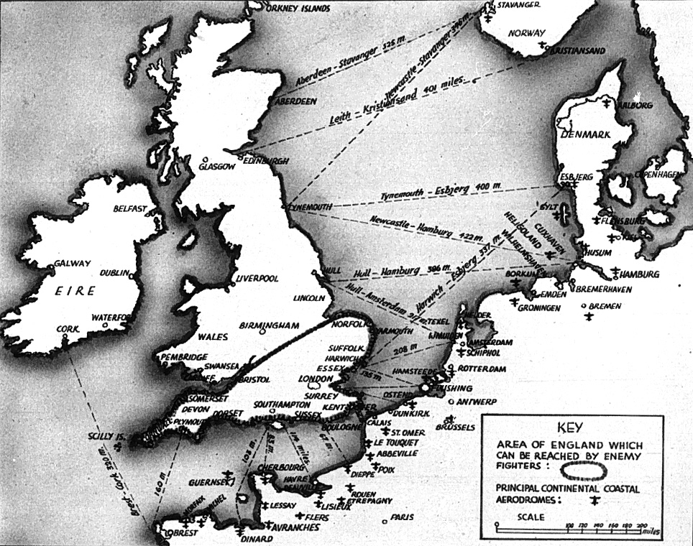
09) What military challenge would Germany have if Hitler wanted to attack Britain that he did not have to deal with when he had attacked the other European countries?

10) Fill in the thought bubble for this World War II picture.

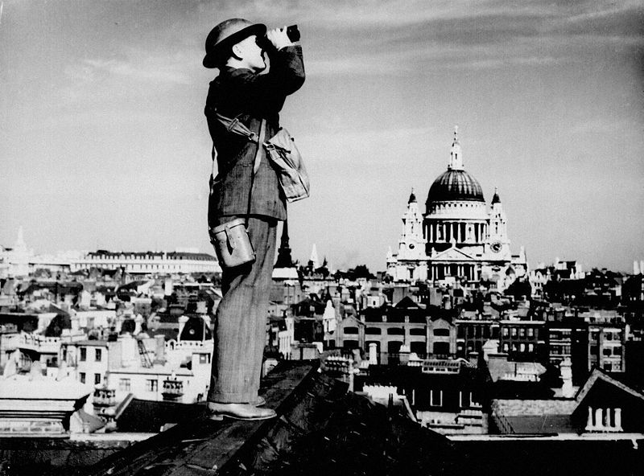

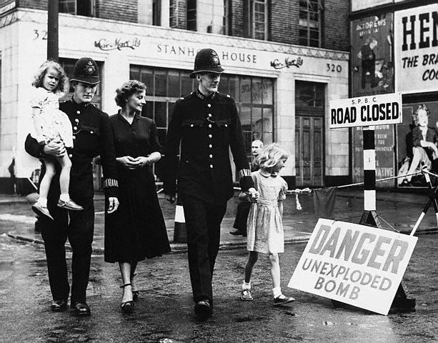
11) You are a war photojournalist. Give your picture a title, and explain why you selected the title.

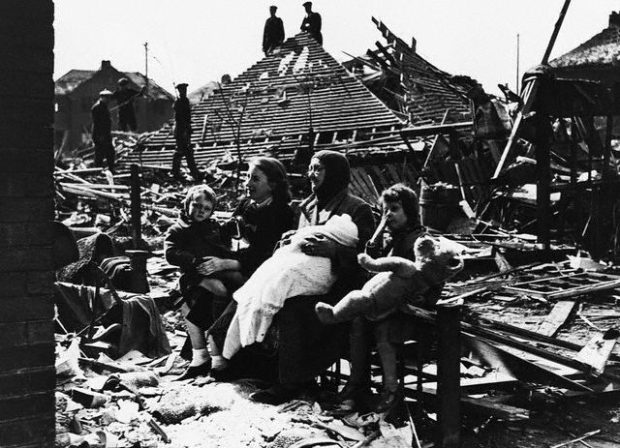
12) You are a war photojournalist. Give your picture a title, and explain why you selected the title.

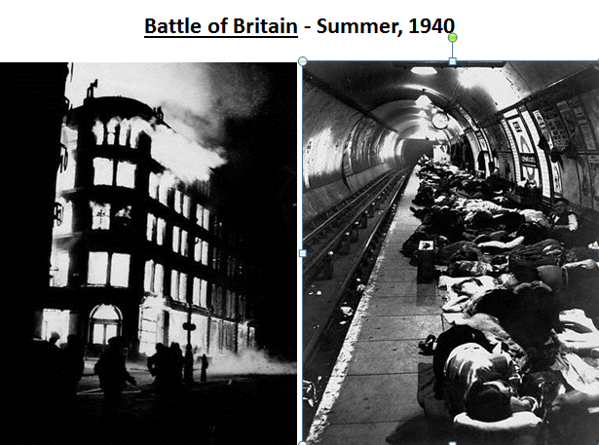
13) ROLEPLAY: You are a 3rd Grade teacher. Explain to your students what is going on in these two pictures.

14 - 15) ROLEPLAY: You are a British official hired by Churchill to create an anti-German propaganda piece based on this picture. Create a propaganda piece and describe which propaganda technique(s) you used.
_____________________________________________________________________________________
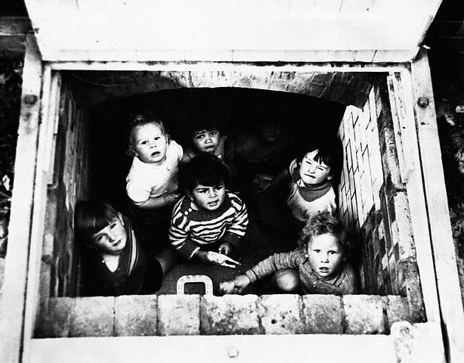
_____________________________________________________________________________________

16 -17) ROLEPLAY: You are a British official hired by Churchill to create an anti-German propaganda piece based on this picture. Create a propaganda piece, and describe which propaganda technique(s) you used.
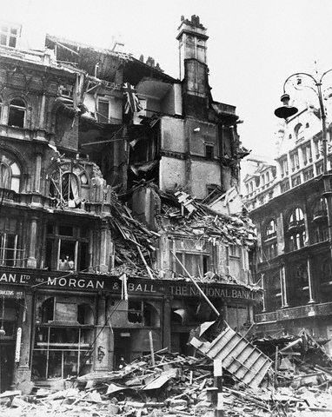

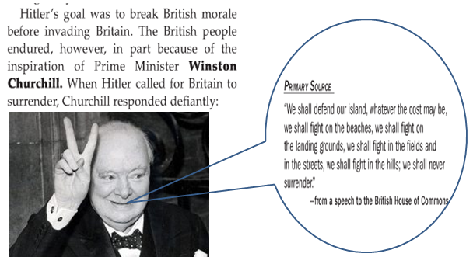
18) Why do you think Hitler wanted to break British morale before invading Britain?

19) Why do we, as people, value “never surrendering?”
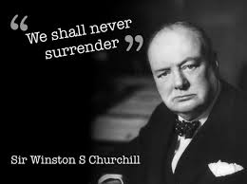

20) Even though America was not in World War II at the time, why do you think it was important to America that Britain won the “Battle of Britain?”
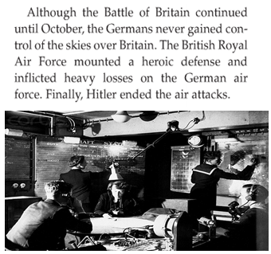

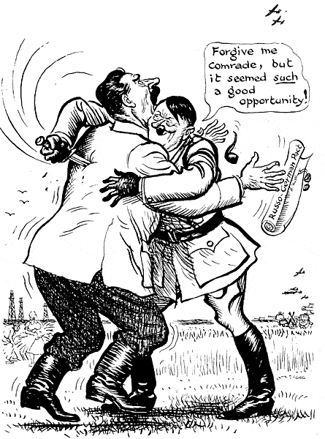
21) What is the main idea of this political cartoon?

22) What did you find to be the most interesting item of this slide?
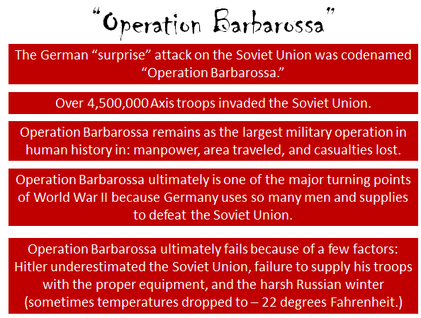

23) ROLEPLAY: You are a Soviet officer. Give a speech to your troops explaining why you are going to use the tactic of “scorched earth policy” as your troops are retreating.




