Class Discussion: V-26.4D: “Victory…and Tragedy” & V-26.4E: “The Holocaust”
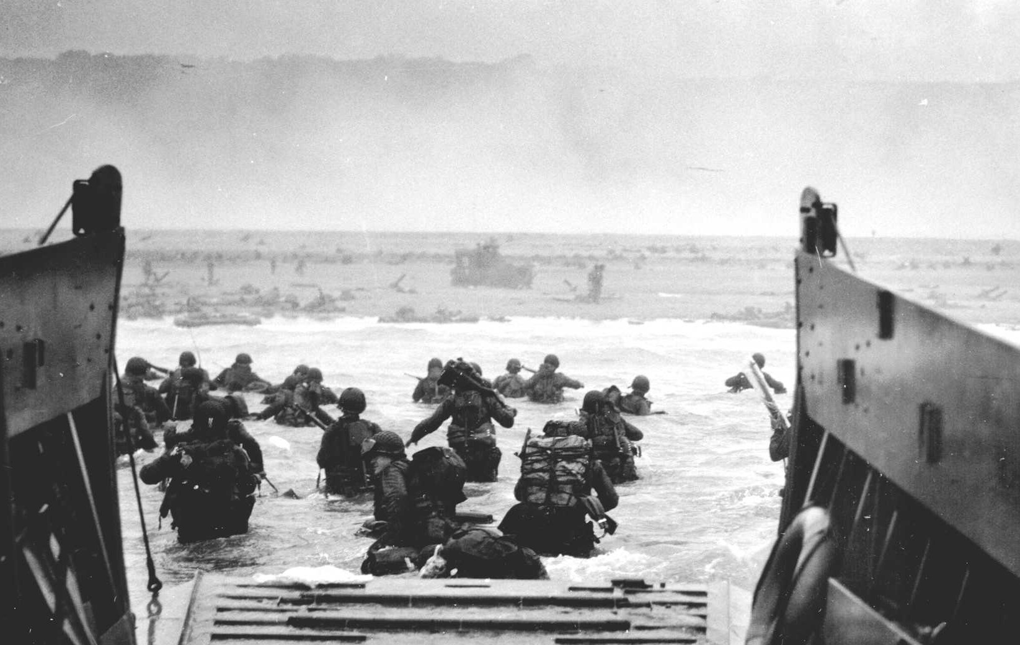
01) Based on what you have learned, which soldier do you think had the scariest assignment, a Civil War soldier, a Spanish-American War soldier, a World War I soldier, or a D-Day World War II soldier? Explain.

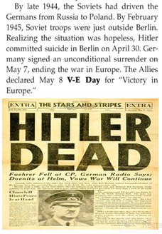
02) Why do you think Hitler ended his own life?

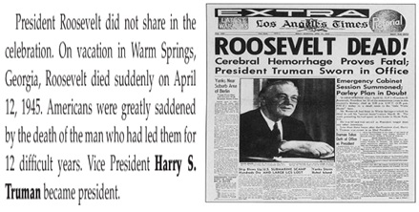
03) Why do you think many Americans cried when they heard the news that F.D.R. was dead?

04) What do you think was the main point of Truman’s quote?
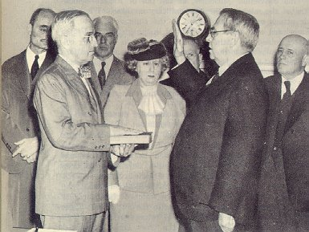
"...I don't know whether you fellows ever had a load of hay fall on you, but when they told me yesterday what had happened, I felt like the moon, the stars, and all the planets had fallen on me."

05) Discuss what images come to your mind when you hear the word, “evil.”

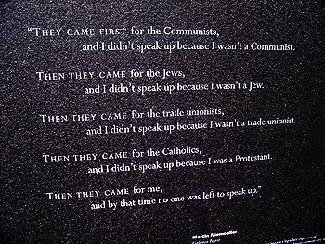
06) What is the main idea of this poem?

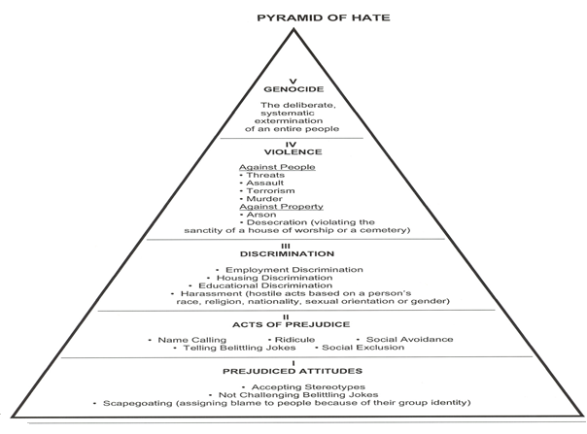
07) What do you think the main idea of the “Pyramid of Hate” is?

08) Give an example of when you have experienced the bottom level of the “Pyramid of Hate.”
09) Give an example of when you have experienced the second level of the “Pyramid of Hate.”

10) Why do you think the Holocaust was called “The Final Solution” by the Nazis?

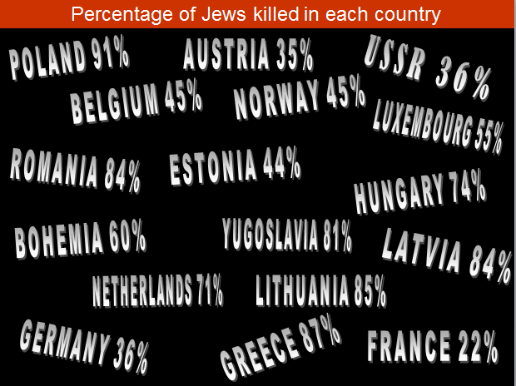
11) What thoughts did you have when you viewed this slide in the video?

12) Identify the examples of “hate” in the paragraph and identify which level they fit on the “Pyramid of Hate.”

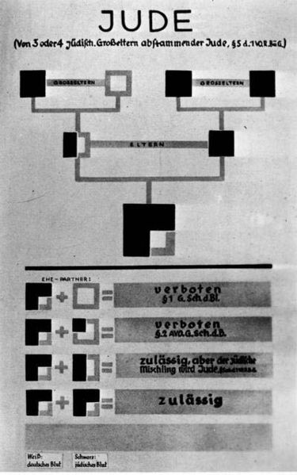
13) Explain what you think the following image is.

_

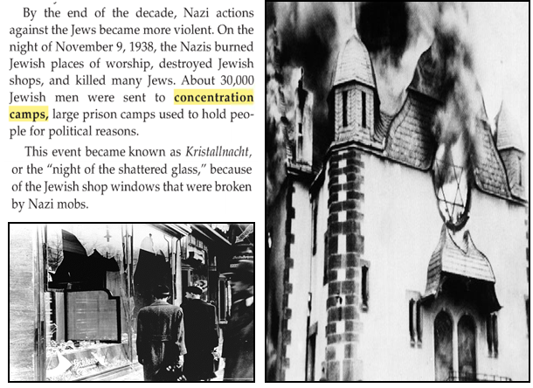
14) Identify the examples of “hate” in the paragraphs and identify which level they fit on the “Pyramid of Hate.”

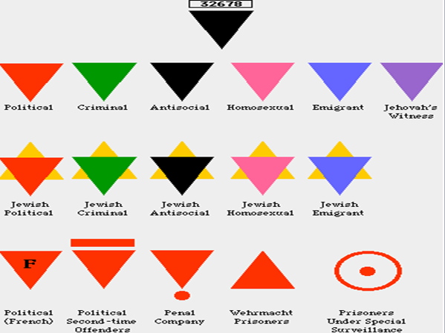
15) What thoughts did you have when you viewed this slide in the video?

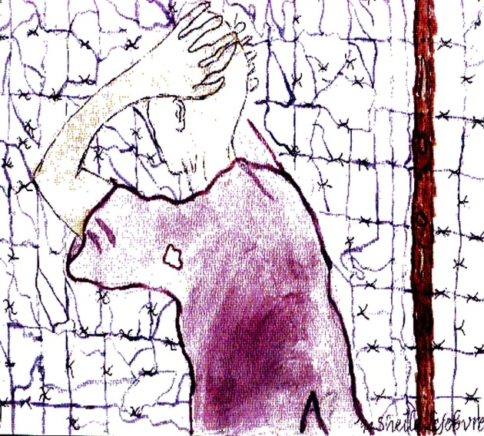
16) I used this picture to begin V-26.4E. Give it a title and explain why you chose that title.

17) Why do you think Hitler waited until he invaded the Soviet Union to begin the mass killing of Jews?

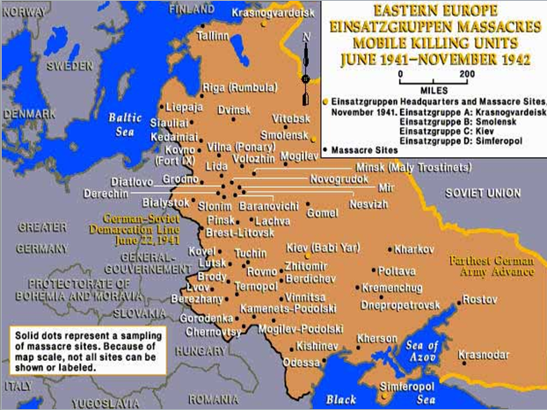
18) What went through your mind when you saw this slide on the video?

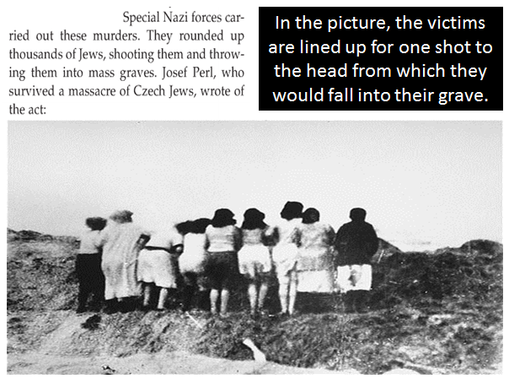
19) What went through your mind when you saw this slide on the video?

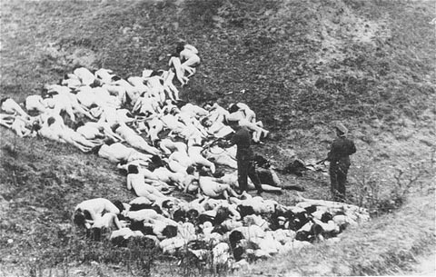
20) What went through your mind when you saw this slide on the video?

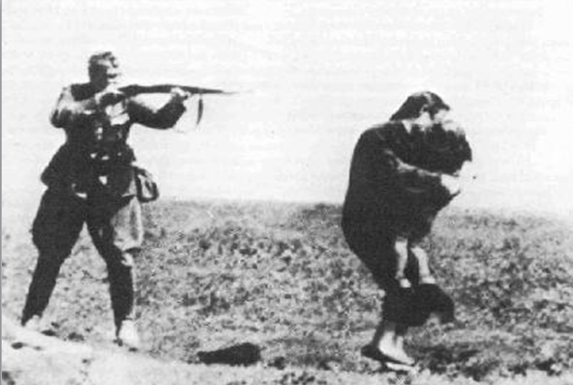
21) What went through your mind when you saw this slide on the video?

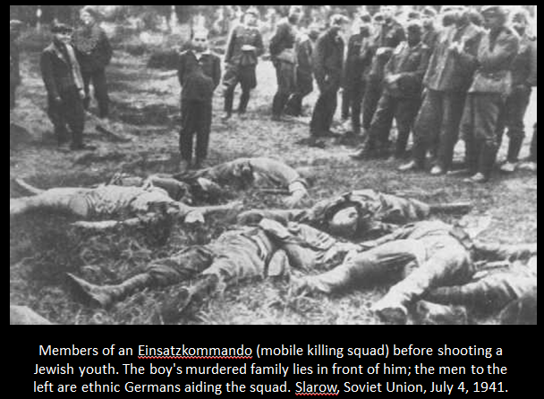
22) What went through your mind when you saw this slide on the video?

23) What went through your mind when you saw this slide on the video?
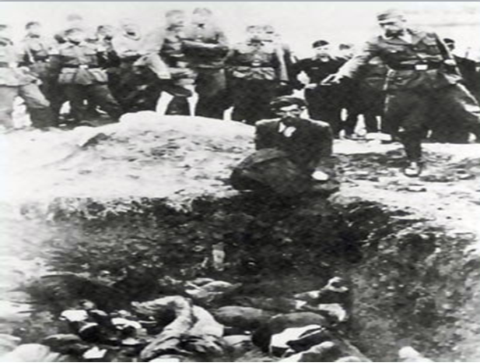

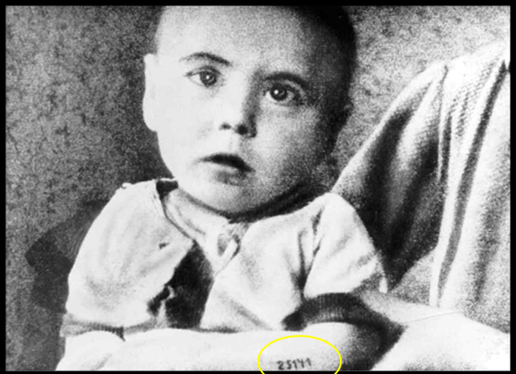
24) What went through your mind when you saw this slide on the video?

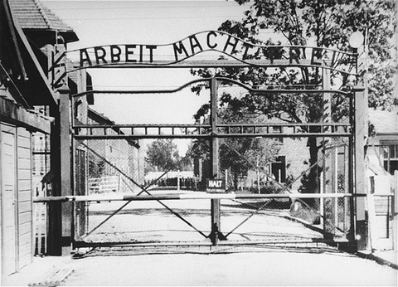
25) Why do you think the Nazis put “Work Will Set You Free” at the front gate at Auschwitz?

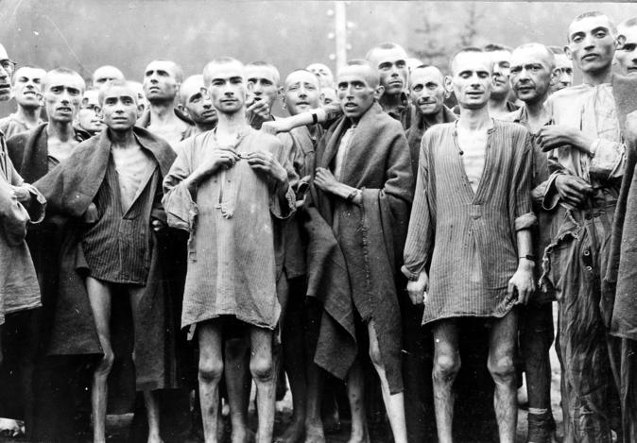
26) Why do you think the Nazis targeted Jews, Gypsies [Roma], homosexuals, the disabled, and homeless people?

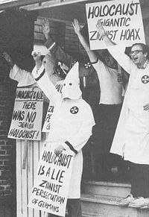
27) Even though there are numerous pieces of evidence to confirm the Holocaust, there are groups of people who try to deny that it occurred or that try to revise parts of the Holocaust. Holocaust denial is explicitly or implicitly illegal in thirteen countries: Austria, Belgium, Czech Republic, France, Germany, Israel, Liechtenstein, Lithuania, Luxembourg, Poland, Portugal, Romania and Switzerland. In your opinion, do you agree or disagree with the decision to make Holocaust denial illegal in those thirteen countries? Explain.

28) What do you think causes some people to practice cruelty and prejudice against other people? In your life, how can you help others who are teased, bullied, or isolated?

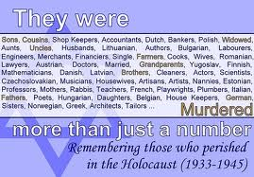
29) What do you think is the most important lesson we can learn from the Holocaust that we can apply to our lives today?

30) Listed below are six quotes. Select one of them and explain what the quote means to you.
- “Prejudice is a lazy man’s substitute for thinking.” Author Unknown
- “Never doubt that a small group of thoughtful committed citizens can change the world; indeed it is the only thing that ever has.” Margaret Mead
- “Racism isn’t born, folks, it’s taught. I have a two-year old son. You know what he hates? Naps! End of list.” Dennis Leary
- “The test of courage comes when he are in the minority. The test of tolerance comes when we are in the majority.” Ralph W. Sockman
- “Prejudice is the child of ignorance.” William Hazlitt
- “You cannot shake hands with a clenched fist.” Golda Meir & Indira Gandhi

