Class Discussion: “V-23.1C: “Trench Warfare”
01) Why do you think this war was called the “Great War” instead of World War I when it began?

02) Which of the following countries fought for the Allies in World War I?
Austria-Hungary France Germany Great Britain
Italy Japan Ottoman Empire United States
03) If you were Germany & Austria-Hungary, what would you think about Italy based on the
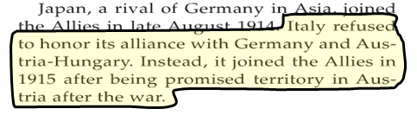
highlighted portion of the text?

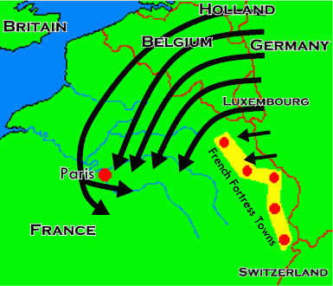
04) Looking at the map, why did it make strategic sense for Germany to attack France by going through Belgium?

05) Even though the Belgians eventually lost to the Germans, how did they help the Allies win World War I?

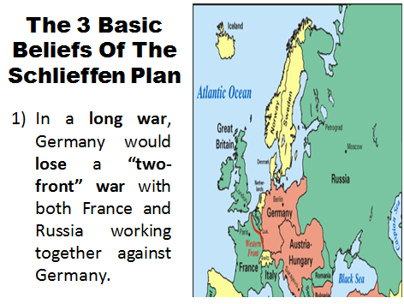
06) Using EXACTLY 10 words, explain the main idea of the first part of the Schlieffen Plan.

07) Physically demonstrate the first part of the Schlieffen Plan using one person as Germany, one person as France, and one person as Russia.

08) ROLE-PLAY: You are Count Alfred von Schlieffen. In 8th Grade terms, explain the 2nd part of your plan to your lower ranking officers.
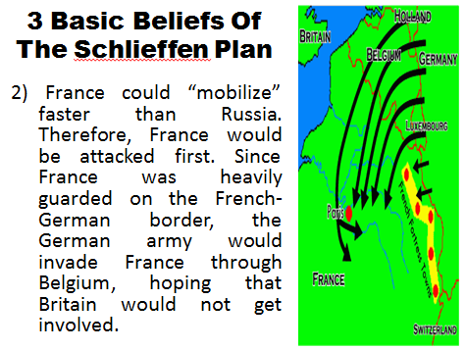

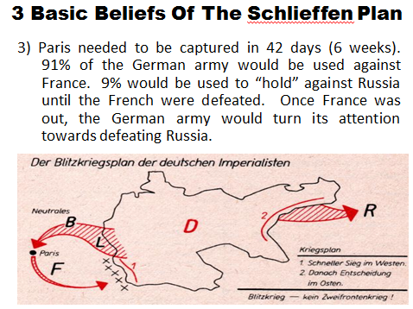
09) Create a limerick (lines 1, 2, & 5 rhyme; lines 3&4 rhyme) that captures the essence of the 3rd part of the Schlieffen Plan.

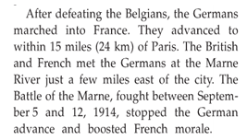
10) Why do you think the “Battle of the Marne” boosted French morale?

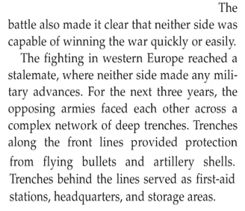
11) What is a “stalemate?”

12) Why do you think the new war technologies led to a “stalemate” in World War I?
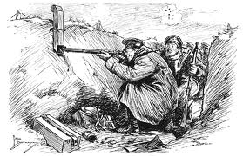
13) Based on what you learned from the video, “If you were a soldier, would you rather be a soldier in the Civil War who could be asked to march many miles each day to get to different battle sites, or would rather be a World War I soldier that would stay in a trench for long stretches of time?” Explain.

14) Discuss and describe three things that you found interesting about this picture of “Trench Warfare.”

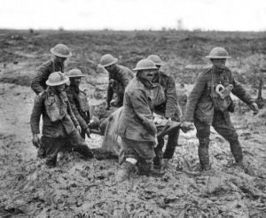
15) Fill in the thought bubbles for these WWI soldiers.

16) In this passage, what kind of mental toll do you think the highlighted portion would cause a soldier to have?

17) For you “First Person Shooter Gamers” in the room, what was the main point of the two paragraphs?

18) Discuss and describe three things that you found interesting about “Rat Infestation.”
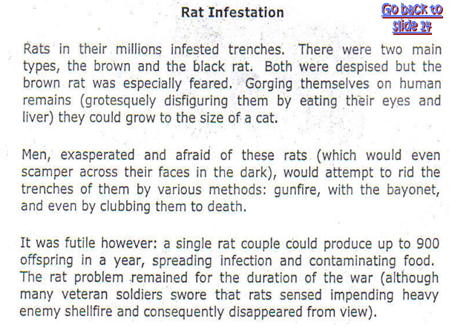

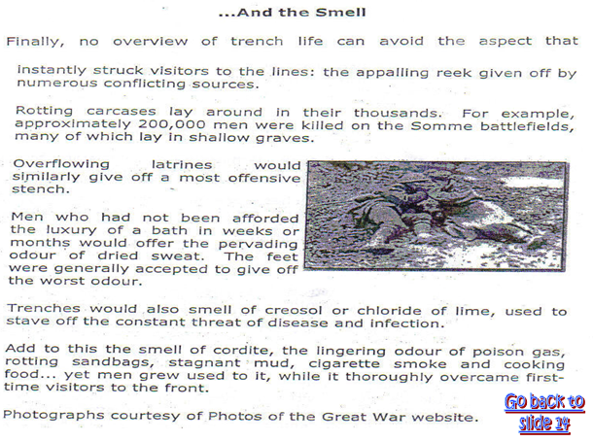
19) Discuss and describe three things that you found interesting about “And the Smell…”

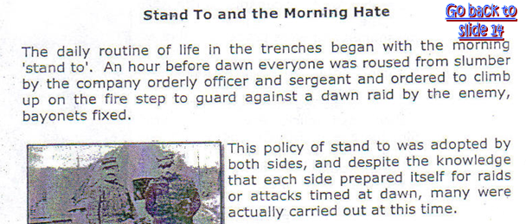
20) Based on the following two paragraphs, why do you think it was common for the every day soldier to dislike his officers?

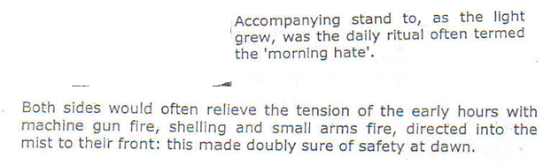
21) Why do you think the phrase “morning hate” became the nickname given to the time period after “stand to?”

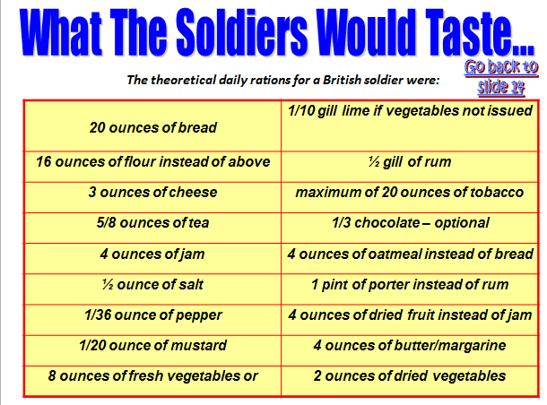
22) Discuss and describe three things that you found interesting about “What The Soldiers Would Taste...”

23) Why do you think lice flourished in trench warfare conditions?
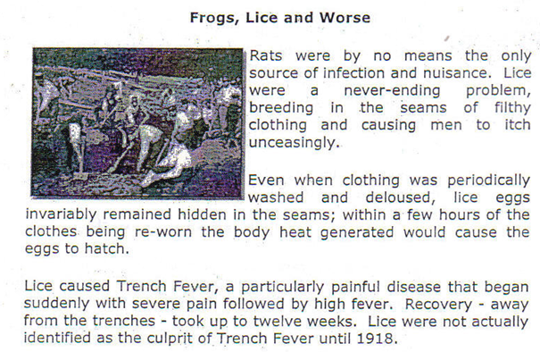

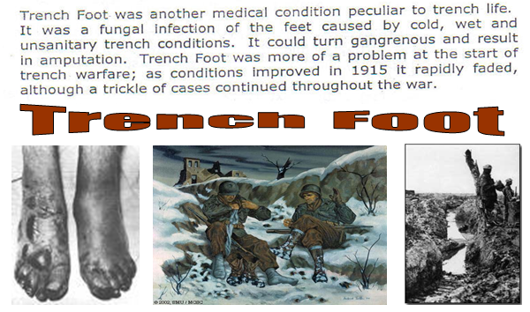
24) Discuss and describe three things that you found interesting about “Trench Foot & Wet Gangrene.”

