Class Discussion: “V-23.1D: “Technology of War”
01 – 04) Role-Play: You are a photographer. You are entering this photograph into a 1915 contest. Give the photograph a thought-provoking title, and explain in three sentences why you selected that title to capture the essence of the picture.
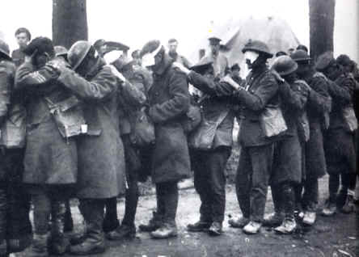

05 – 08) Role-Play: You are a newspaper editor of Le Figaro (the biggest newspaper in Paris, France at that time.) You are trying to decide which one of these photographs to place on the front page of your newspaper. Describe which one you would select, give it a title, and explain in three sentences why you would select it over the other photograph.
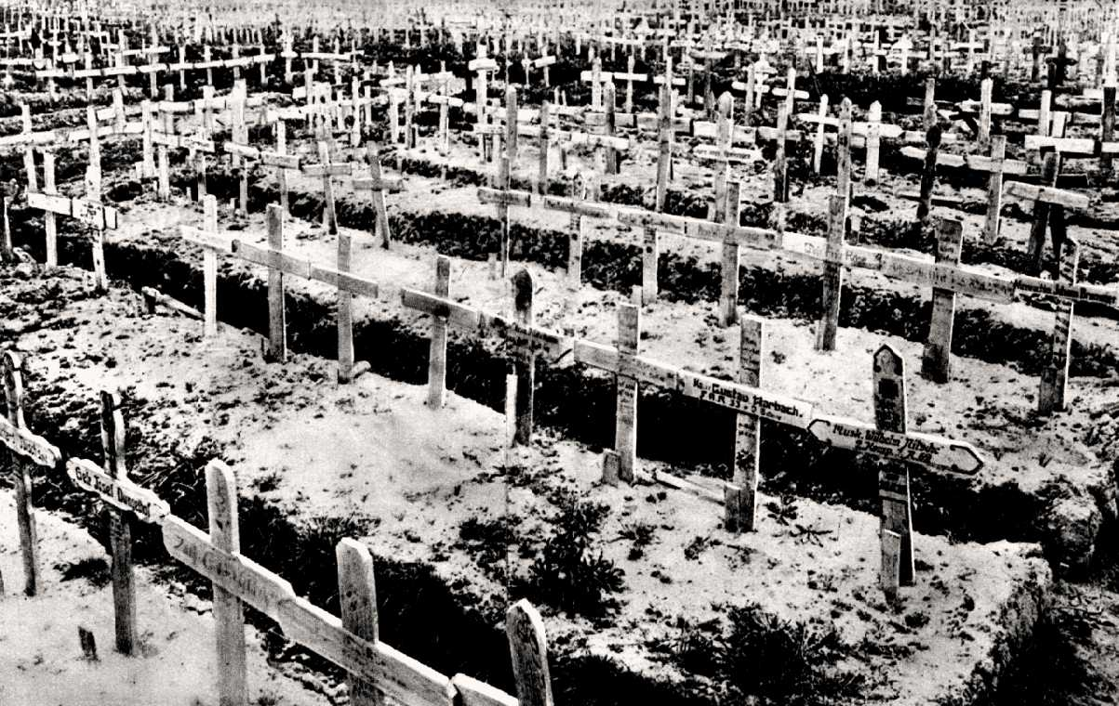
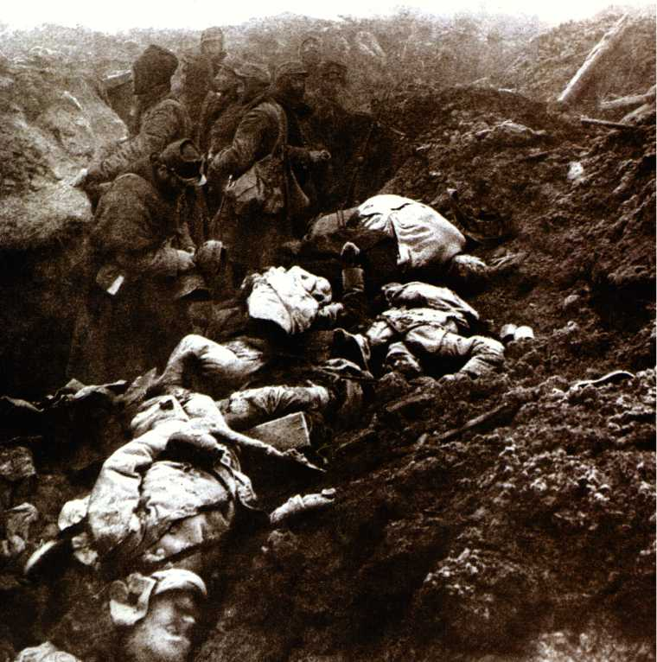
09) Discuss the most interesting thing you took from these two paragraphs.

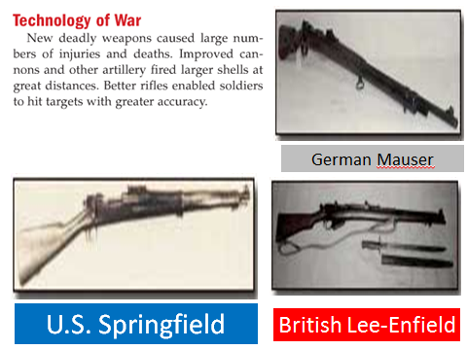
10 - 12) TAKE A POSITION: Explain how the following paragraph either demonstrates or does not demonstrate “progress.” Be able to defend your position with a MINIMUM of three sentences.

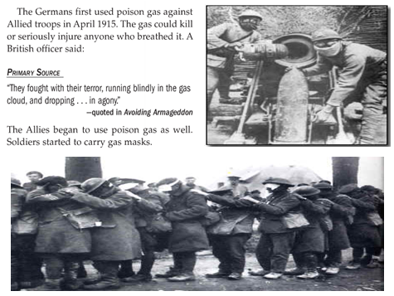
13 – 15) TAKE A POSITION: Is all fair in love and war? Should poison gas be allowed in warfare? Explain your position (WITH A MINIMUM OF THREE SENTENCES) on Germany’s use of poison gas in World War I.

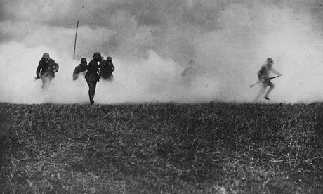
16 – 18) TAKE A POSITION: Here is a quote from a British commander is response to Germany’s decision to use poison gas… “It is a cowardly form of warfare which does not commend itself to me or to other English soldier…. We cannot win this war unless we kill or incapacitate more of our enemies than they do of us, and if this can only be done by our copying the enemy in his choice of weapons, we must not refuse to do so.” If you were a high-ranking British officer at a meeting where he said this quote, would you agree with his position or disagree with his position? Explain your position using a minimum of three complete sentences.

19) Discuss the most interesting thing you took from this slide.
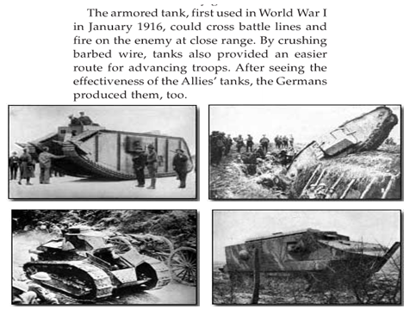

20) Discuss the most interesting thing you took from this slide.
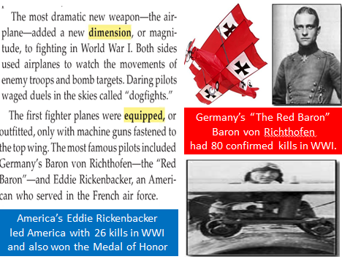

21 – 23) ROLE-PLAY: You are a German military advisor. Your task is to decide what is the best use of money for your military. Which would you spend more of your investment in…. the zeppelins or the Unterseeboots (submarines)? Explain your decision using a minimum of three complete sentences.
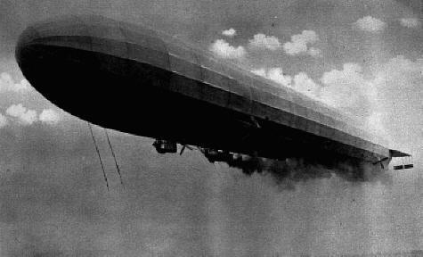

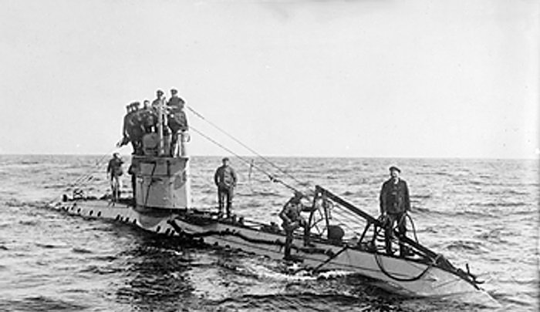

24 – 26) ROLE-PLAY: You are a social studies textbook editor. You would like to add one World War I poem to the textbook, since space limitations do not allow you to add more than one. Which one of the following poems would you select, and why? Answer using a minimum of three complete sentences.
