Small Group Discussion: “V-23.4: “The War At Home”
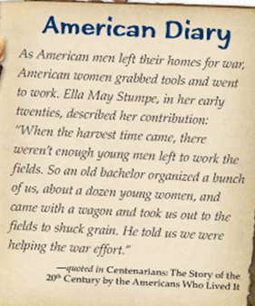
01) What is the main idea of the “American Diary” that begins section 23.4?

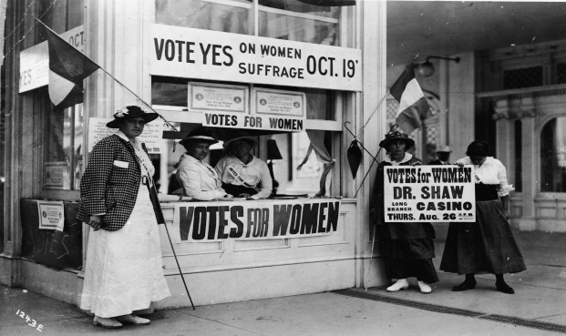
02) MAKING A PREDICTION: When World War I began in 1914, women could not vote in America. In 1920, the 19th Amendment to the United States Constitution was ratified giving women the right to vote. Why do you think these two events in American History are connected?

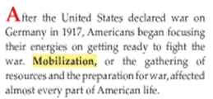
03) Define “mobilization” in 8th Grade words. Don’t use the textbook definition.

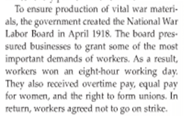
04) In 8th Grade words, summarize the main purpose of the National War Labor Board.

05) Why were American workers treated very well once America began to mobilize for WWI?

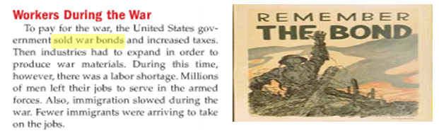
06) List three ways in which America’s entry into World War I affected the American economy.

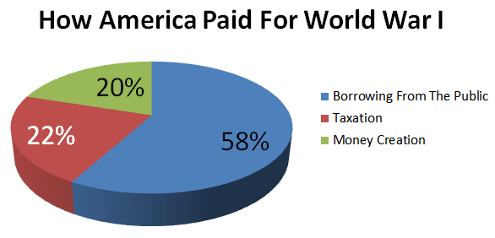
07) What did you find to be the most interesting thing about the pie graph pictured here?

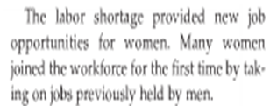
08) Explain how World War I, helped women achieve equality in America.

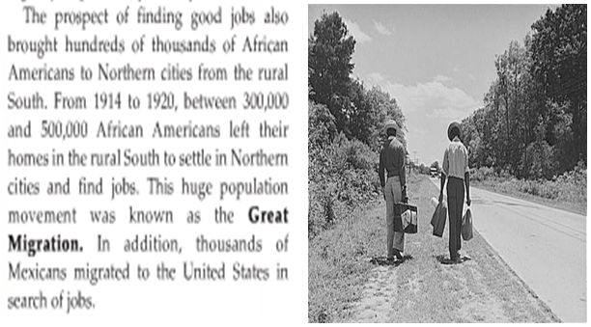
09 What was the “Great Migration” and why did it occur?

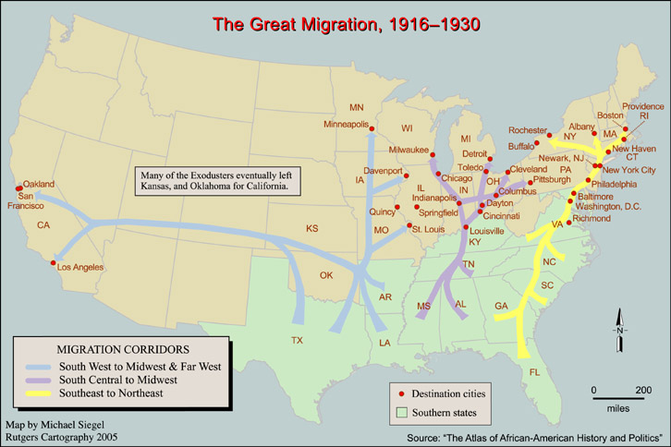
10) Besides available jobs, can you think of another reason why African Americans would leave the South during “The Great Migration?”

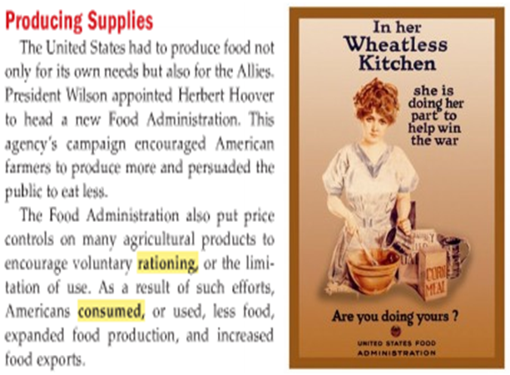
11) Role-play: You are Herbert Hoover, leader of the Food Administration. Explain in exactly three sentences what the purpose of the Food Administration is, and why it is vitally important to helping America win World War I.

12) Describe at least one propaganda technique being used in the Food Administration poster.

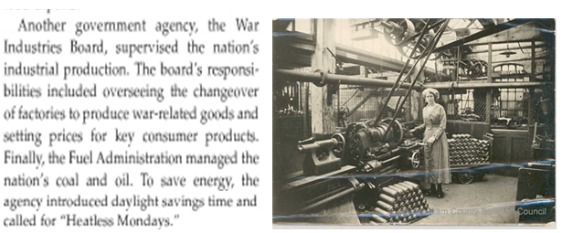
13) Role-play: You are the leader of the War Industries Board. Give three examples of how you would convert a peacetime factory into a World War I factory.

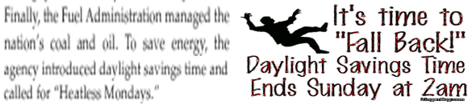
14) Role-play: You are the leader of the Fuel Administration. Explain the purpose of agency to a news reporter.
_____________________________________________________________________________________________

15) Role-play: You are President Woodrow Wilson. The Speaker of the House wants to understand why Congress should spend money on the Committee on Public Information. Explain it to him, using exactly three sentences.

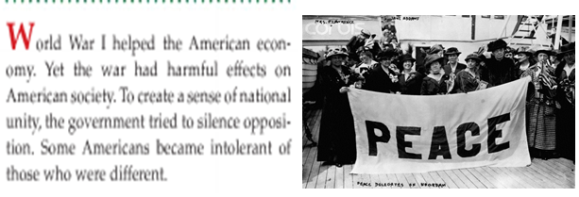
16) MAKE AN INFERENCE: What do you think the textbook meant when it stated, “Some Americans become intolerant of those who were different.”?

17) SUMMARIZE: Describe two reasons from this paragraph as to why some Americans were against America joining World War I.
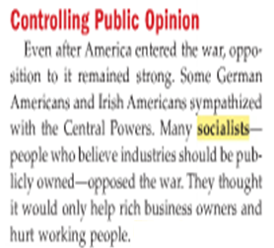

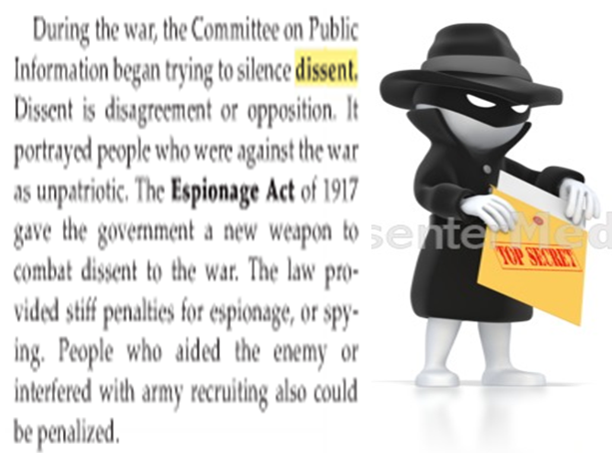
18) Do you think it is “unpatriotic” for an American to vocally protest against a war that America is fighting? Explain.

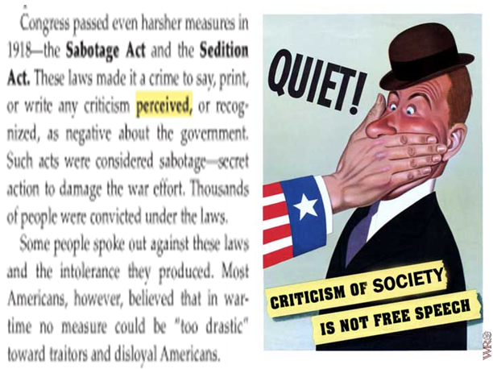
19) What were your thoughts on this passage from the text… Do you think during wartime that the 1st Amendment freedoms of speech and press should be limited to ensure that we win the war? Explain.

