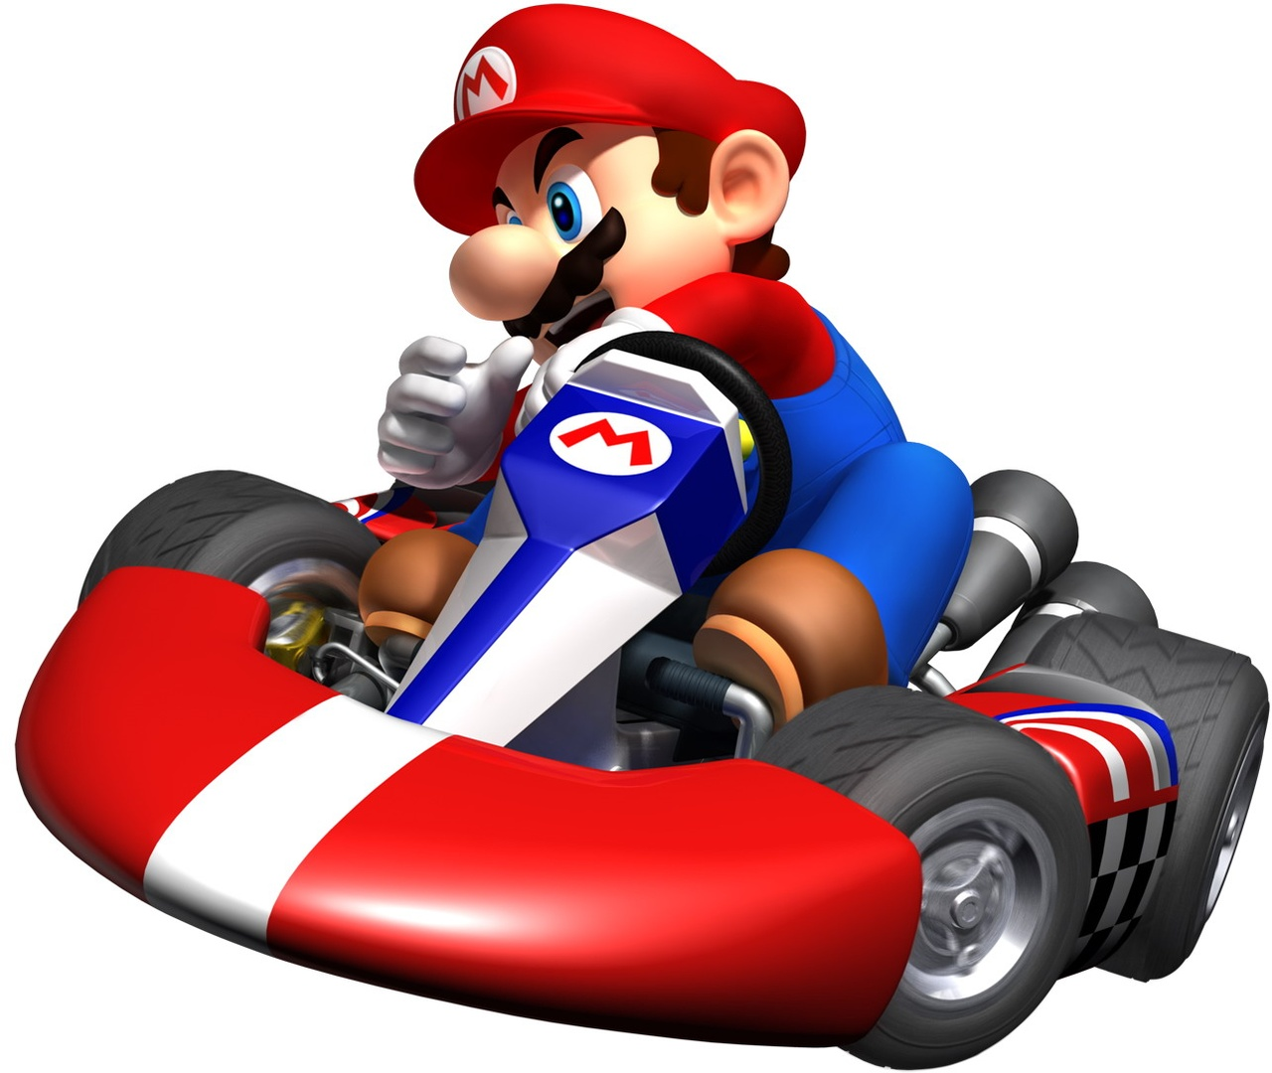
Mario Kart 2017

Overall Objective
The purpose of Mr. Morris “gamifying” 8th Grade History is to increase student engagement, learning, and fun in the classroom. Hopefully, by the end of this semester, you will all improve, not just in your academics, but also in the following ten qualities that highly successful people have in common: confidence, creativity, enthusiasm, effort, focus, resilience, initiative, curiosity, dependability, and empathy.
Mario Cart Grand Prix
Each week (beginning Monday,) a new race will begin. Each team will try to complete tasks to advance their driver. On Fridays, we will conduct the race (unless a Quiz, Test, or special circumstance forces the race to occur on the next available date.) For each race, the following points will be awarded:
1st | 2nd | 3rd | 4th | 5th | 6th | 7th | 8th | 9th | 10th | 11th | 12th
50 | 40 | 30 | 25 | 20 | 15 | 12 | 10 | 8 | 6 | 4 | 2

During the last week of March, we will hold our last “Qualifying Race.” The top six teams will be entered into the “Championship Bracket.” The bottom six teams will be entered into the “Consolation Bracket.” When we return from Spring Break, each team’s points will be reset to zero. The teams in the Championship Bracket will compete against each other until the end of the semester to win the Championship. The teams in the Consolation Bracket will compete against each other until the end of the semester to win the Consolation Championship.

Team Creation
There will be four teams in each homeroom. The Team Captains will be determined by the highest average GPA for First Semester. The rest of the Team members will be drafted by the Team Captains. The Teams are as follows…
Mario Kart Teams: 8B
 | Team #1: | Team #2: | Team #3: | Team #4:
Team Captain | Kylie | Connor | Kyler | Noah
Team Member | Emma B. | Bri | Tyler | Michael
Team Member | Kaitlyn | Paige | Liz | Wells
Team Member | Hannah | Clayton | Carly | Ashley
Team Member | Emma | Avery | Spencer | Dyllan
Team Member | Jake | Tristan | Ethan | Abby
Team Member |  |  |  | Sophie

Mario Kart Teams: 8A
 | Team #1: | Team #2: | Team #3: | Team #4:
Team Captain | Gianna | Baylee | Tiffany | Faith
Team Member | Michael | Brig | Cody | Will
Team Member | Makenzie | Trevor | Logan | Zach
Team Member | Nathaniel | Matt | Nate | Josh
Team Member | Gabby | Emily | Kristen | Anna
Team Member | Cael | Hannah | Ryan S. | Jackson
Team Member |  |  | Mariah | Rian P.

Mario Kart Teams: 8C
 | Team #1: | Team #2: | Team #3: | Team #4:
Team Captain | Alison | Clare | Josh | Ally
Team Member | Lily | Tatumn | Nathan | Dylan
Team Member | Corinne | Tristen | Abby | Chad
Team Member | Quinton | Deseray | Maggie | Emily
Team Member | Teighlor | Aisha | Brian | Max
Team Member | Noah | Jason | Sam | Kaylee
Team Member |  |  |  | Patrick

Driver Selection
With all three homerooms included, there are twelve different teams. This means there will be twelve different drivers competing in our Mario Kart Challenge. Each team will submit a “Driver Request Form.” Each team will need to rank/prioritize the different drivers that your team would like to be. Mr. Mo will go through the requests and give your team your highest requested driver. If there is a tie with another team’s request, Mr. Mo will randomly select which team gets the driver. The different drivers are: Mario, Luigi, Peach, Daisy, Yoshi, Toad, Koopa Troopa, Shy Guy, Baby Mario, Baby Luigi, Baby Peach, Baby Daisy, Bowser, Donkey Kong, Wario, and Waluigi.
Mario Kart Organizer
Each student has already been given a plastic organizer from First Semester. You will use the same organizer for our Mario Kart Challenge to store all of the badges, items, etc. during the Second Semester. This organizer must be brought to class if the student wants to use any of the items that are in the organizer.
Tune-Ups
Academically, you will still receive grades on homework, projects, quizzes, and tests. However, you will be spending some class time / homework time working independently on “Tune-Ups.” Tune-Ups are optional activities that you can complete to earn XP (Experience Points.) Tune-Ups are never directly a part of a student’s academic grade. Tune-Ups will relate to the material we are covering in the chapter. The deadline for turning in a Tune-Up is the day of the Test. Tune-Ups will be offered to all students through Canvas.
Pit Stops
Pit Stops are similar to Tune-Ups. The Pit Stops are also optional. They are never part of a student’s academic grade. Pit Stops earn every member of the team XP. The deadline for turning in Pit Stops is the day of the Test. Pit Stops will also be offered to all teams through Canvas.
Pedal to the Metal
Pedal to the Metal activities are ways in which your team can advance your driver on the racetrack. These activities could vary from academic endeavors to non-academic activities. Your team’s performance on quizzes and tests will be used. Your team’s active participation in classroom discussions will be used. By winning these activities, your team will improve your chances of winning each race that is held.
XP (Experience Points)
XP (Experience Points) are earned by each student in the game. Each student begins at 0 XP. XP is never related to a student’s academic grade. XP can be earned in a variety of ways, such as through Tune-Ups and Pit Stops.
Team Leaderboard
A shared Google Sheet will keep track of every Team’s current points in the standings. Every student will be able to access the Google Sheet.

Individual Leaderboard
A shared Google Sheet will also keep track of every student’s XP and level. However, each student will be encouraged to use a “Gamer Nickname” so they can remain anonymous, if they would like. Mr. Morris will simply hide the column in Google Sheets that displays your real name. Every student will be able to access the Google Sheet.

Leveling Up
Every student begins the game at Level #0. As students accumulate XP, they can level up. Leveling up not only helps the student, but it also helps their team. Each time a student levels up, they will earn a “Badge” and will be allowed to draw an item out of the “Item Box.”
LEVEL | LEVEL NAME | XP |  | LEVEL | LEVEL NAME | XP
1 | Ernie Irvan | 1,000 |  | 26 | Bobby Isaac | 105,000
2 | Tim Richmond | 2,000 |  | 27 | Kevin Harvick | 110,000
3 | Neil Bonnett | 3,000 |  | 28 | Fireball Roberts | 115,000
4 | Harry Gant | 4,000 |  | 29 | Mark Martin | 120,000
5 | Cotton Owens | 6,000 |  | 30 | Terry Labonte | 125,000
6 | Geoff Bodine | 8,000 |  | 31 | Dale Jarrett | 130,000
7 | Greg Biffle | 10,000 |  | 32 | Joe Weatherly | 135,000
8 | Buddy Baker | 15,000 |  | 33 | Herb Thomas | 140,000
9 | Jeff Burton | 20,000 |  | 34 | Kyle Busch | 145,000
10 | Denny Hamlin | 25,000 |  | 35 | Junior Johnson | 150,000
11 | Jim Paschal | 30,000 |  | 36 | Tim Flock | 155,000
12 | Wendell Scott | 35,000 |  | 37 | Bill Elliott | 160,000
13 | Carl Edwards | 40,000 |  | 38 | Rusty Wallace | 165,000
14 | Ricky Rudd | 45,000 |  | 39 | Buck Baker | 170,000
15 | Dale Earnhardt, Jr. | 50,000 |  | 40 | Ned Jarrett | 175,000
16 | Richie Evans | 55,000 |  | 41 | Bobby Allison | 180,000
17 | Alan Kulwicki | 60,000 |  | 42 | Tony Stewart | 185,000
18 | Brad Keselowski | 65,000 |  | 43 | Lee Petty | 190,000
19 | Davey Allison | 70,000 |  | 44 | Cale Yarborough | 195,000
20 | Kurt Busch | 75,000 |  | 45 | Darrell Waltrip | 200,000
21 | Matt Kenseth | 80,000 |  | 46 | David Pearson | 210,000
22 | Benny Parsons | 85,000 |  | 47 | Jeff Gordon | 220,000
23 | Fred Lorenzen | 90,000 |  | 48 | Jimmie Johnson | 230,000
24 | Bobby Labonte | 95,000 |  | 49 | Dale Earnhardt | 240,000
25 | Rex White | 100,000 |  | 50 | Richard Petty | 250,000+

Badges
Students can earn badges in the game in a variety of ways. The most common way is when a student levels up.
Item Box
When an student levels up, the student will be allowed to randomly draw one item from the “Item Box.” These items will be items from Mario Kart, such as: shells, bananas, mushrooms, etc. These items will help your team have an edge in the races.
Quiz & Test Score Virtual Currency Contribution
Every time we take a graded Quiz or Test, each student who scores a 92% or higher will add $1.00 to their team’s “Closing Celebration Fund.”
Closing Celebration
On the final academic day of the second semester, we will hold a “closing celebration” in class. Each team will be encouraged to bring in food/beverages. Mr. Morris will have you fill out an evaluation form on the Mario Kart experience. For the team that wins the Championship, you will be able to spend the money in your “Closing Celebration Fund” on food/beverages/items for the party. For the team that wins the Consolation Championship, you will be able to spend ½ the money in your “Closing Celebration Fund.”
Beta Testing
This is Mr. Mo’s first time trying the Mario Kart Challenge for 8th Grade. I am really excited to go on this journey with all of you. That being said, I am sure I will be making changes and modifications along the way. If you have any comments, concerns, or suggestions, please email or talk to me about them.
