Class Discussion: “V-24.1: “Time of Turmoil” Name__________________
01) What similarities do you see between “capitalism” and how American public schools are run?
____________________________________________________
____________________________________________________
____________________________________________________
____________________________________________________
____________________________________________________
____________________________________________________
____________________________________________________
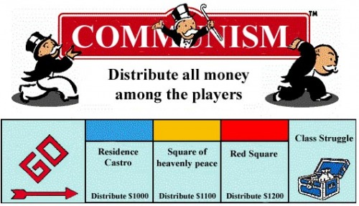
02) Describe an imaginary school which believed in a “communist” view on grades versus the more capitalistic view that American schools currently use.
____________________________________________________
____________________________________________________
____________________________________________________
____________________________________________________
____________________________________________________
____________________________________________________
____________________________________________________
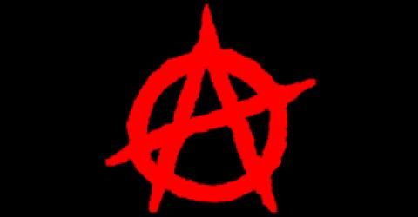
03) Describe a school which believed in an “anarchist” view on school versus the system that we used today.
____________________________________________________
____________________________________________________
____________________________________________________
____________________________________________________
____________________________________________________
____________________________________________________
____________________________________________________
04) What do you think is the main point of this political cartoon?
_____________________________________________________________________________________________
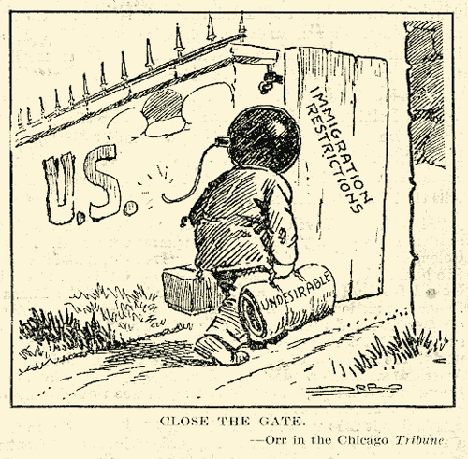
_____________________________________________________________________________________________

05) What do you think is the main point of this political cartoon?
_____________________________________________________________________________________________
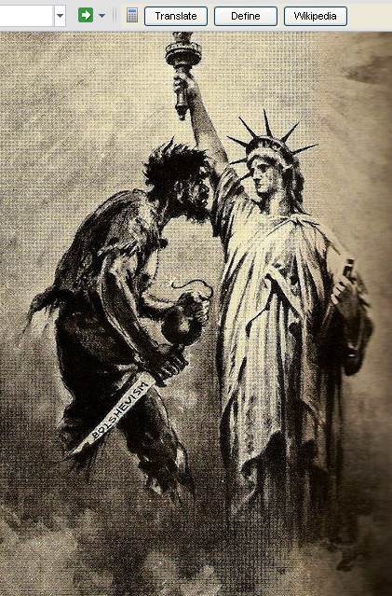
_____________________________________________________________________________________________

06) Explain what is being shown in this political cartoon?
_____________________________________________________________________________________________
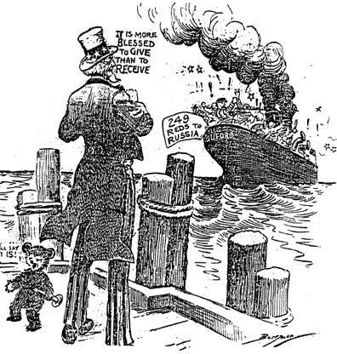
_____________________________________________________________________________________________

07) What is the main idea of this political cartoon?
_____________________________________________________________________________________________
_____________________________________________________________________________________________
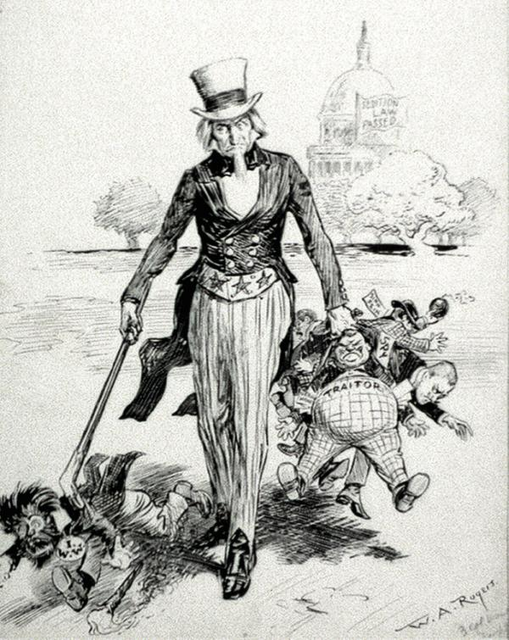

08) Explain what is being shown in this political cartoon?
_____________________________________________________________________________________________
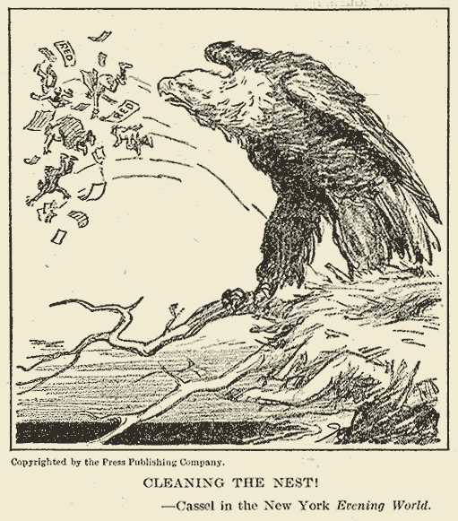
_____________________________________________________________________________________________

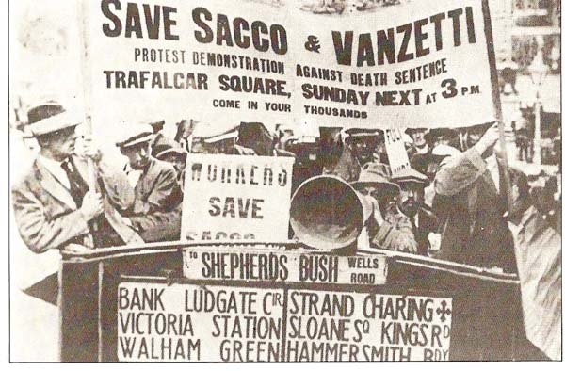
09) Why do you think the textbook included the story of the Sacco & Vanzetti Trial in this section?
__________________________________________
__________________________________________
__________________________________________
__________________________________________
__________________________________________
__________________________________________
__________________________________________
10) What is the main idea of this political cartoon?
_____________________________________________________________________________________________
_____________________________________________________________________________________________
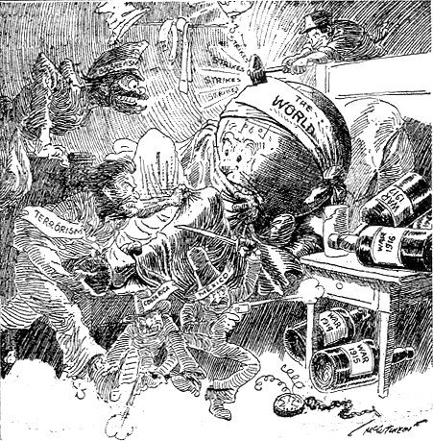

11) What is the main idea of this political cartoon?
_____________________________________________________________________________________________
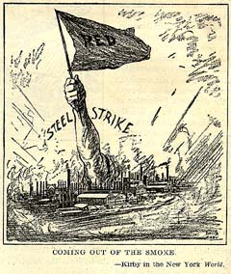
_____________________________________________________________________________________________

12) What is the main idea of this political cartoon?
_____________________________________________________________________________________________
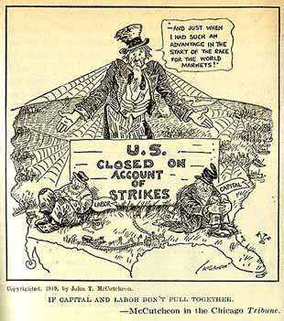
_____________________________________________________________________________________________

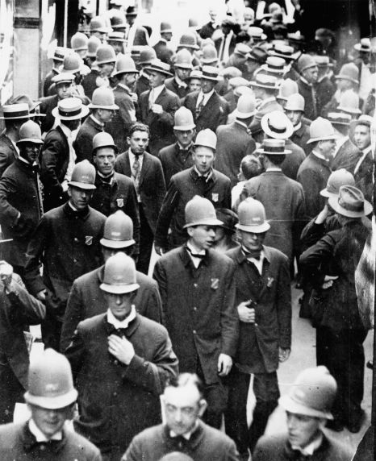
13) Why do you think many Americans were opposed to the police striking? Why was this strike more unpopular than other types of strikes?
____________________________________________
____________________________________________
____________________________________________
____________________________________________
____________________________________________
____________________________________________
____________________________________________
14) What is the main idea of this political cartoon?
_____________________________________________________________________________________________
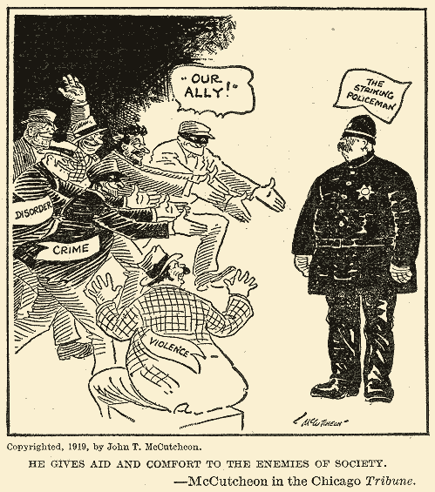
_____________________________________________________________________________________________

15) What is the main idea of this line graph?
_____________________________________________________________________________________________
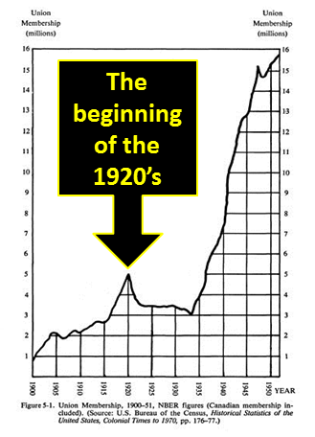
_____________________________________________________________________________________________

16) Why do you think race relations were strained in 1919?
_____________________________________________________________________________________________



