Class Discussion: “V-24.2B: “Calvin Coolidge”
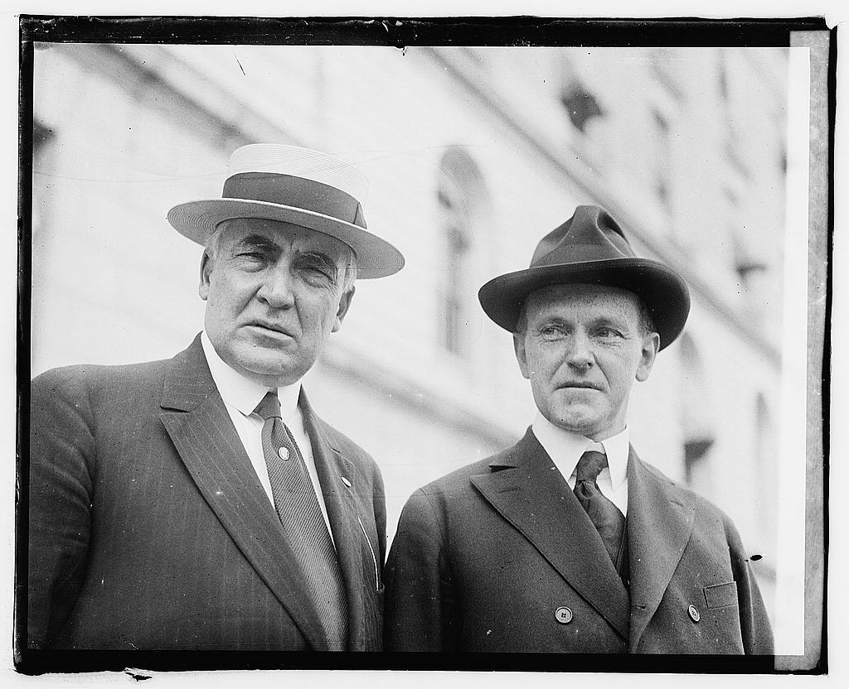
01) If Warren G. Harding and Calvin Coolidge were 8th Graders at R.B.M.S., contrast what each would might be doing during a Friday Reteach.

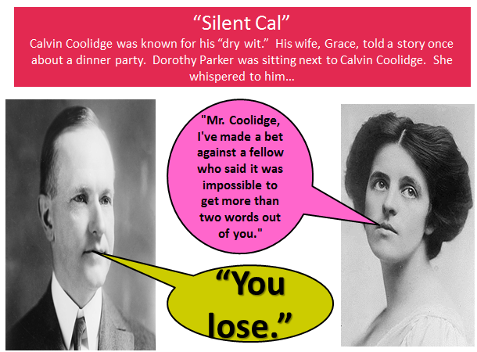
02) What does this story tell you about Calvin Coolidge’s personality?

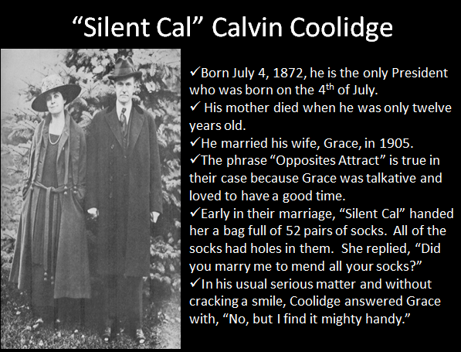
03) Which story from the video did you find to be the most interesting/amusing about “Silent Cal” Calvin Coolidge? Why did you like it?

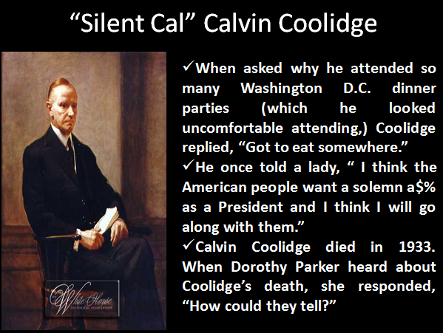

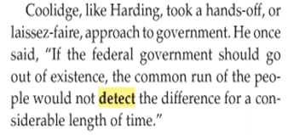
04) What do you think President Coolidge meant by this quote?

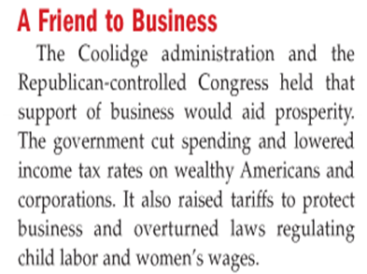
05) Explain why our country SHOULD subscribe to the Republican view that we should cut spending, lower taxes on the wealthy and corporations, and reduce the number of laws that tell businesses what they can and cannot do.

06) Explain why our country SHOULD NOT subscribe to the Republican view that we should cut spending, lower taxes on the wealthy and corporations, and reduce the number of laws that tell businesses what they can and cannot do.

07) What do you think is the main idea of this political cartoon?

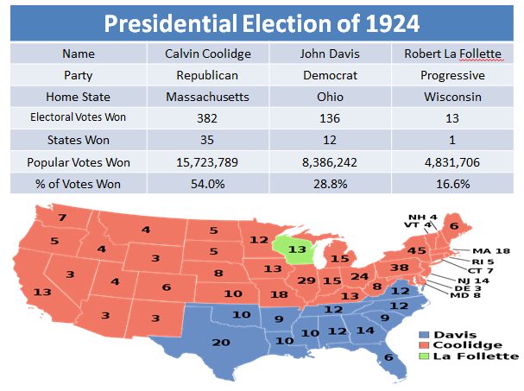
08) What did you find to be the most interesting part of the Presidential Election of 1924?

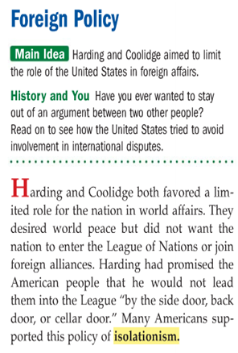
09) What do you think is meant by the phrase “foreign policy” and why do you think it is an important aspect of a President’s job?

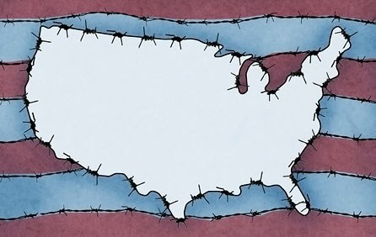
10) Why do you think the policy of “isolationism” was very popular to many Americans in the 1920’s?

11) Why is it difficult to enforce a treaty that outlaws war?

