Assembly Line Activity
Directions
To begin with, we are going to watch an assembly line clip from the old comedy, “I Love Lucy” @ https://www.youtube.com/watch?v=WmAwcMNxGqM.
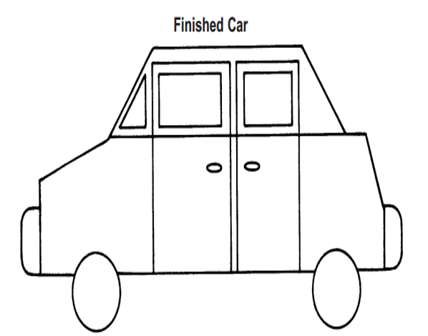
Today, we are going to cover the assembly line concept. Each group will represent an automobile factory. Group #1 will be Chev-one-let. Group #2 will be Two-ota. Group #3 will be Three-cedes Benz. Group #4 will be Four-d. The groups will be “manufacturing” Model T’s and then selling them for “profit.” Each factory will use the assembly line concept to try to construct a large QUANTITY of automobiles with the best QUALITY as possible.

Each factory will have a Boss (the group’s Leader.) Each factory will be given the appropriate materials to complete the cars: index cards, markers, scissors, glue, etc. Before production begins, the Boss will assign jobs to each worker. The car must be on the provided index cards to count. Once the time begins, the Boss is not allowed to physically help make the automobiles. They can offer words of encouragement, advice, etc. The Boss is the only one who can take the automobiles to the “Judge.”
The Judge plays the role of the American consumer. The Judge (played by Mr. Mo in 8B, Mrs. Hoffman in 8A, and Mrs. Cobert in 8C) will give a “rating” to each car they purchase from the Bosses. A “5” is the highest rating, whereas a “0” is the lowest rating. When the Judge gives the rating to the Boss, Mr. Mo will record the result on the Smart Board.
At the end of the activity, we will compare the productivity of the four factories. The most productive factory will earn 8 rolls for Friday’s race. Second place will earn 6 rolls, Third Place 4 rolls, and Fourth Place will earn 2 rolls.
Finally, we will hold a discussion about productivity and the concept of the assembly line.
Conclusion Discussion
01) What helped your factory’s productivity during this activity?
02) What hurt your factory’s productivity during this activity?
03) What did this teach you about the concept of the assembly line?
04) Do you have any suggestions for me for next year when I do this activity?

