Class Discussion: “V-24.4A: “The Roarin’ 20’s!”
01) What did the historian mean by “a delighted concern over things that were exciting but didn’t matter profoundly” when discussing the Charles Lindbergh flight?
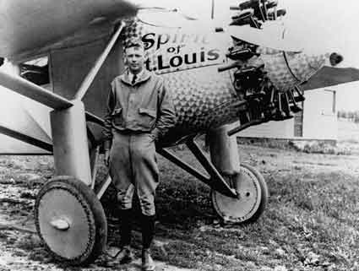

02) List three modern-day examples of what the historian was talking about when he said ““a delighted concern over things that were exciting but didn’t matter profoundly,” when discussing the Charles Lindbergh flight?

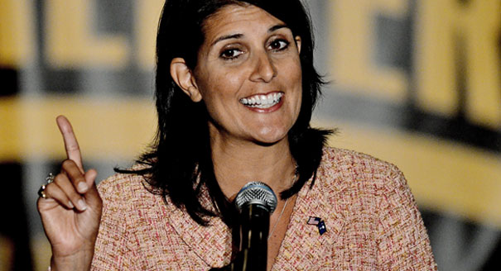
03) Do you think there will be a woman as President of the United States within the next twenty years? Explain.

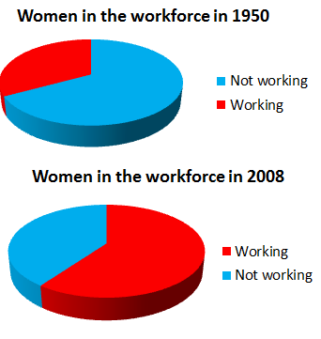
04) What could be a possible positive social effect of the information shown on the pie graphs?

05) What could be a possible negative social effect of the information shown on the pie graphs?
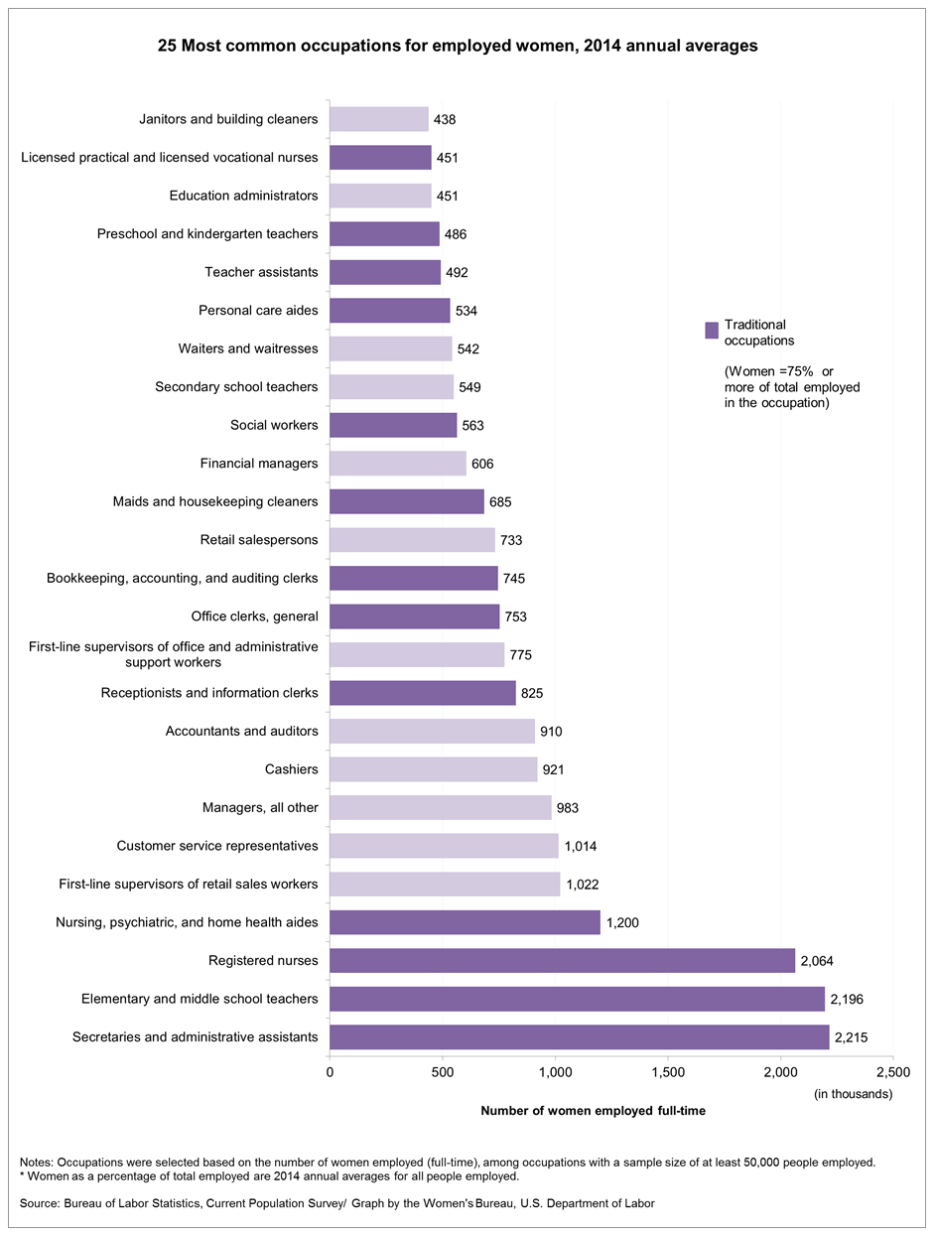
06) What necessary job skills do many of these occupations have in common that would be important?

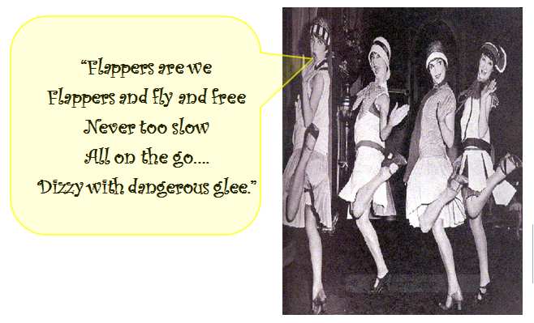
07) What do you think is the main idea of this poem?

08) What do you think is a cultural reason why “fashion” changes from decade to decade?
09) What do you think is an economic reason why “fashion” changes from decade to decade?
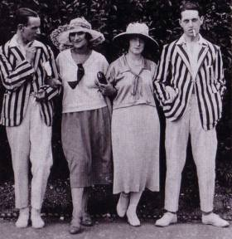

10) Hollywood became influential during the Roaring 20’s. Do you think Hollywood should do more to help reduce the violent crimes America has in this country? If so, what steps do you think Hollywood should take? If not, why do you think it is not Hollywood’s business to care how they portray violent crime?
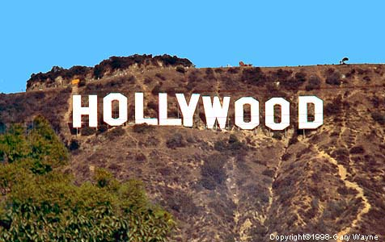

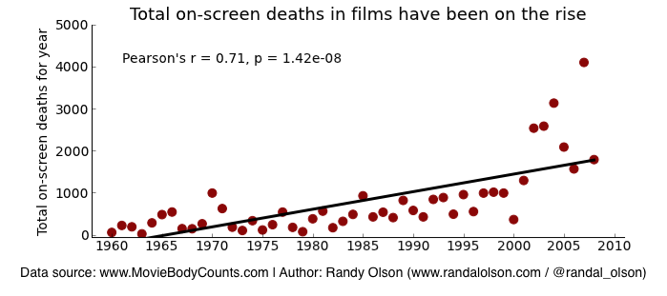

11) Movie theater popcorn is a Hollywood tradition. Richard B. McKenzie, professor emeritus at the UC Irvine Merage School of Business and author of Why Popcorn Costs So Much at the Movies and Other Pricing Puzzles wrote a book on the subject. He wrote that the average large bag of popcorn in America is sold for $8.15, yet costs $.90 cents for the raw goods to make. What economic concept does this show, and why do movie theaters do this?

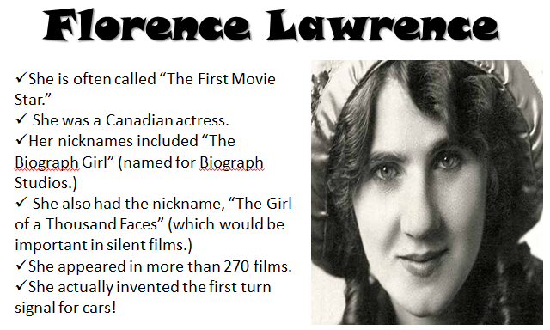
12) Can you think of a person in modern times to compare Florence Lawrence to?

13) Can you think of a person in modern times to compare Rudolph Valentino to? Explain your answer.
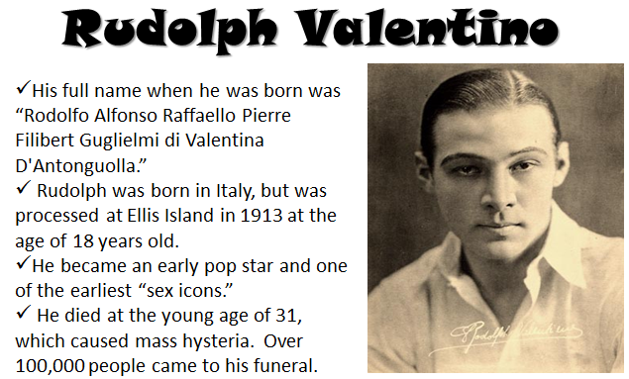

14) Can you think of a person in modern times to compare Clara Bow to?
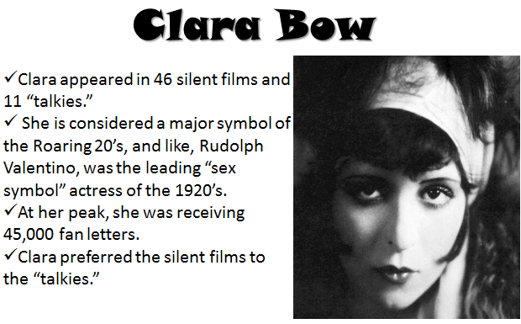

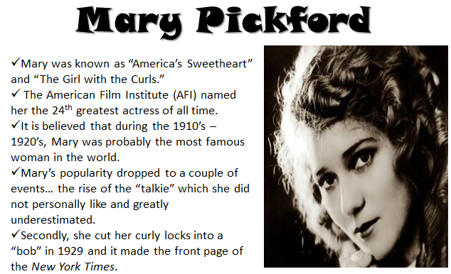
15) Can you think of a person in modern times to compare Mary Pickford to?

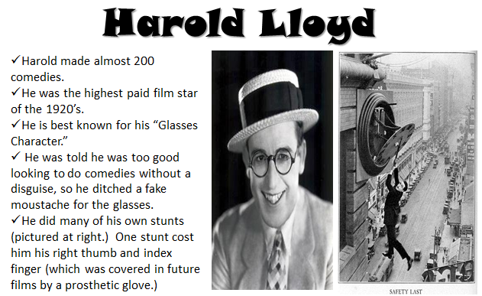
16) Can you think of a person in modern times to compare Harold Lloyd to?

17) Can you think of a person in modern times to compare Buster Keaton to? Explain your answer.
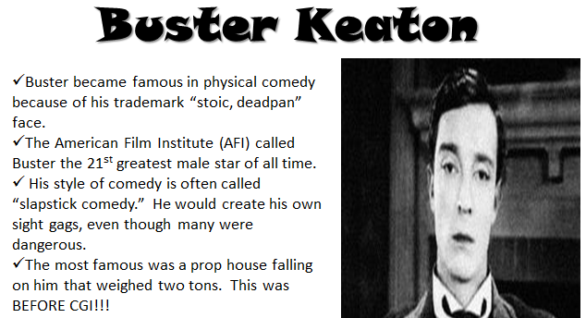

18) Can you think of a person in modern times to compare Charlie Chaplin to?
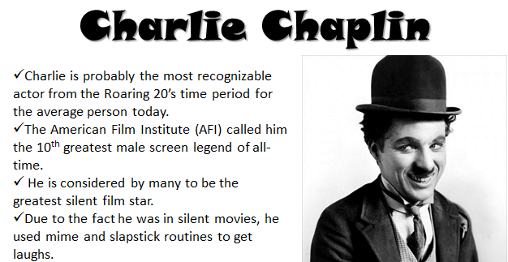

19) Which do you think would be the toughest cultural experience….. a twenty hour car ride with no music, a week with no television, or a year without going to the movies? Explain your answer.

20) Can you list a modern-day equivalent for this sports star of the 1920’s?
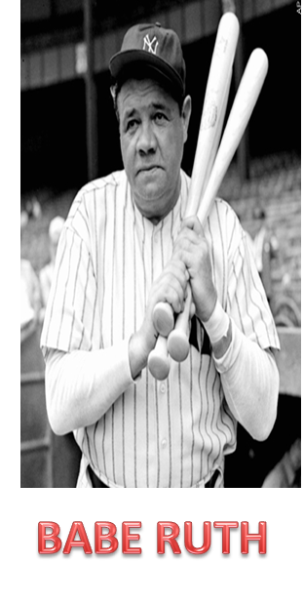

21) Can you list a modern-day equivalent for this sports star of the 1920’s?
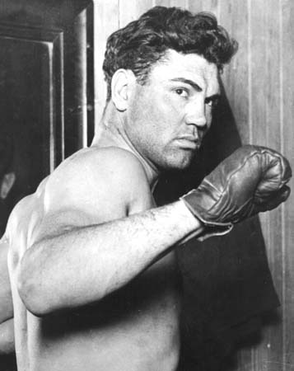
JACK DEMPSEY

22) Can you list a modern-day equivalent for this sports star of the 1920’s? Explain.
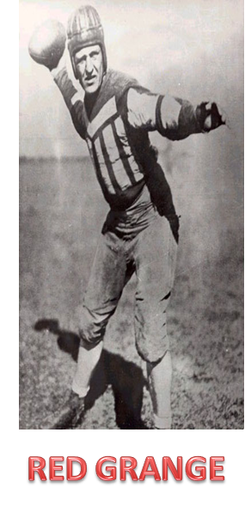

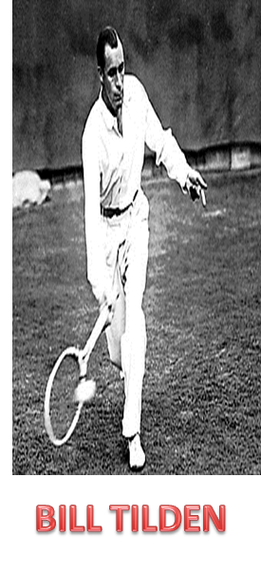
23) Can you list a modern-day equivalent for this sports star of the 1920’s? Explain.

24) Can you list a modern-day equivalent for this sports star of the 1920’s? Explain.
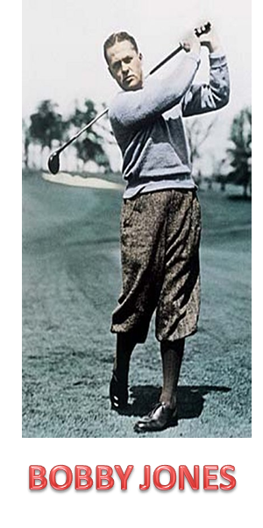

25) What two fads would you insert into the boxes if a future history textbook was discussing fads of today?
