Class Discussion: “V-24.4B: “Prohibition” Name_______________________________________________
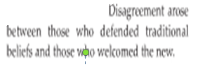
01) Do you think it is common for older Americans to believe that “the America they know” is changing too much? Explain.

02) List three modern-day examples of how older generations of people have commented to you about not liking certain changes in life that you do not seem to mind.

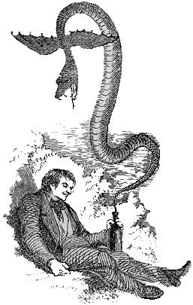
03) What do you think is the main idea of this political cartoon?

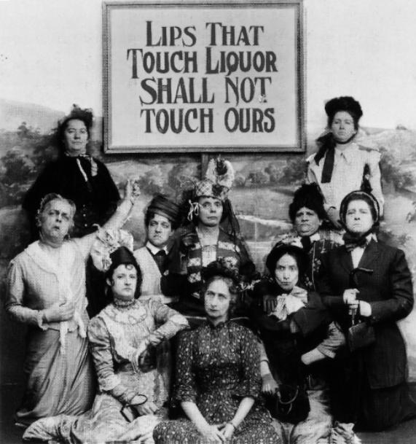
04) Do you think signs, like the one shown here, would be effective propaganda in order to make alcohol illegal? Why or why not?

05) What type(s) of propaganda are being utilized in the propaganda above?
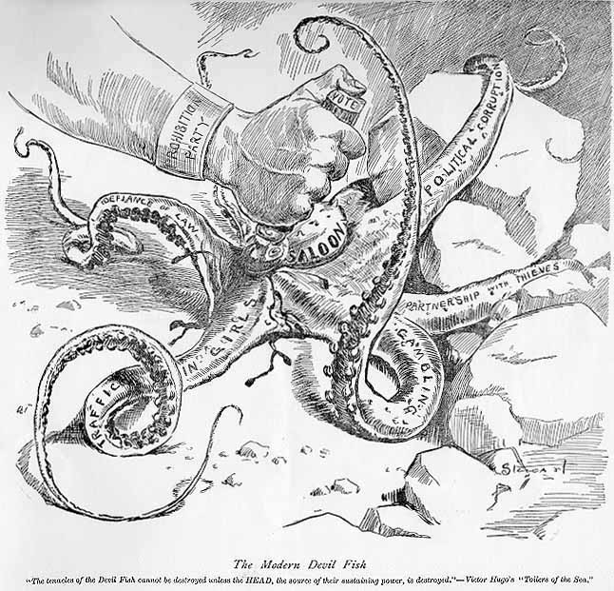
06) What is the main idea of this political cartoon?

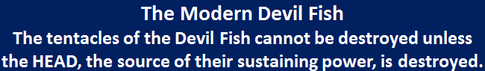

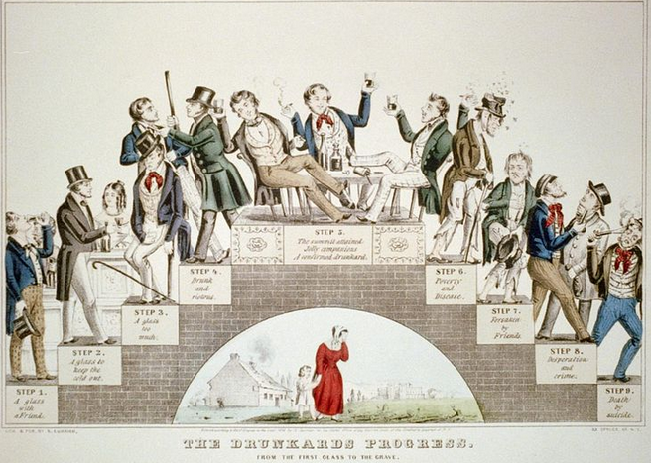
07) What is the main idea of this political cartoon?

______________________________________________________________
______________________________________________________________
______________________________________________________________
______________________________________________________________
______________________________________________________________
______________________________________________________________

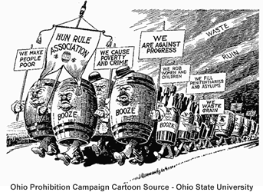
08) What is the main idea of this political cartoon?

answer.

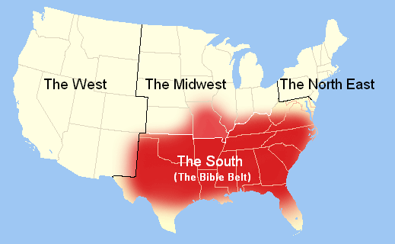
09) Explain the connection between the map and the text.

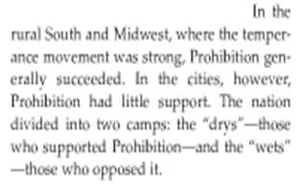

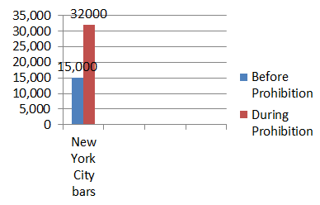
10) What seems odd about this bar graph?

11) Explain the connection between the bar graph and the picture.

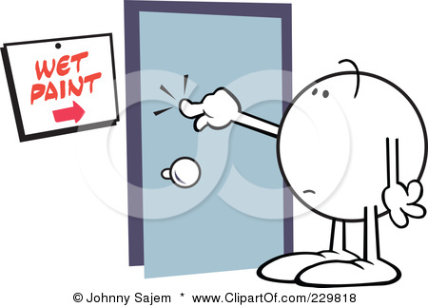

12) Role-play… You are a hardworking police officer in Chicago. Before Prohibition, you drank alcohol occasionally and saw nothing wrong with the legality of alcohol. You were also a great father of three children and a devoted husband. Now, it is the era of Prohibition. You are determined to enforce the law. However, seven of Al Capone’s goons have cornered you. They have given you an ultimatum….
Option 1) You can “look the other way” while they open a speakeasy on a street you patrol. In exchange, you will be paid a bribe, which equals 1/4th of your weekly salary.
Option 2) You can choose to try to stop them and not get paid. Your family “will not make it to next Christmas”.
Explain why many policemen took Option #1 in Chicago.
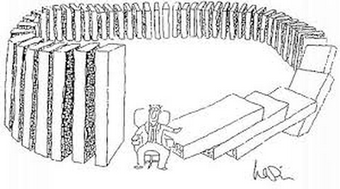
13) Based on questions #10 - #12, explain how the “Noble Experiment” of Prohibition had “unintended consequences”. Wikipedia defines “unintended consequences” as… “In the social sciences, unintended consequences are outcomes that are not the ones intended by a purposeful action.”

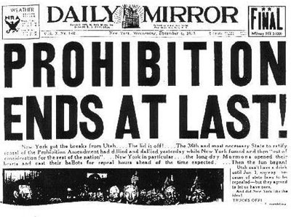
14) Do you think this newspaper was happy or sad about the news that the 21st Amendment
was going into effect? Explain.

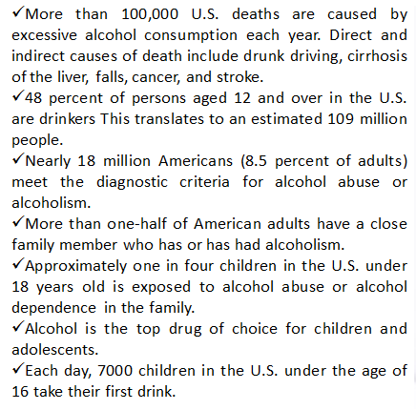
15) Which one of these alcohol statistics surprised you the most? Explain.

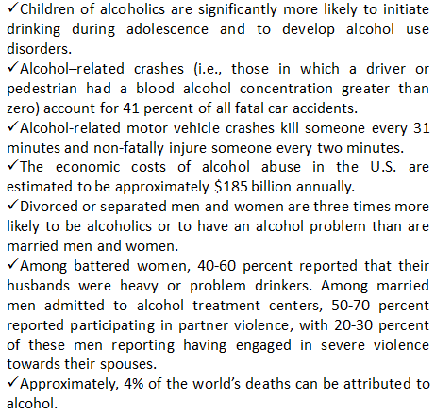
16) Which one of these alcohol statistics surprised you the most? Explain.

