Small Group Discussion: “V-24.4C: “A Clash of Cultures” Name_______________________________________
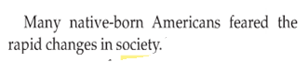
01) Why do some people turn to violence when “change” threatens to transform their lives?

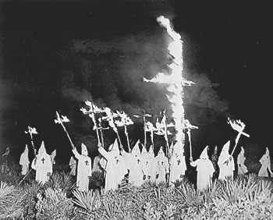

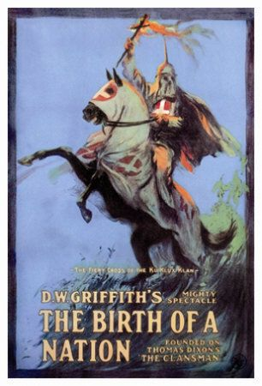
02) A ticket to the movie, The Birth of a Nation, cost $2.00 back in 1915. In today’s money, that would be over $40.00. Would you ever pay $40.00 to see a movie today? Explain.

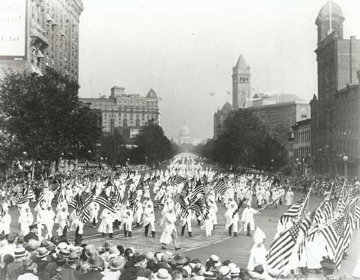
03) The 1st Amendment protects the Ku Klux Klan to be able to hold rallies, parades, and to run candidates for political office. What are your thoughts about this?

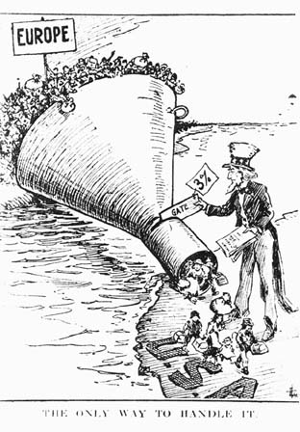
04) What is the main idea of this political cartoon?

05) Would the K,K.K. be happy or upset about the effects of the National Origins Act, as
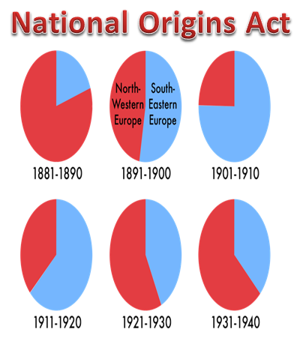
displayed in the pie graphs here? Explain.

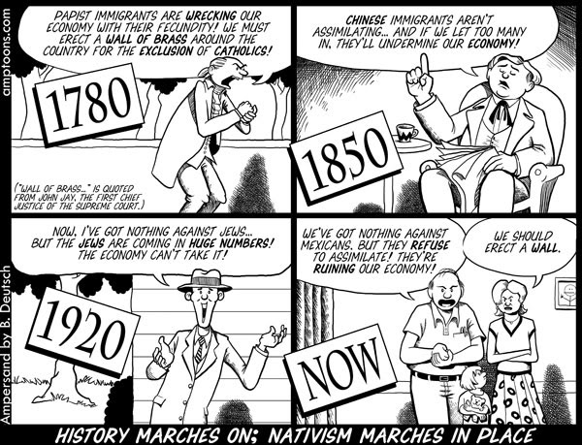
06) What is the main idea of this political cartoon?

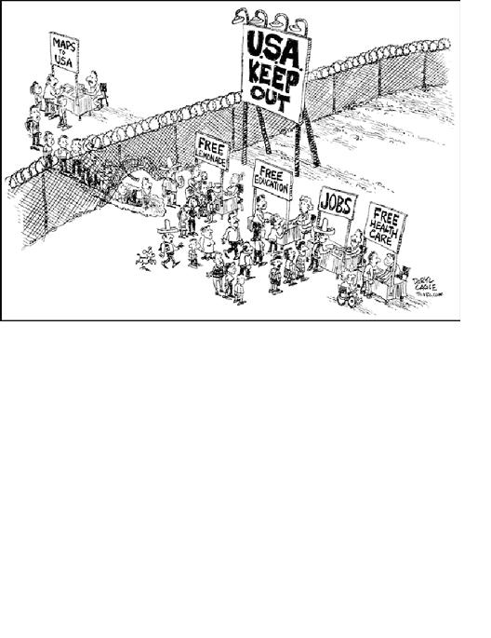
07) What is the main idea of this political cartoon?

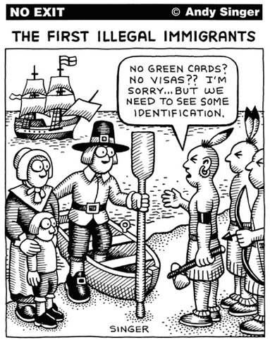
08) What is the main idea of this political cartoon?

09) Why do you think Calvin Coolidge declined to run for reelection in 1928?
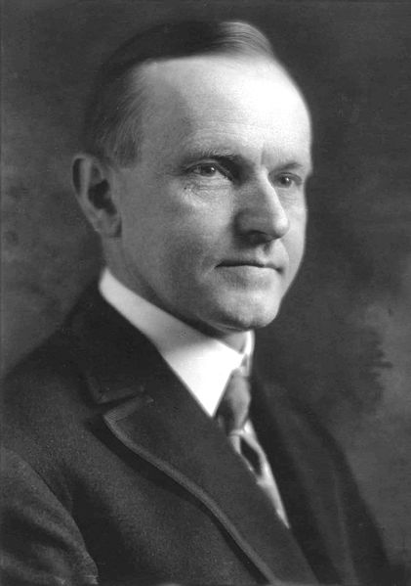

10) Did Herbert Hoover have a good resumé for a Presidential candidate in 1928? Explain.
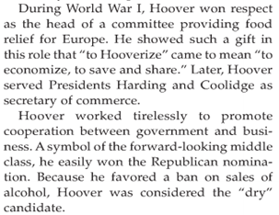
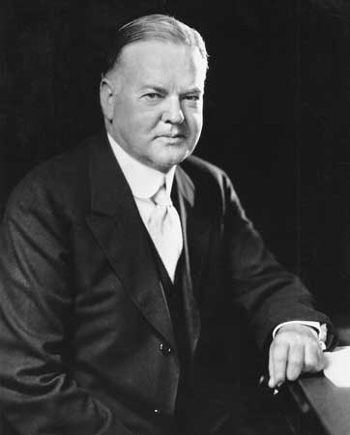

11) Al Smith’s Roman Catholic background was an issue in the Presidential Election of 1928.
Do you think a person’s religion should be discussed in a Presidential Election? Explain.
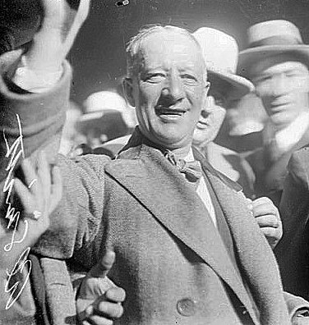
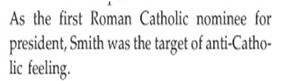

13) What do the Electoral Votes in the Election of 1928 show about how Americans felt about Republicans and the economy in 1928?
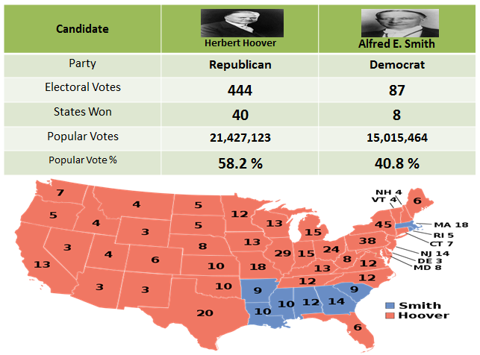

14) What do the Electoral maps of 1920, 1924, and 1928 show about the Democratic Party’s geographic situation in the 1920’s?
_____________________________________________________________________________________________
_____________________________________________________________________________________________
_____________________________________________________________________________________________
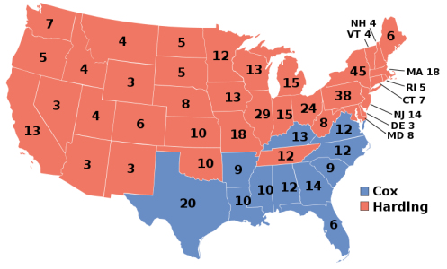
Election of 1920

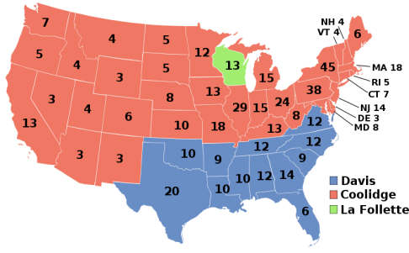
Election of 1924

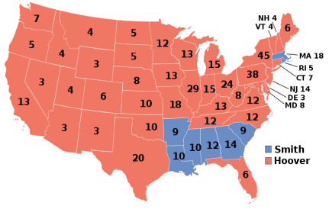
Election of 1928

