Class Discussion: “V-24.4C: Part II--- “Science Vs. Religion”
01) Mr. Mo called this section “Science vs. Religion.” List a couple of examples of when science and religion clash in modern day society.

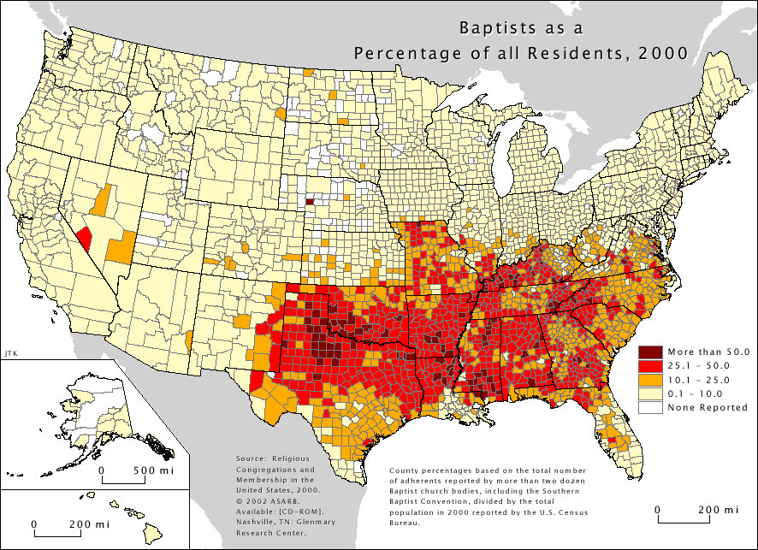
02) What impact do you think the map on the right has on modern day Presidential elections?

03) In 2007, a Gallup poll asked Americans the following questions... “Would you vote for a __________ for President of the United States?" The numbers listed below show the percentage of Americans who said they would vote for the person who was labeled with the listed characteristic. Make some observations about what you thought was interesting from this poll.
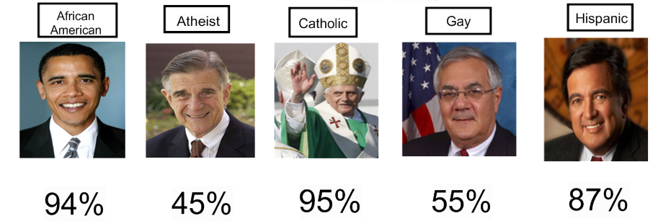

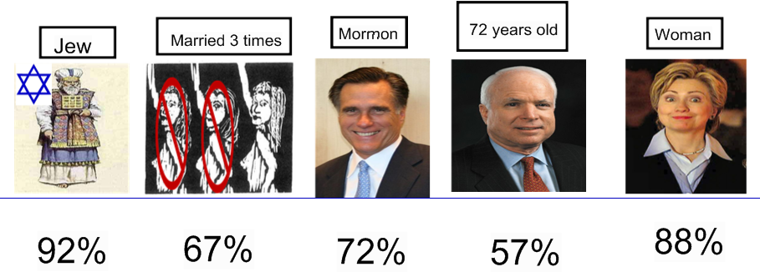

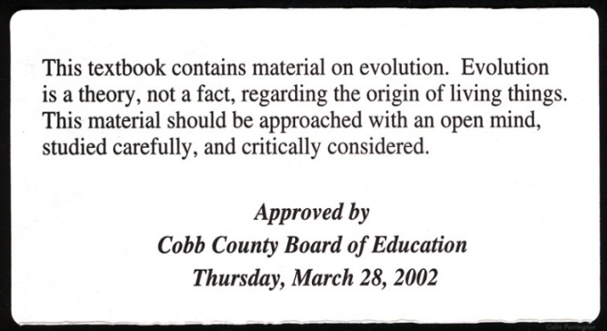
04) What were your thoughts on this sticker that was placed in science textbooks of Cobb County, Georgia in 2002?

05) Do you think the right decision was made in 2006 to remove the above sticker from those same textbooks? Explain.
06) What do you think the following line 2010 Gallup poll says about America?

C
A
B

B
A
C

07) Is the author of this cartoon a proponent or an opponent of evolution being taught in
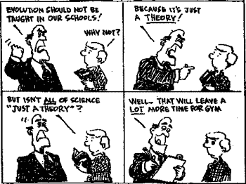
school? Explain.

08) Is the author of this cartoon a proponent or an opponent of evolution being taught in
school? Explain.
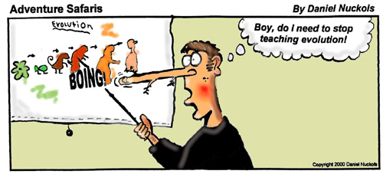

09) What are your thoughts on this bar graph?
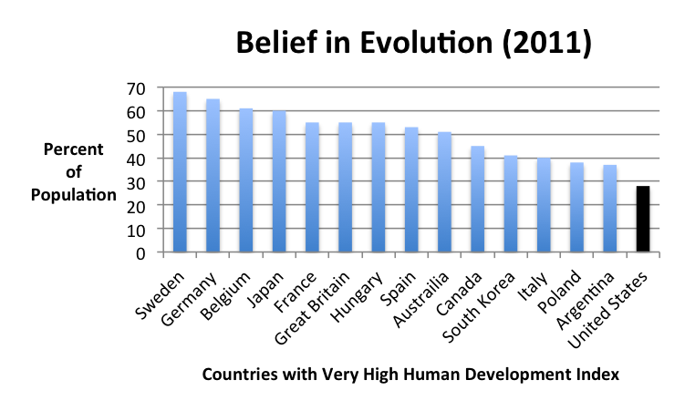

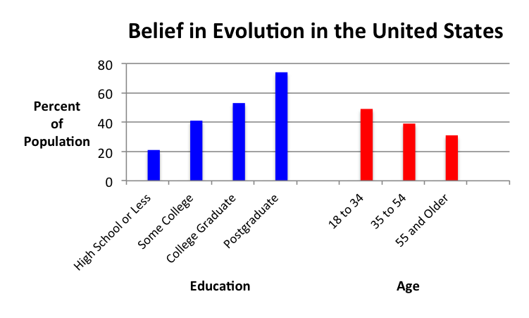
10) What are your thoughts on this bar graph?

12) What does this bar graph show about religion, science, and politics?

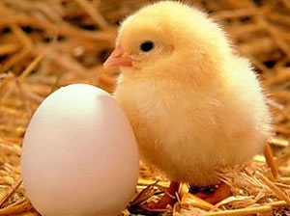
13) Which came first… the chicken or the egg?

