Class Discussion: “V-25.1A: “The Stock Market Crash”
01) What are your thoughts on this picture from the Great Depression time period?
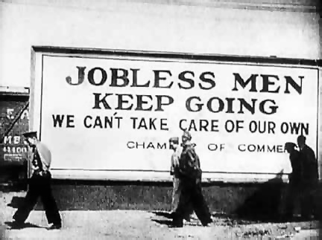

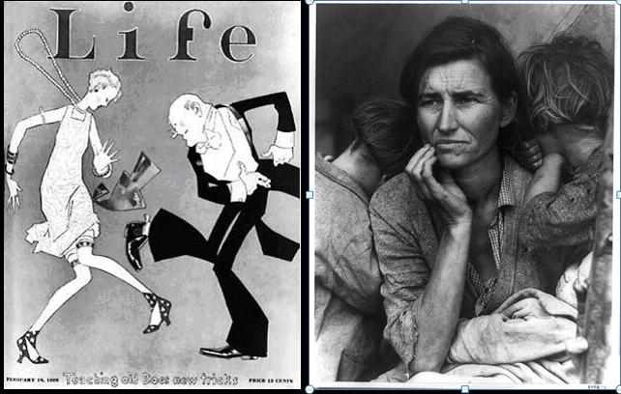
02) How do these two pictures contrast? Think of some adjectives used to contrast the two.

03) Explain how “First Fig” symbolically captured “The Roaring 20’s” time period and how it foreshadowed the Great Depression time period?
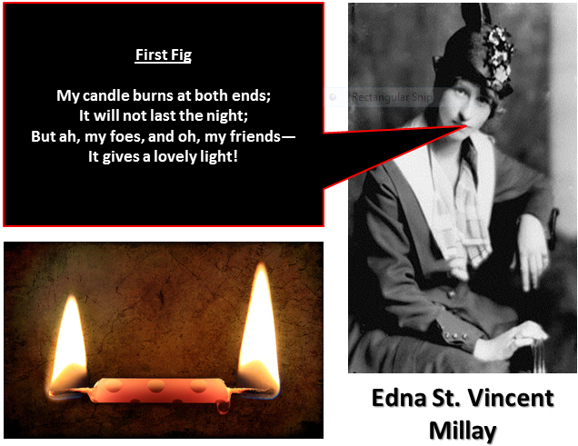

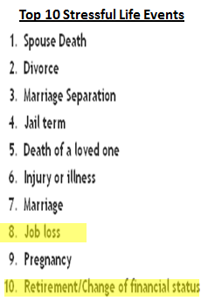
04) Why do you think Mr. Mo mentioned this list when introducing the Great Depression chapter?

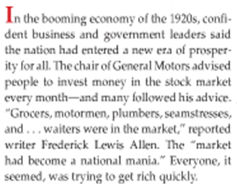
05) What do you think was meant by “The market had become a national mania?”

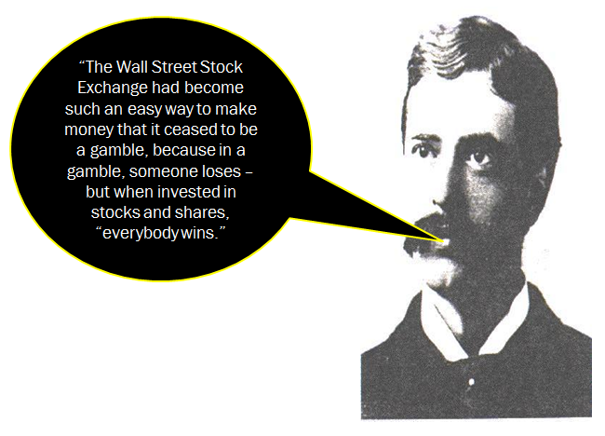
06) What does this quote show about America’s attitudes about the stock market in the 1920’s?

07) What thoughts do you think are going through this guy’s head?
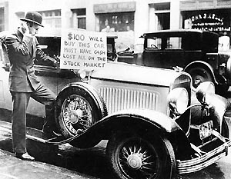

08) Why do you think the book used the phrase “dizzying heights” when discussing the value of stocks in the late 1920’s?

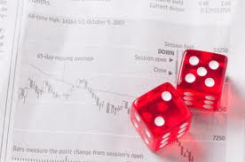
09) ROLEPLAY: One person in your group is a banker. Another person is a stockbroker. Another person is the investor. Demonstrate (in a skit) how purchasing stocks “on margin” worked. (Best Group’s Skit will receive 3 rolls for Friday’s race.)

10) Why is purchasing stocks “on margin” a very risky choice to make?

11) If purchasing stocks “on margin” is risky, why did 1920’s investors do it?

12) Why did some investors begin to “unload their stocks” [sell their stocks] in late September of 1929?

13) Create a haiku using the picture here as your inspiration. Remember, a haiku is a seventeen syllable poem (5-syllable first line, 7-syllable second line, & 5-syllable third line.) [The team with the best haiku will earn 3 rolls for Friday’s race.]
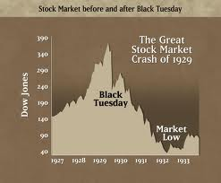

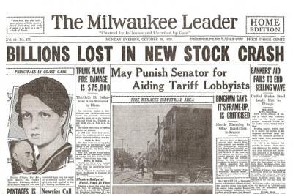
14) (ROLEPLAY) You are sitting down to have a cup of “morning joe” [coffee] and read your newspaper. You open the paper and see this headline. What thoughts are going through your mind about the 1000 shares of RCA Corporation that you bought earlier this year at $112.00 per share, knowing that you bought most of this stock “on margin?” (Note: The price would be $3.00 a share by 1932.)

15) What emotions do you think the citizens of Pittsburgh felt when they opened their morning paper and saw this?
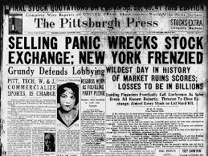

16) What is the main idea of this cartoon?
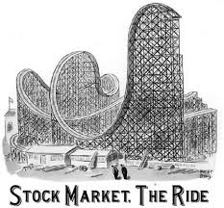

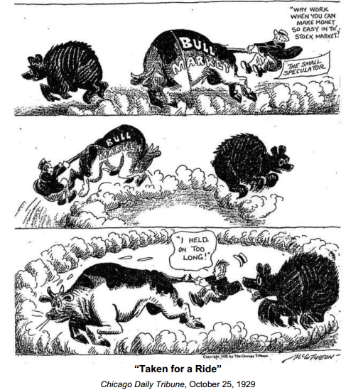
17) What do you think is the main idea of this political cartoon?

