Stock Market WS #3 Name___________________________
Hour ____ Date __________________
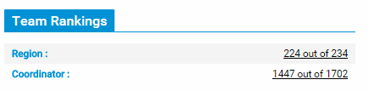
Directions: Answer the following questions over the stocks your group owns in the Stock Market 100 Grand Challenge.
01) What is your team’s Region Ranking currently?
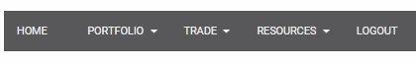
_________________________________________
02 - 04) Click on the “Portfolio” tab.
Next, click on “Account Holdings.”
Look at your stocks.

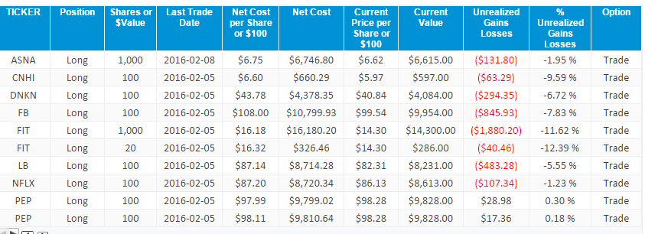

What has been your best performing stock? ___________________________________
What has been your worst performing stock? ___________________________________
What is your group’s “Total Current Value?” ___________________________________

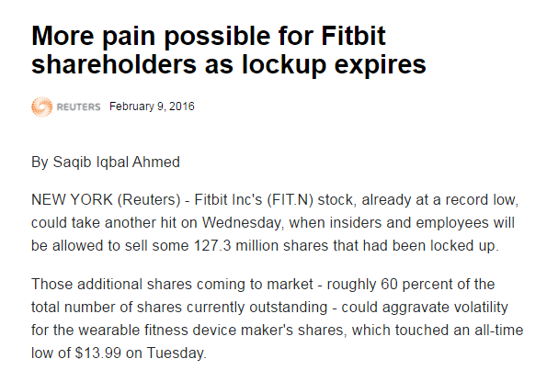
05) Next, look up a news article on one of your stocks and/or the stock market in general.

Write the link of your article
______________________________________________________________________________
06 – 10) Write a five sentence description of what you think the article is discussing AND/OR explain what impact you believe the article will have on the price of your stock(s).
______________________________________________________________________________
______________________________________________________________________________
______________________________________________________________________________
______________________________________________________________________________
______________________________________________________________________________
______________________________________________________________________________
______________________________________________________________________________
______________________________________________________________________________
______________________________________________________________________________

