Class Discussion: “V-25.1C: “Joblessness, Hopelessness, & Poverty
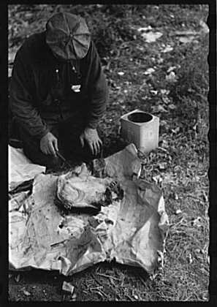
01) What animal is this hobo killing for his soup? Why do you think he is doing that?

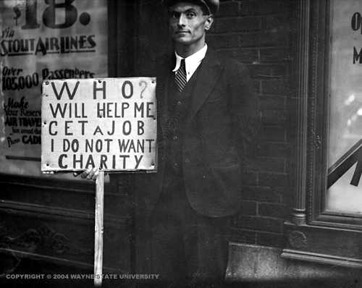
02) If you were the photographer who took this picture, what title would you give it? Explain. The team with the best title and explanation will win 3 rolls for this week’s race.

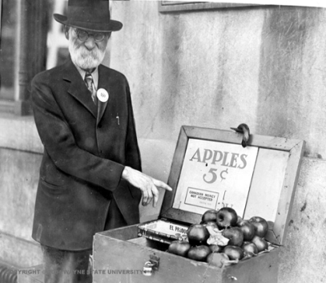
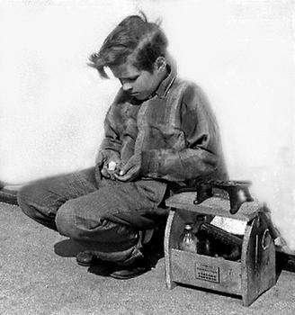
03) Of the two people pictured here, who do you think felt a greater sense of “worthlessness—and loneliness?” Explain.

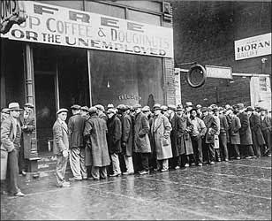
04) Why do you think depressions are extremely tough on charitable organizations?

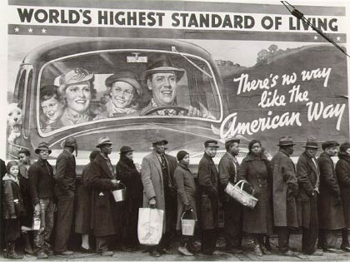
05) What is ironic and/or interesting to you about this Great Depression picture?

06) For those of you that complain about the school lunches, what do you think this girl would say to you?
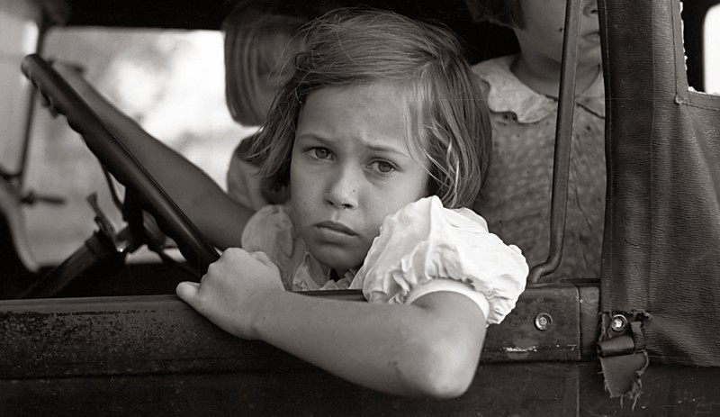

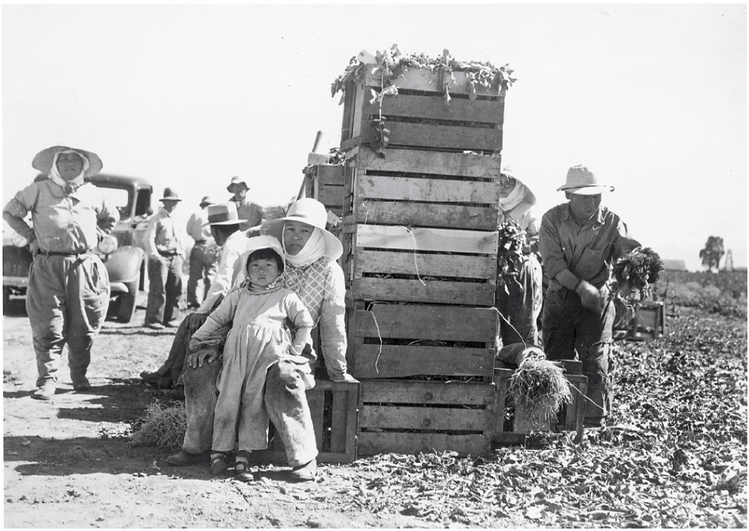
07) What is empathy? Why do Americans expect our President to have empathy for our problems?

08) Role-play… You are President Hoover. One of your advisors tells you that the American people are nicknaming the shantytowns “Hoovervilles”. Describe the emotions going through your mind upon hearing this.
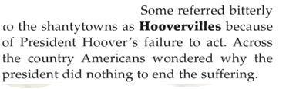

09) Fill in the Thought Bubble for the guy on the left.
10) Fill in the Thought Bubble for the guy on the right.

11) These people are having a conversation on politics (President Hoover, Congress, etc.) Write down what the conversation sounds like.
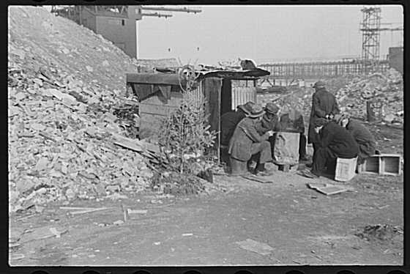

12) Why was this called a “Hoover Flag?”

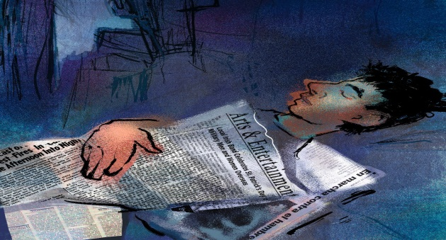
13) Why was this called a “Hoover Blanket?”

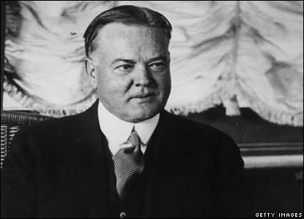
14) DEFEND A POSITION: Someone comes up to you and asks the following question “Do you think Presidents get too much credit when times are good in America and too much blame when times are bad in America? Take the affirmative (“Yes”) position and explain why you believe Presidents do get too much credit and too much blame.

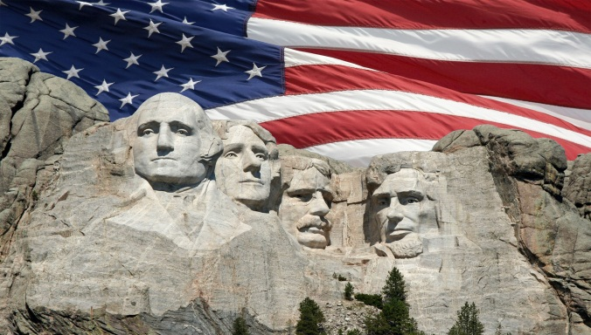
15) DEFEND A POSITION: Someone comes up to you and asks the following question “Do you think Presidents get too much credit when times are good in America and too much blame when times are bad in America? Take the negative (“No”) position and explain why you believe Presidents get the appropriate amount of credit and blame.

16) Create a haiku & title using this photo as your inspiration. The team with the best haiku and title will win 3 rolls for this week’s race.
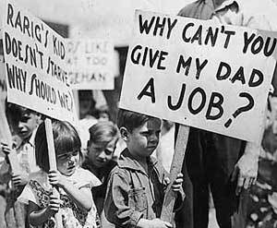

17) Create a limerick & title using this photo as your inspiration. The team with the best limerick and title will win 3 rolls for this week’s race.
