Class Discussion: V-25.3B: “Entertainment & The Arts”
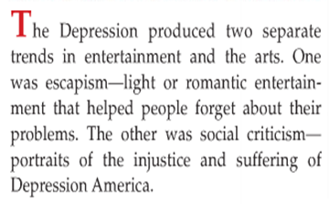
01) Role-play: If you were a movie director during the Great Depression, which one of the two types of movies would you have been more likely to make: light/romantic escapist movies or socially critical movies showing the injustice and suffering of Great Depression America? Explain your answer.

02) Sixty years from now when talking about this decade, the history books will write the sentence that “_________________” became enormously popular during the 2010’s. What do you think the word(s) would be? Explain.

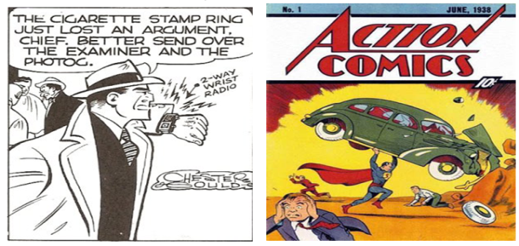
03) What do you think led to the popularity of Dick Tracy and Superman during the 1930’s?

04) If the movie was actually called Snow White and the Eight Dwarfs and you were the unnamed eighth dwarf, what would be your dwarf name? Explain.
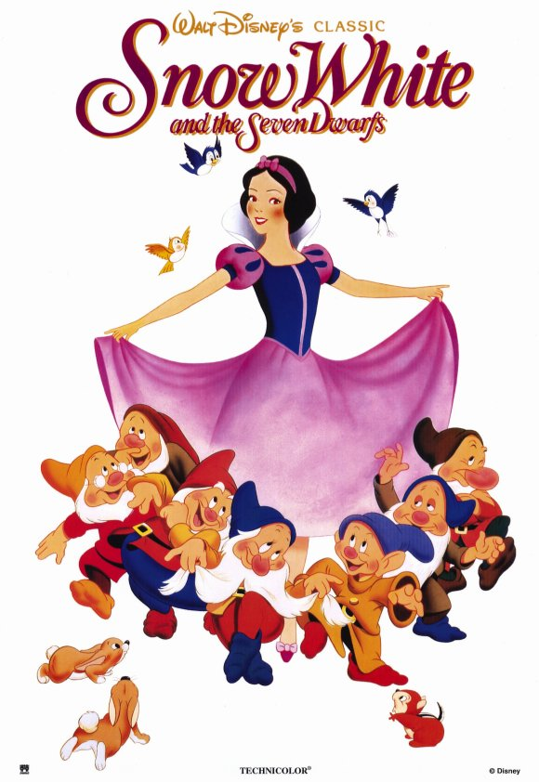

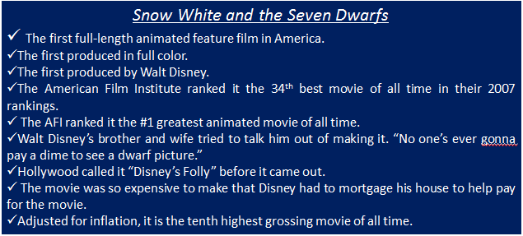
05) What is a valuable life lesson we can learn from Walt Disney?
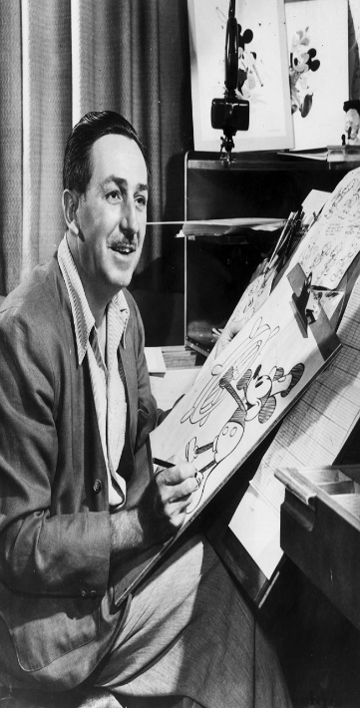

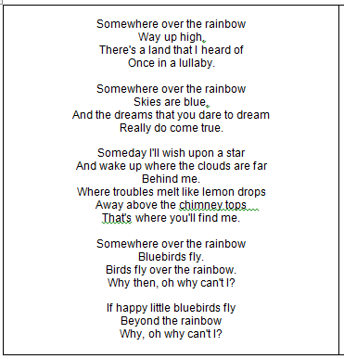
06) Read the following lyrics from the Wizard of Oz song “Somewhere over the Rainbow.” Why do you think this song had such an impact during the Great Depression time period?

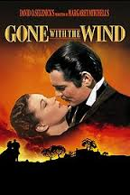
07) What did you find to be the most interesting factoid about the movie, Gone With The Wind?

