Class Discussion: V-25.4C: “Working For Workers”
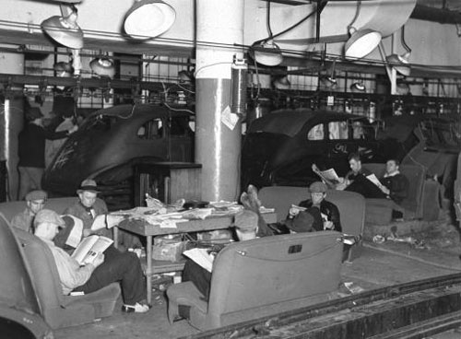
01) Why do you think the “sit-down strike” was effective?

02) What do you think was the original purpose of the “minimum wage?”

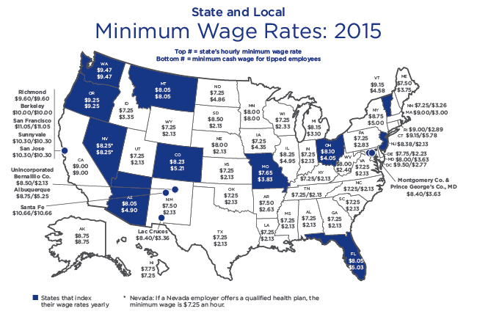

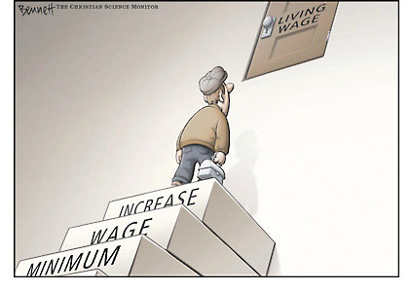
03) How are these two political cartoons different?
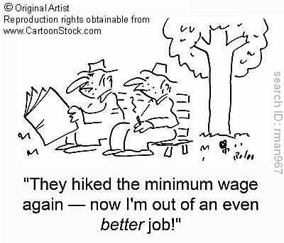

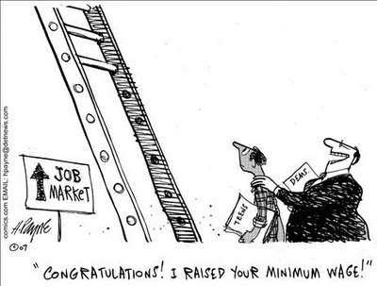
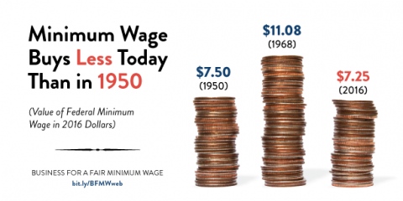
04) How are these two political cartoons different?

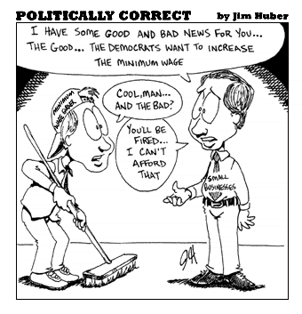
05) What is the main idea of this political cartoon? Which modern day political party would use this cartoon to help prove their viewpoint?

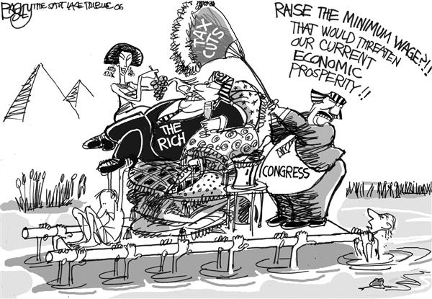
06) What is the main idea of this political cartoon? Which modern day political party would use this cartoon to help prove their viewpoint?

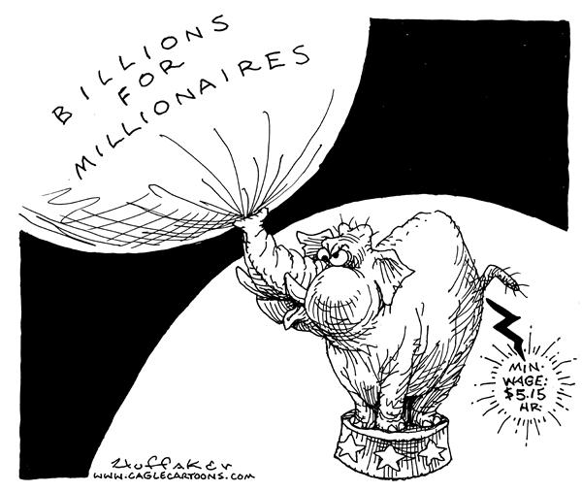
07) What is the main idea of this political cartoon? Which modern day political party would use this cartoon to help prove their viewpoint?

08) What do you think is the main idea of this picture?
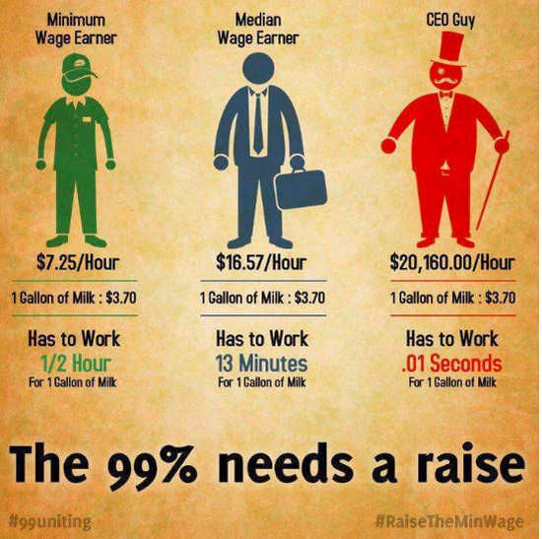

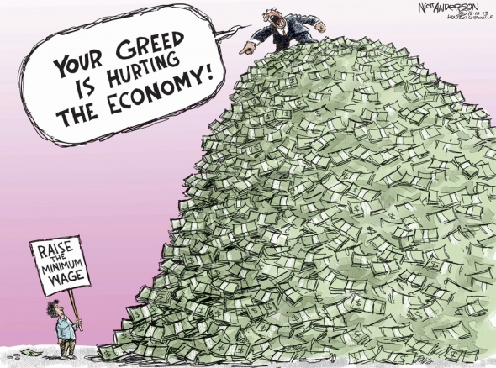
09) How are these two political cartoons different?
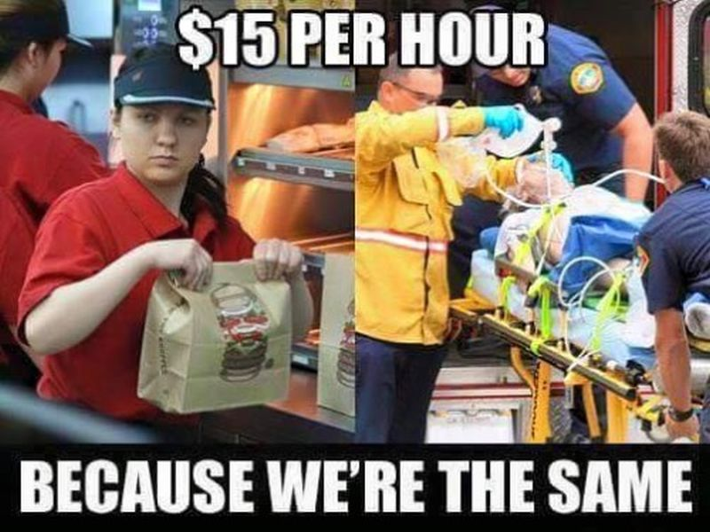

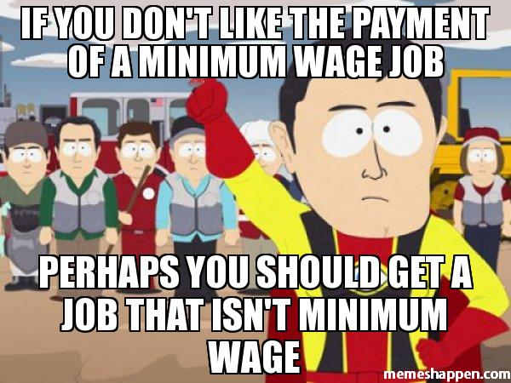
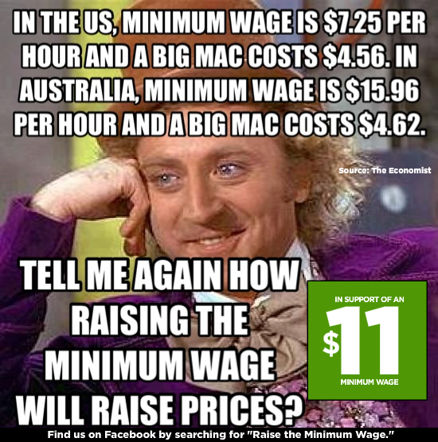
10) How are these two political cartoons different?

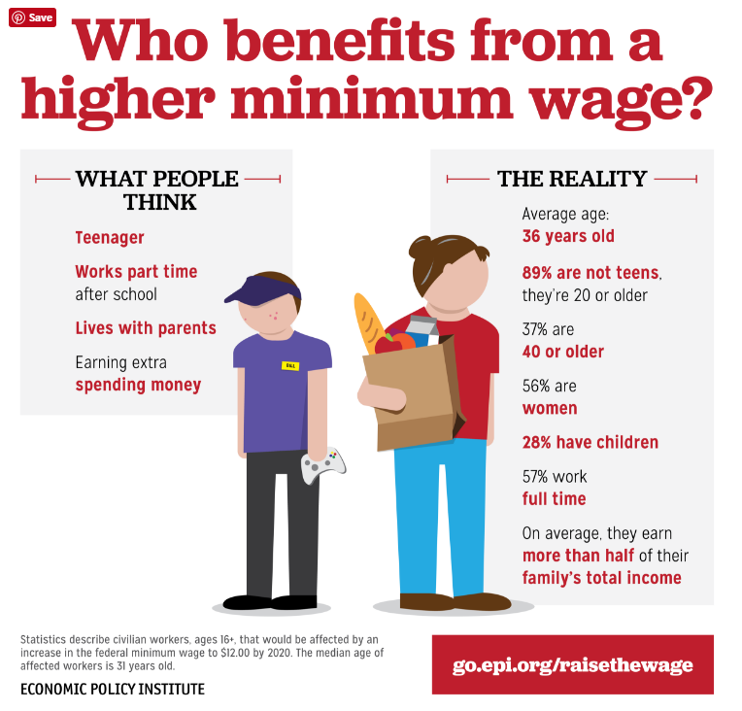
11) What did you find interesting about this picture?

