Class Discussion: V-“Yertle the Turtle”
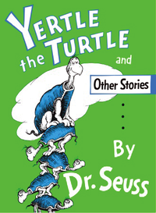

01) Why do you think Yertle the Turtle thought he was superior to the other turtles?
02) Why do you think the other turtles obeyed his commands?
03) In the story, what World War II figure does Yertle the Turtle symbolize?
04) In the story, what people from the World War II time period do the turtles symbolize?
05) What are three adjectives you would use to describe Yertle the Turtle?
06) Why do you think that Yertle the Turtle never seemed content with what he already had?
07) In your opinion, is Mack the Turtle a hero? Explain your answer.
08) Why do you think Dr. Seuss ended the story with “And the turtles, of course, all the turtles are free, as turtles and, maybe, all creatures should be.”?

