Class Discussion: V-26.1B: “The Rise of Dictators”
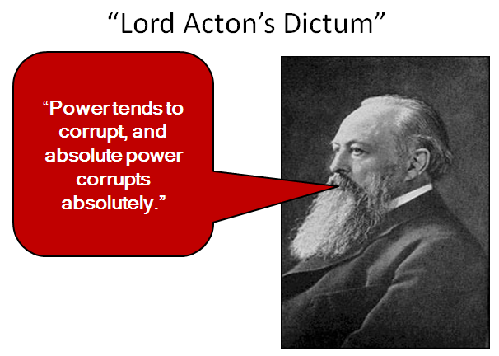
01) What does this quote mean to you?

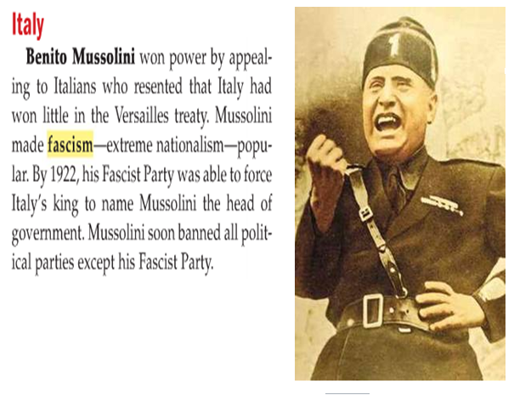
02) Why do dictators, like Mussolini, ban all political parties but their own?

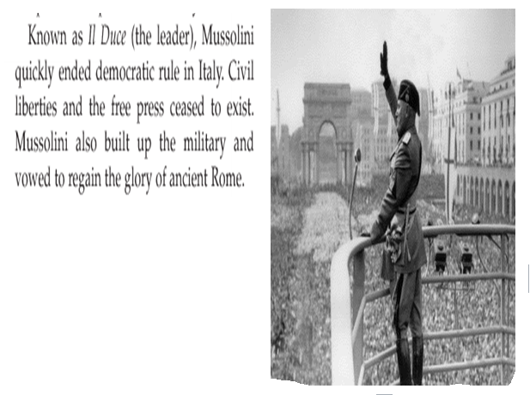
03) Why do dictators, like Mussolini, ban a “free press?”

04) Why do you think Mussolini attacked Ethiopia in 1935?
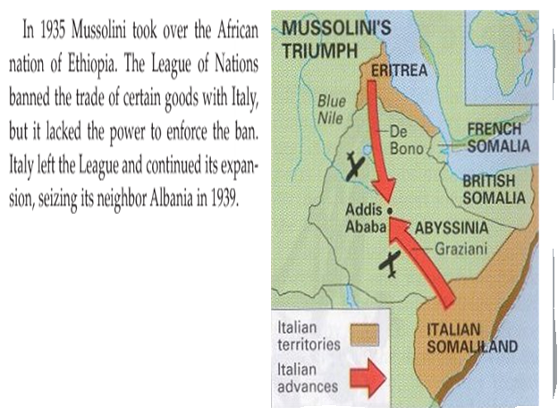

05) What do you think Hitler learned about the League of Nations by watching Mussolini’s actions in Africa?
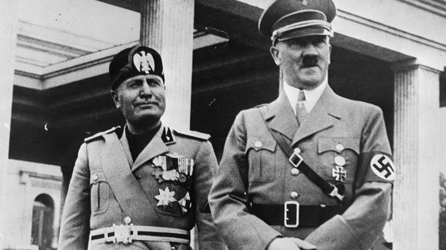

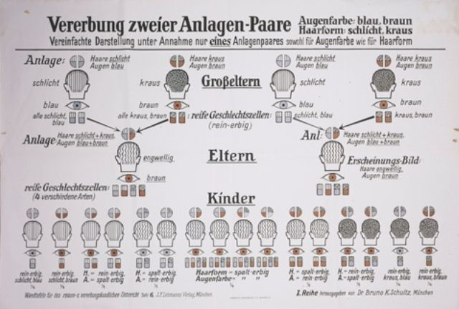
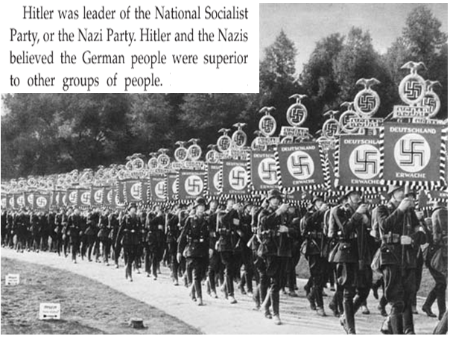
06) Why do you think Hitler and the Nazis felt like Germans were the “superior race” [Aryan Race?) What do you think gave them the idea?

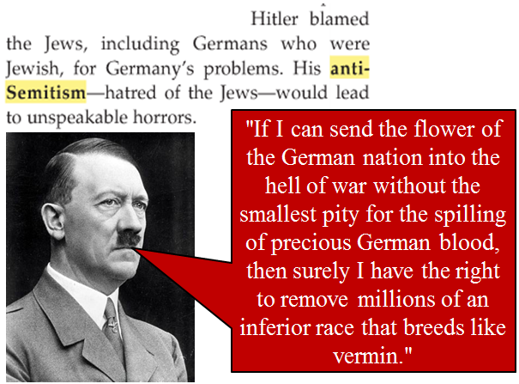
07) What do you think was Hitler’s main idea in his quote shown here?

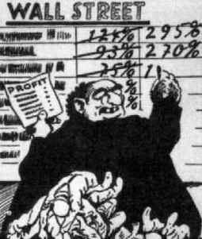
08) What do you think is the main idea of this political cartoon?

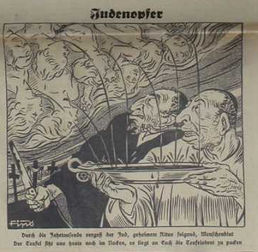
09) What do you think was the main idea of the political cartoon in this Nazi newspaper?

10) What do you guess is the English translation of the German expression of this Nazi newspaper…
“Die Juden sind unser Unglück!”?
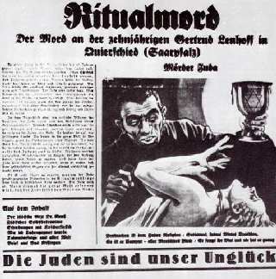

11) Based on the text here, which country do you think was the most concerned with the “rise of Hitler?” Explain your answer.
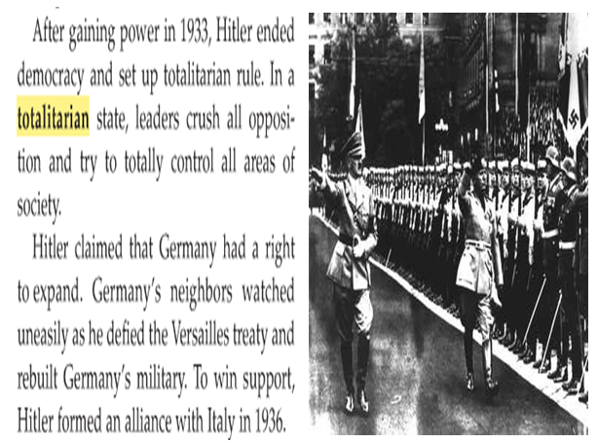

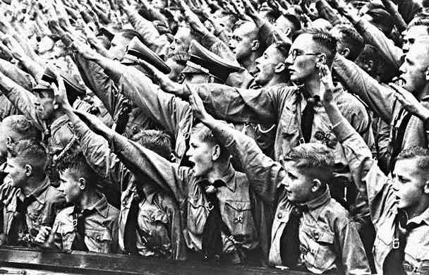
12) What did you find to be the most interesting portion of the “Social Control” video clip?

13) In the clip “Dark Side of Nazi Rule,” it mentioned how most Germans learned how to “see nothing” and “hear nothing” when it came to the persecution of Jews and others in Nazi Germany. If you were a German in Nazi Germany, do you think you would have had the courage to stand up for a Jewish neighbor who was getting beaten up by a Gestapo agent in the street? Explain.
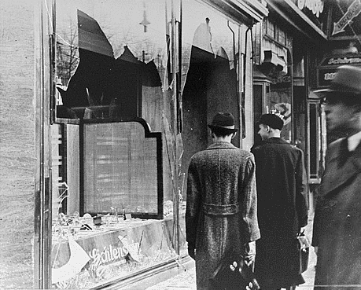

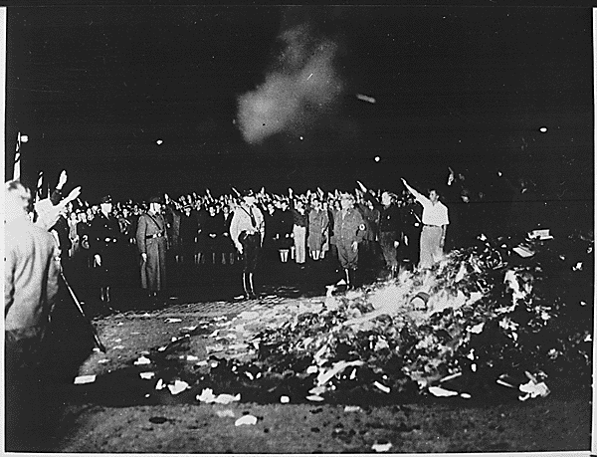
14) In 1821, German author, Heinrich Heine said, “Das war Vorspiel nur. Dort, wo man Bücher verbrennt, verbrennt man am Ende auch Menschen.” Translated into English, he said, “Where they have burned books, they will end in burning human beings.” How do you think Heine was able to accurately make that sort of prediction over one hundred years before Hitler’s Germany did it?

15) Why do you think Germany, Italy, and Japan joined together to form the “Axis Powers” of World War II?
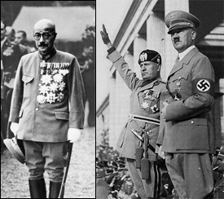

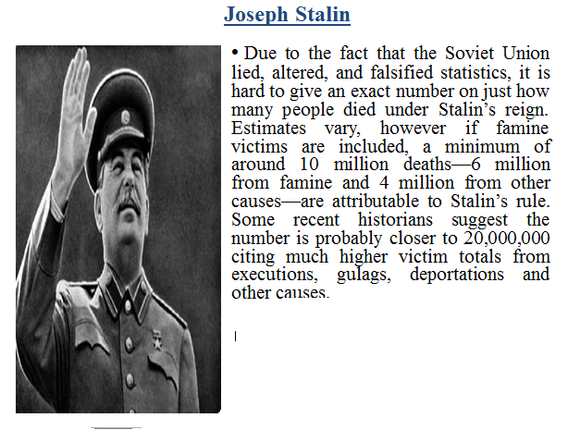
16) As the leader of the Soviet Union, millions of Russians died under Stalin’s rule. Why do you think people do not talk about Stalin nearly as much as they talk about Hitler?

