Class Discussion: V-26.1C: “Hitler Prepares For War!”
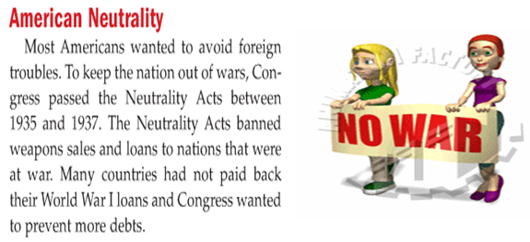
01) Why do you think Americans wanted no part of any wars during the 1930’s?

02) What is the main idea of this political cartoon?
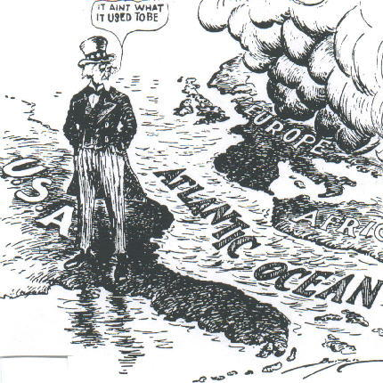

03) Is it better to stand up to bullies or give them what they want? Explain.

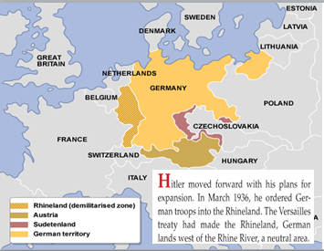
04) What does this slide show about the League of Nations in 1936?

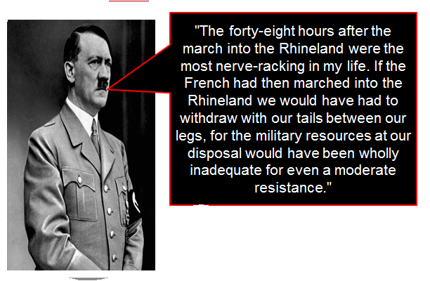
05) Summarize what Hitler’s point was in this quote.

06) What does the Hitler quote above demonstrate about whether or not bullies should be stood up to?
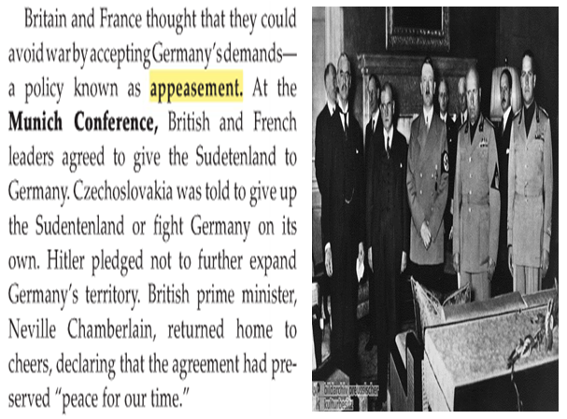
07) What is the most practical history lesson that we can learn from the “Munich Conference?”

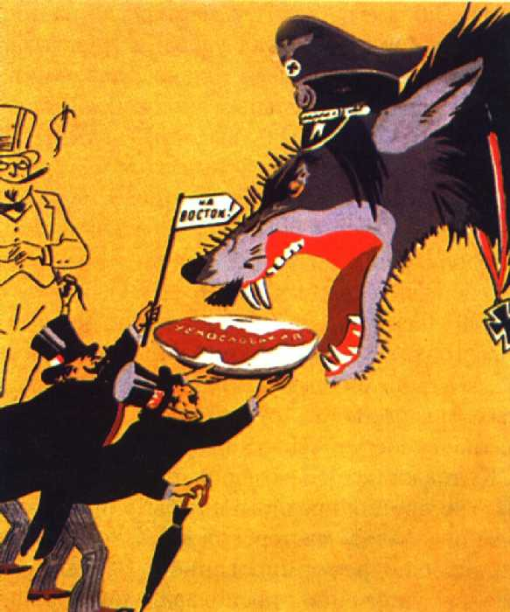
08) What is the main idea of this political cartoon?

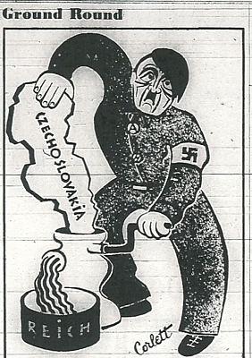
09) What is the main idea of this political cartoon?

10) What is the main idea of this political cartoon?
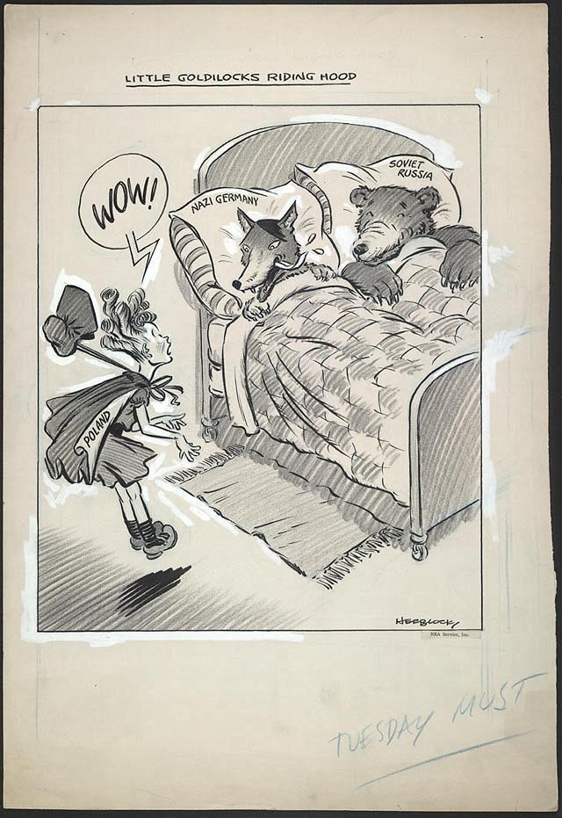

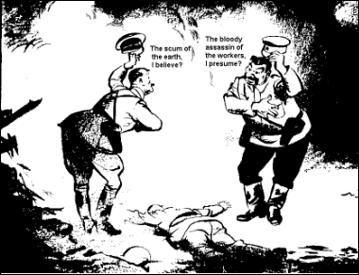
11) What is the main idea of this political cartoon?

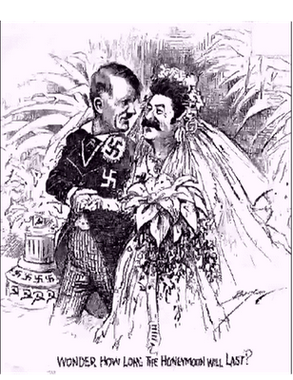
12) What is the main idea of this political cartoon?

13) Why would Stalin make a deal with Hitler when he hated Hitler?
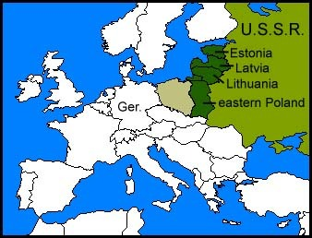
14) Why would Hitler make a deal with Stalin when he hated Stalin?

15) What is the main idea of this political cartoon?
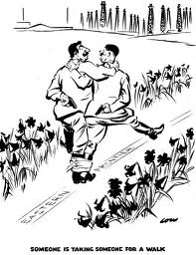

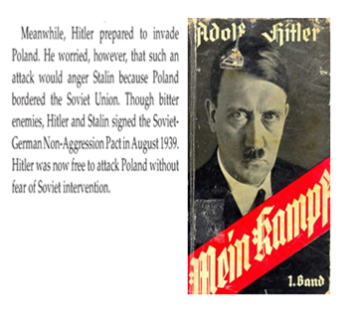
16) If you were Stalin and you had read the book Mein Kampf, why might you think twice about signing the German Non-Aggression Pact in August of 1939?

