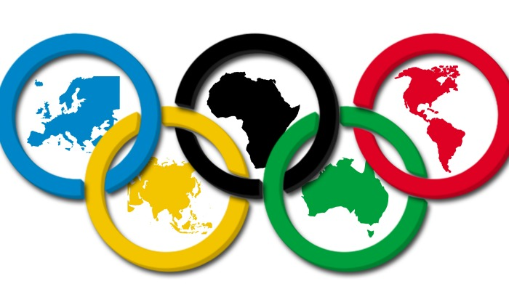
Olympic Teams 2016 - 2017

8B Olympic Teams
 | Team #1: _______ | Team #2: _______ | Team #3: _______ | Team #4: _______
Team Captain | Clayton H. | Liz F. | Emma B. | Kyler P.
Olympian #2 | Noah F. | Kylie C. | Kaitlyn B. | Wells F.
Olympian #3 | Tyler F. | Ashley G. | Sophie P. | Michael B.
Olympian #4 | Abby M. | Connor B. | Bri A. | Jakob N.
Olympian #5 | Paige D. | Avery T. | Ethan R. | Dyllan L.
Olympian #6 | Tristan T. | Hannah E. | Spencer M. | Emma M.
Olympian #7 | Carly K. | ------------ | ------------ | ------------
8A Olympic Teams
 | Team #1: _______ | Team #2: _______ | Team #3: _______ | Team #4: _______
Team Captain | Will C.,Jr. | Nathan P. | Ryan S. | Tiffany S.
Olympian #2 | Mariah U. | Makenzie D. | Baylee M. | Zach D.
Olympian #3 | Gabby P. | Brig B. | Anna J. | Hannah S.
Olympian #4 | Faith O. | Michael A. | Cael S. | Matthew H.
Olympian #5 | Giana F. | Kristen B. | Jack M. | Logan G.
Olympian #6 | Josh H. | Cody C. | Emily Q. | Trevor C.
Olympian #7 | Rian P. | Nathan H. | ------------ | ------------
8C Olympic Teams
 | Team #1: _______ | Team #2: _______ | Team #3: _______ | Team #4: _______
Team Captain | Alison H. | Ally R. | Josh D. | Sam S.
Olympian #2 | Max P. | Josh V. | Jason W. | Kaylee R.
Olympian #3 | Corinne L. | Nate B. | Brian R. | Clare J.
Olympian #4 | Aisha V. | Dylan B. | Patrick W. | Noah S.
Olympian #5 | Lily E. | Tatumn B. | Emily H. | Maggie R.
Olympian #6 | Teighlor R. | Tristen S. | Quinton M. | Deseray V.
Olympian #7 | ------------ | ------------ | ------------ | ------------

