Class Discussion: “V-23.1B: “The Spark”
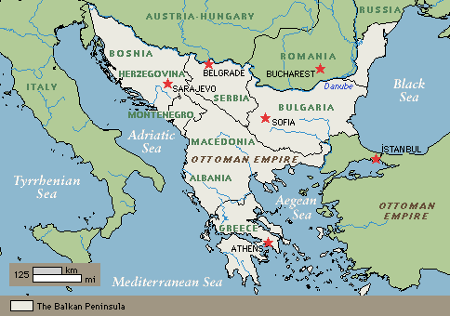
01) What do you think the book meant by the phrase “a hotbed of nationalist and ethnic rivalries?”

02) If Gavrilo Princip had a Twitter account back in 1914, show a tweet that he would leave on his account that summarizes the paragraph shown here.

03) Based on the context, what do you think the word “disconsolate” meant in the story, “It’s The Princip(le)?

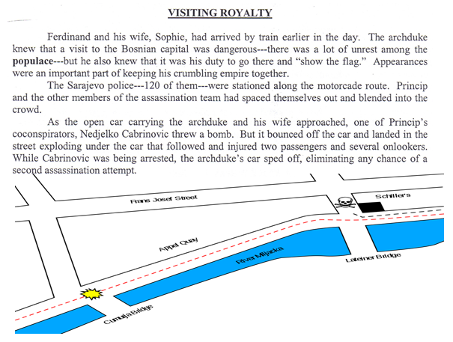
04) Summarize the following passages in five sentences.

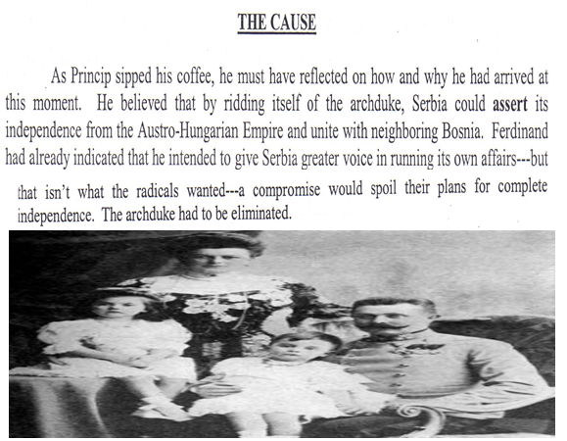
05) Why do “radicals” not like compromise?

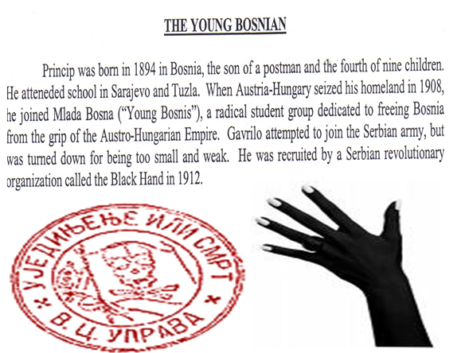
06) Summarize the following passages in three sentences.

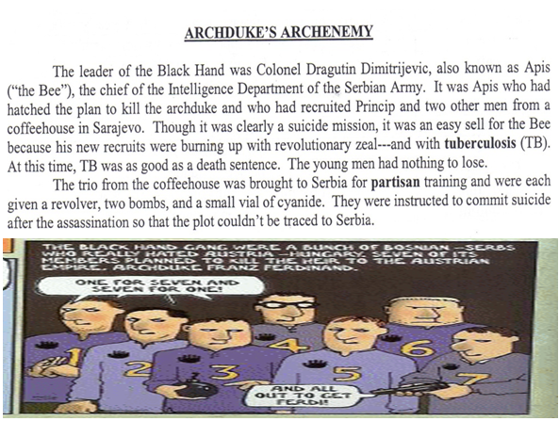
07) Why was Gavrilo Princip the perfect person for the job to kill the Archduke, based on the following passages?

08) Summarize the following passages in five sentences.
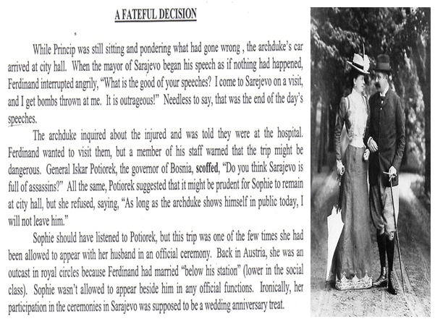

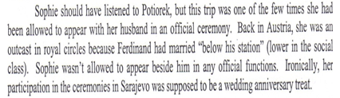
09) Based on the passage, why was Sophie so happy to be by the “side of her man” on this trip?

10) What do you think the author meant by the phrase “In what can be best described as either an ill-advised display of bravado or monumental stupidity…”?

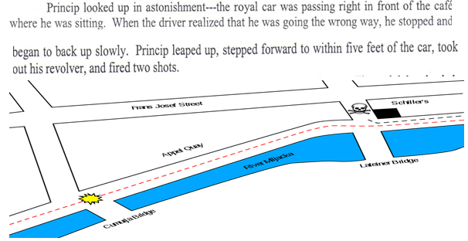
11) If you were going to pick a song that captures the essence of this passage, what song would you pick? Explain.

12) Role Play: One of you will take the role of Ferdinand. One of you will take the role of Sophie. You will act out a scene of this paragraph.

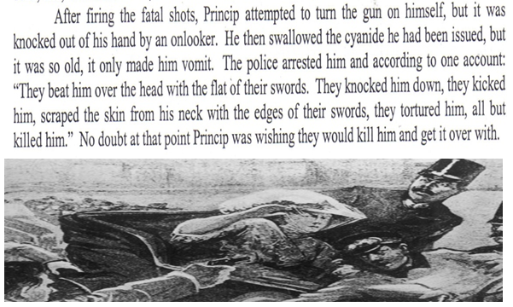
13) Based on the passage here, on a scale of 1-10 (with 1 being a bungling fool and 10 being a criminal mastermind,) where would you rate Gavrilo Princip? Explain.

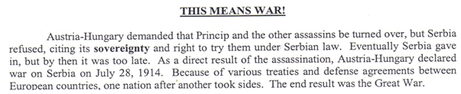
14) Based on this passage, which country deserves more of the blame for World War I, Austria-Hungary, Serbia, or do you blame both of them equally? Explain.

15) Which one of our “ANIMAL” causes of World War I is demonstrated in this political cartoon? Explain.
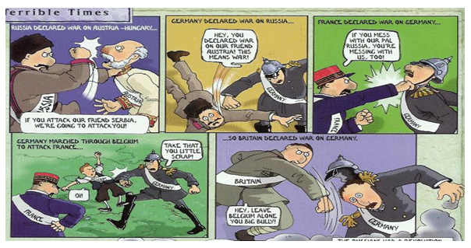

16) What do the following three paragraphs teach us about “point-of-view” and perspective?
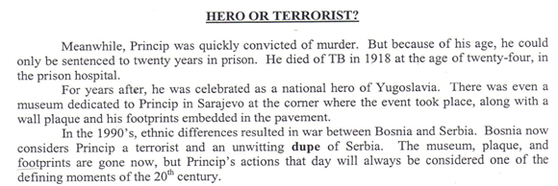

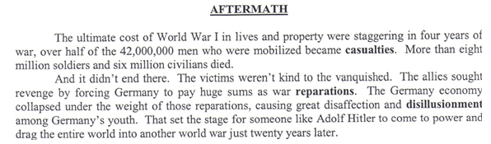
17) What do the following two paragraphs teach us about history?

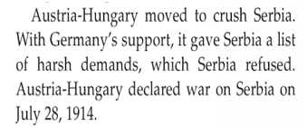
18) Why do you think the textbook’s author used the verb “crush” in this passage?

19) Brainstorm a reason why Austria-Hungary may have given Serbia a “list of harsh demands?”

20) What was significant about the date “July 28, 1914” (the date that Austria-Hungary declared war)?

21) Fill in the boxes below.
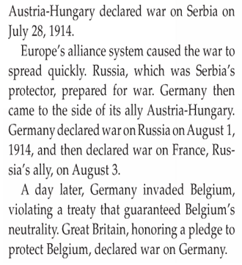

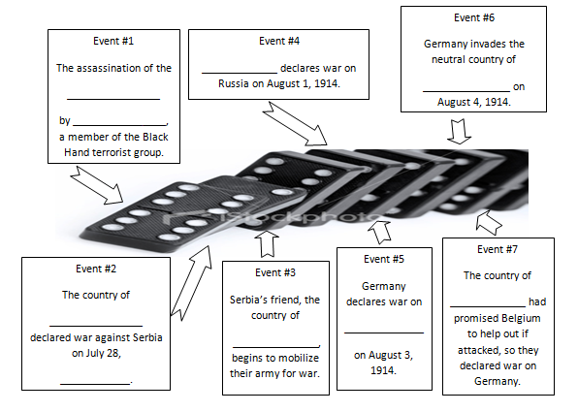

22) What was the main idea of the political cartoon?
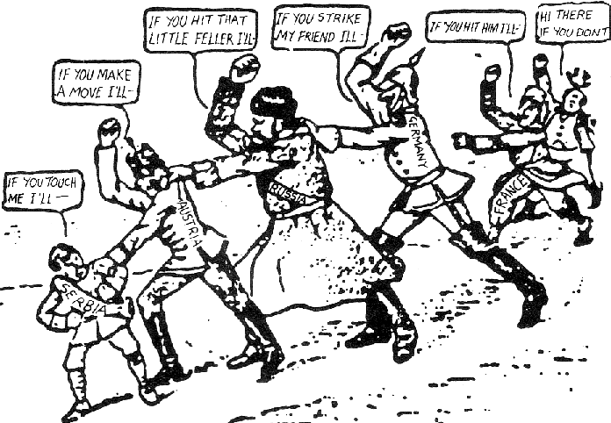

23) What was the main idea of the political cartoon?
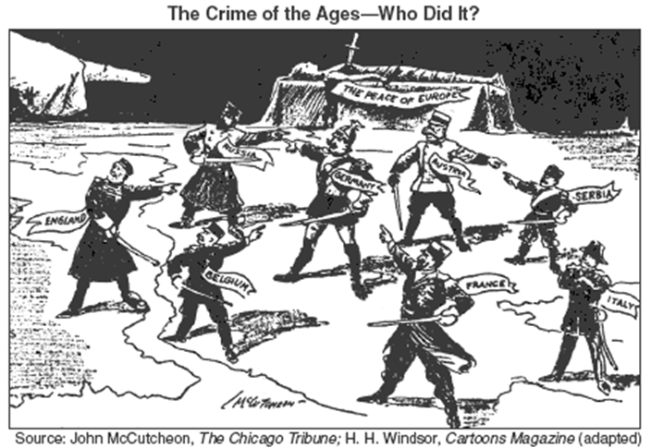

_____________________________________________________________________________________________
_____________________________________________________________________________________________
06) (the one entitled, “The Crime of the Ages—Who Did It?”)
_____________________________________________________________________________________________
_____________________________________________________________________________________________
_____________________________________________________________________________________________
_____________________________________________________________________________________________
07) What is the most important life lesson / lesson for America that we can learn from V-23.1B?
_____________________________________________________________________________________________

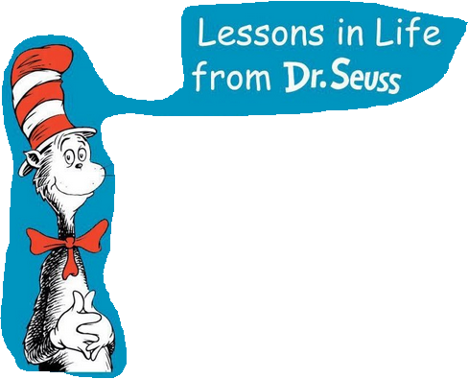
24) What is a life lesson we can learn from the events that occurred in V-23.1B?

