“Flyboys” Characters
Picture | Name | Description
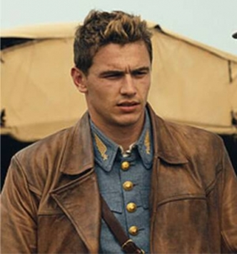 | Blaine  Rawlings | He is the main character. After the bank forecloses on the family ranch, he looks for a new “adventure” as a volunteer fighter pilot in the French “Lafayette Escadrille.”
 | William  Jensen | He comes from a family of war heroes. He assumes he will be just as brave as his family was. However, his confidence during the war is shaken by its events.
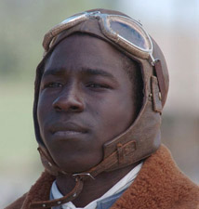 | Eugene  Skinner | He is an African-American boxer who has moved to France to be treated more fairly. He volunteers to join the Escadrille as a way to pay France back.
 | Briggs  Lowery | He comes from a very rich family. His father is extremely disappointed in him so he “strongly encourages” Briggs to join the war so that Briggs will “finally do something worthy of the family name.”
 | Eddie  Beagle | He is the real “wild card” of the group. His aim is not the best which leads some in his squad to question if he is really fighting on their side? There seems to be something off about his past.
Picture | Name | Description
 | Captain  Thenault | He is the leader of the Escadrille on the ground. He helps to train the Americans and gives them their missions.
 | Reed Cassidy | He is the leader of the Escadrille in the air. He is a battle-hardened leader who has lost many friends in the war so far.
 | Lucienne | She is a local French woman who becomes the “love interest” of Rawlings as the story progresses.
 | Lyle  Porter | He joins the Escadrille later in the movie. He is a very religious man who likes to sing Christian songs as he is fighting.
 | Nunn | He also joins the Escadrille later on with Porter. When his plane is shot down, Rawlings learns a hard lesson about the Great War.
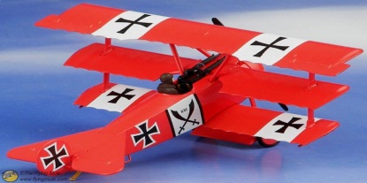 | Triple  Ace | He is a skilled German fighter pilot. He believes in the “rules of war” and fights with honor.
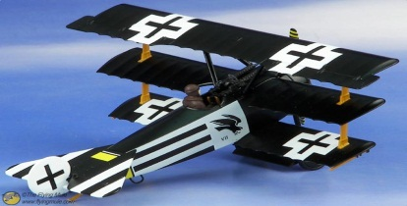 | Black Falcon | He is the main antagonist of the story. He is a skilled German fighter pilot, but he does not practice the “rules of war.” He is the arch-enemy of Cassidy.

