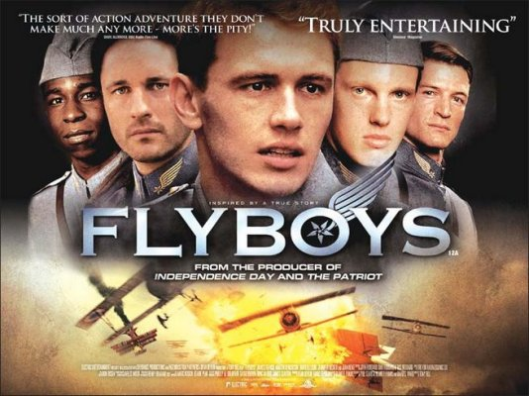
“Flyboys” Questions

Directions: Listed below are twenty questions. Select ten to answer. For each answer, you need to use a MINIMUM of four “Body Sentences.” Body sentences are your main thoughts. Introduction and conclusion sentences WILL NOT count towards your four “body sentences”.
For the other ten questions, you can earn 50 XP for each extra question answered with 4 “Body Sentences.” In total, you could earn 500 XP for the extra work.
If you receive a 64% or lower on this assignment, you will not be allowed to have drinks, snacks, and popcorn for the movie, “Boy in the Striped Pajamas” during the World War II chapter.
01) What did you like about the movie OR what was your favorite part?
02) What part(s) of the movie did you not like OR what did you think could have improved?
03) Which character did you like the best in the movie?
04) At the beginning of the movie, the “Lafayette Escadrille” members are told that the average life expectancy of a pilot was six weeks. If you were joining the “Lafayette Escadrille,” what would be going through your mind upon hearing this fact?
05) Just as in the movie, “Glory” that we watched last year, the trainees are not accepted right away by the veterans. Why do you think this theme is common in both movies?
06) Cassidy gave the men a sidearm and told them if the plane caught on fire, they had three options: burn to death, jump out of the plane falling to their death, or they could shoot themselves. ALL of these options are horrible, but which choice would you make if confronted with that scenario?
07) After watching the movie and reading about “trench warfare,” which one would you rather have been: a member of the “Lafayette Escadrille” or a soldier in the trenches during World War I?
08) If you were a member of the “Lafayette Escadrille” what insignia (symbolic picture) would you have painted on your plane?
09) Why do you think the “Black Falcon” was so despised by the “Lafayette Escadrille?”
10) Why do you think being in an airplane would be very appealing to Skinner (considering the time period he lived in?)
11) Why does Jensen stop flying missions during the middle of the movie?
12) How does Lowry’s character change during the movie, especially in his relationship with Skinner?
13) Why does Rawlings feel guilty about shooting down the “Triple Ace?”
14) Cassidy tells Rawlings, “This war ain’t gonna be won by either side. One day it will just end.” We heard the same kind of frustrated pessimism from Tripp when we watched “Glory” last year. Why do you think soldiers feel those sentiments, even though they continue to fight nevertheless?
15) On Cassidy’s plane, his insignia has a French phrase, “Je Vois Tout.” This phrase means, “I see all.” Why do you think Cassidy has that on his plane?
16) Which scene or scenes do you think were embellished for the purpose of selling movie tickets and keeping the attention of the audience? Do you think the director has a duty to keep things as historically accurate as possible, or do you think the director has a duty to make money for the movie company? Explain.
17) Which one of the characters reminds you of yourself?
18) Which one of the characters reminds you of another student? (Please keep the comments positive and non-critical.)
19) What did you learn about World War I watching this movie that you probably would not have learned from the textbook?
20) ROLE-PLAY: You are the President of MGM Movie Corporation. You are concerned the title “Flyboys” is not going to be good enough to sell tickets. Create a new title that you feel will be a more interesting choice and explain why you think your title is better.

