Class Discussion: “V-23.2B: “How America Was Drawn Into The Great War”
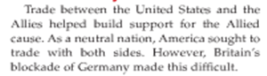
01) What was the main idea of the first paragraph of V-23.2B (shown here)?

02) What were the two main ideas of the second paragraph of V-23.2B (shown here)?
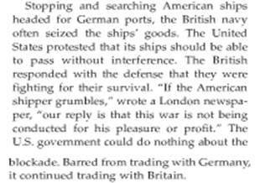

03) What were the two main ideas of the third paragraph of V-23.2B (shown here)?
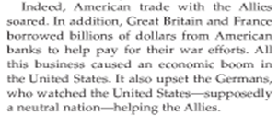

04) The following line graph shows America’s exports from 1914 – 1920. Which sentence from the Question #03 paragraph does this line graph BEST go with? Explain your answer.
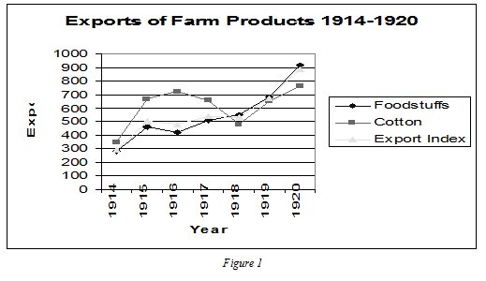

05) ROLE PLAY: You are in the German War Department. You are trying to convince the leaders that Germany should issue the decree that… “In February of 1915, Germany will sink any vessels that enter or leave British ports.” Defend why you support this plan.

06) ROLE PLAY: You are in the German War Department. You are trying to convince the leaders that Germany should NOT issue the decree that… “In February of 1915, Germany will sink any vessels that enter or leave British ports.” Defend why you support this plan.

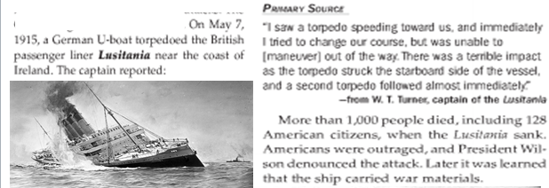
07) Why do you think the following event was such a big deal in American history?

08) What did you find interesting about this newspaper headline?
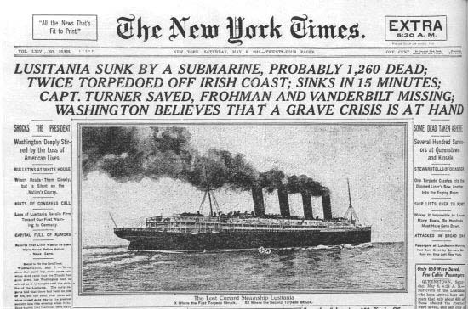

09 – 16) The headline describing the attack on the Lusitania (from Question #08) was from an American newspaper. Recreate another headline from a London newspaper. Britain wanted America to join the war, so they would be looking to use propaganda to affect America’s feelings about the war. You need to include the following:
- A newspaper title
- A headline that uses a form of propaganda designed to try to make Americans emotional and angry about what happened
- Describe what propaganda technique(s) you used
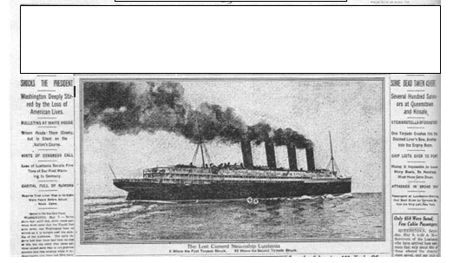

17) What did you find interesting about this paragraph from V-23.2B?

18) ROLE PLAY: If you were a member of Congress in 1916, would you have voted in favor of or against spending money to double the size of the army and to purchase new naval warships? Explain your position.
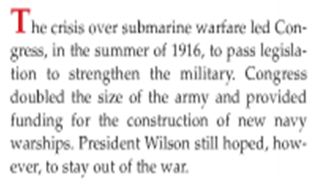

19) What propaganda technique (from your Propaganda Packet) was used in President Wilson’s reelection campaign slogan of 1916? Explain your answer.
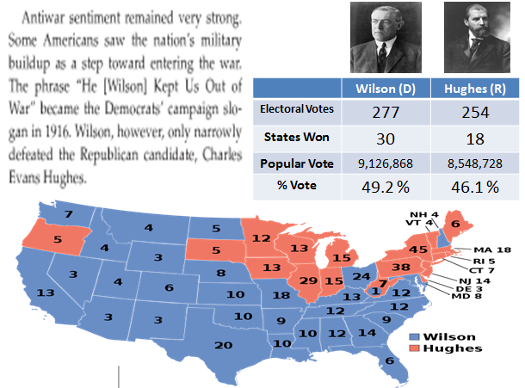

20 – 27) ROLE PLAY: President Woodrow Wilson ran for reelection for President in 1916. You are his Campaign Manager. You are to create an election poster to try to get Americans to vote for him in the upcoming election. Your campaign poster should include the following:
- propaganda designed to try to make Americans reelect President Woodrow Wilson
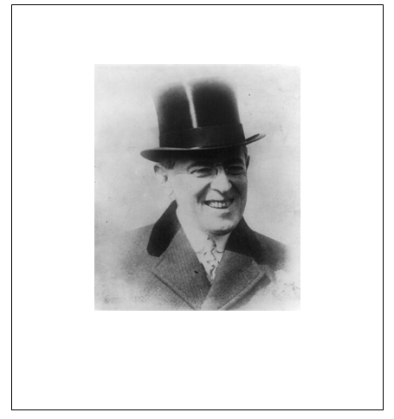
- Describe what propaganda technique(s) you used

Propaganda technique(s) used ___________________________________________________________
28) What did you find to be the most interesting thing about the results of the Presidential Election of 1916 versus the more modern Presidential Election of 2004?
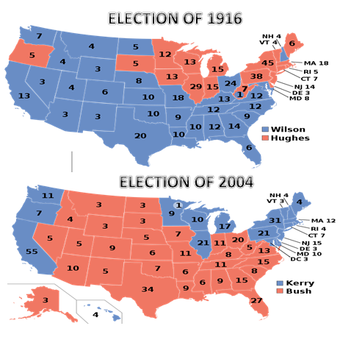

29) The Germans decided in January 1917 to start sinking ALL ships even though they knew this might cause America to enter the war. How was their decision like a poker player betting all of their chips on one hand of poker? Why do you think Germany made this decision in 1917?

30) Why do you think the following event was such a big deal in American history?
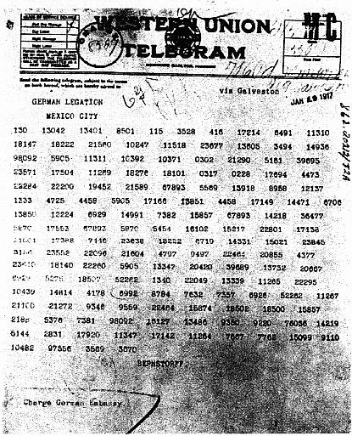

31) Here is a translated copy of the “Zimmermann telegram.” Why do you think Germany would try to get Mexico to declare war on the United States if the United States entered the War?
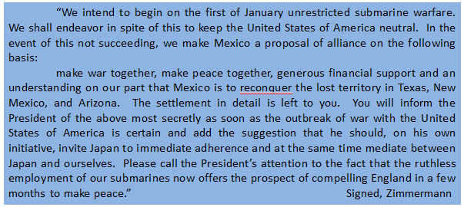

32) Using the Zimmermann telegram from Question #31, when America found out about this telegram, how do you think Americans reacted?

33) What were the main ideas presented in these paragraphs?
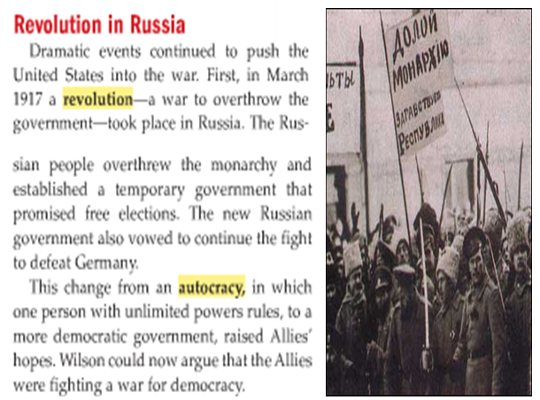

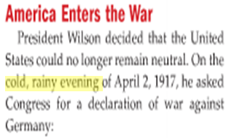
34) Why did you think the textbook describes it as a “cold, rainy evening?” Why didn’t the textbook just say “On April 2, 1917…”?

35) Explain a propaganda technique used by President Wilson in the following portions of a speech he made in support of America finally joining World War I.
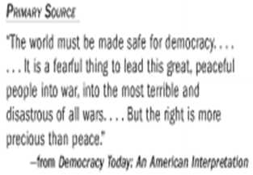

36) ROLE PLAY: You are a member of Congress in 1917. Give a brief speech to your fellow Congress members IN SUPPORT of passing the declaration of war.
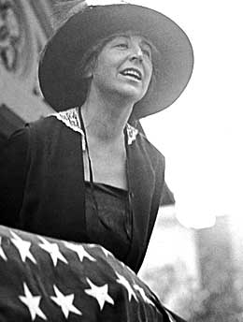

37) ROLE PLAY: You are a member of Congress in 1917. Give a brief speech to your fellow Congress members AGAINST passing the declaration of war.

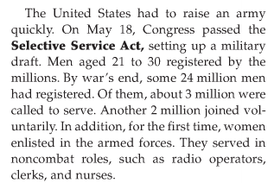
38) In your own 8th Grade words, explain what the “Selective Service Act” was.

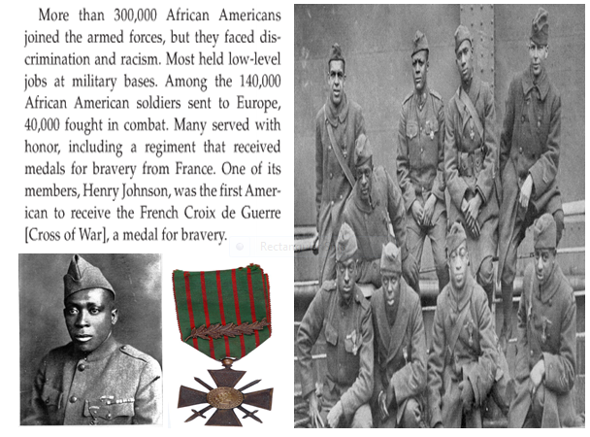
39) What did you find interesting about this paragraph from V-23.2B?

40) ROLE PLAY: If you were an African American male in 1917, would you have volunteered to join the United States Armed Forces? Explain your answer.

