Class Discussion: “V-23.3B: “Americans Helping To Win World War I”
01) Do you think the giving of “nicknames” is common in wartime? Explain.
_____________________________________________________________________________________________
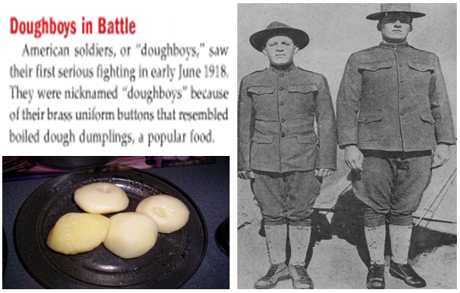
_____________________________________________________________________________________________

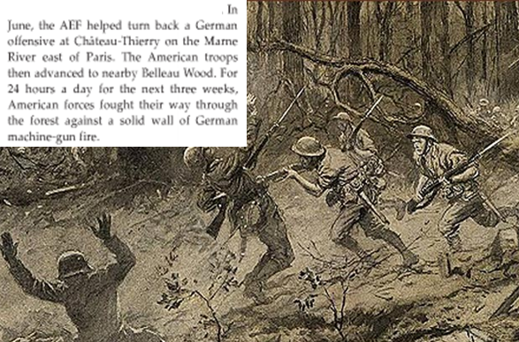
02) Based on the text and this picture from the video, what would make the conditions tough at the Battle of Belleau Wood?
________________________________
________________________________
________________________________
________________________________
________________________________
________________________________
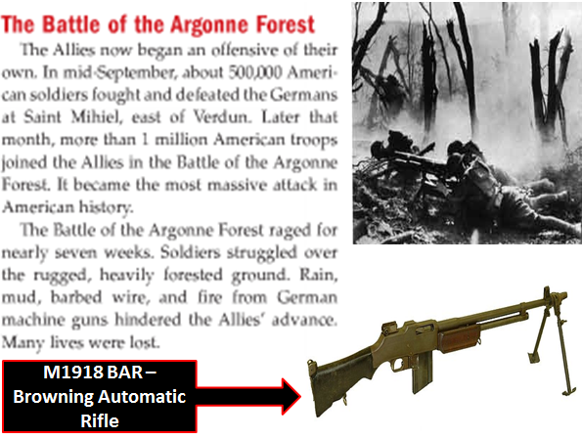
03) What did you find to be the most interesting thing about this slide from the video?
________________________________________
________________________________________
________________________________________
________________________________________
________________________________________
________________________________________
________________________________________
04) Who do you think was “more heroic,” Corporal Alvin York, Captain Eddie Rickenbacker, or do you consider neither person a “hero”? Explain.
_____________________________________________________________________________________________
_____________________________________________________________________________________________
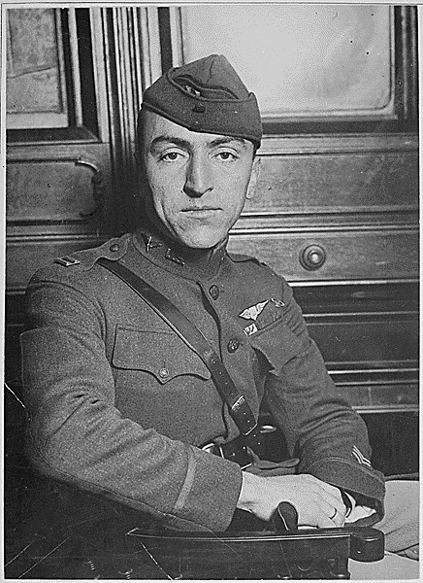
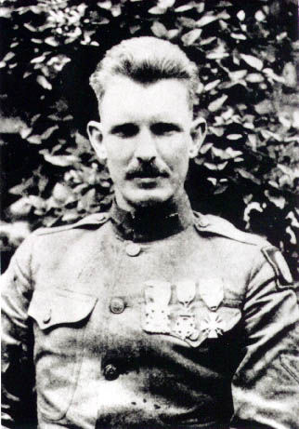
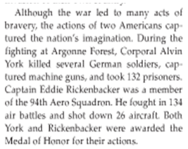
_____________________________________________________________________________________________

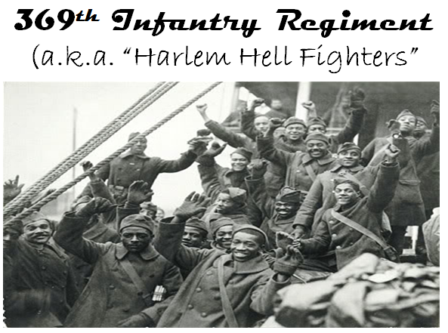
05) What stands out to you about this picture?
____________________________________________
____________________________________________
____________________________________________
____________________________________________
____________________________________________
____________________________________________
____________________________________________
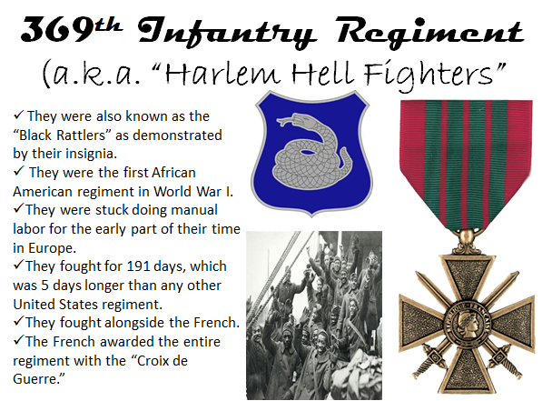
06) What did you find to be the most interesting thing about this slide from the video?
____________________________________________
____________________________________________
____________________________________________
____________________________________________
____________________________________________
____________________________________________
____________________________________________
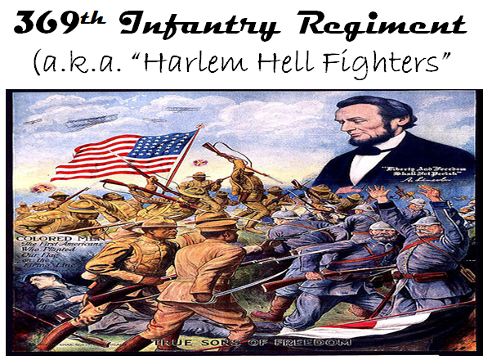
07) What did you find to be the most interesting thing about this slide from the video?
____________________________________________
____________________________________________
____________________________________________
____________________________________________
____________________________________________
____________________________________________
____________________________________________
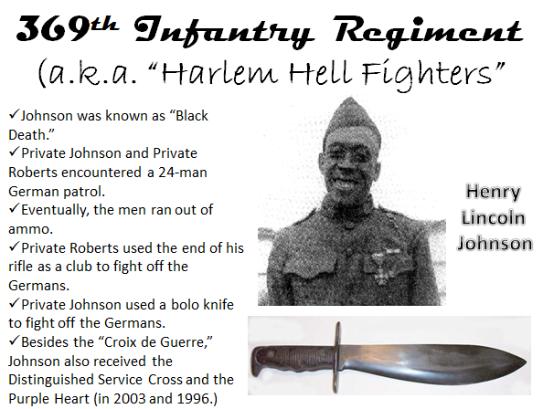
08) What did you find to be the most interesting thing about this slide from the video?
________________________________________
________________________________________
________________________________________
________________________________________
________________________________________
________________________________________
________________________________________
________________________________________
________________________________________
09) What similarities did the “Harlem Hell Fighters” share with the 54th Massachusetts from “Glory” last year?
_____________________________________________________________________________________________
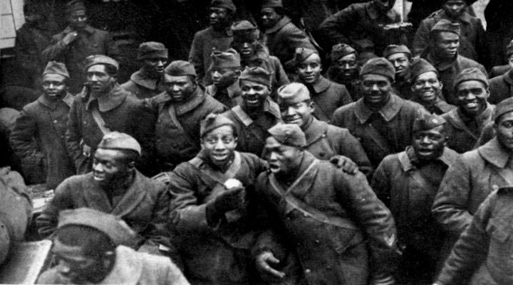
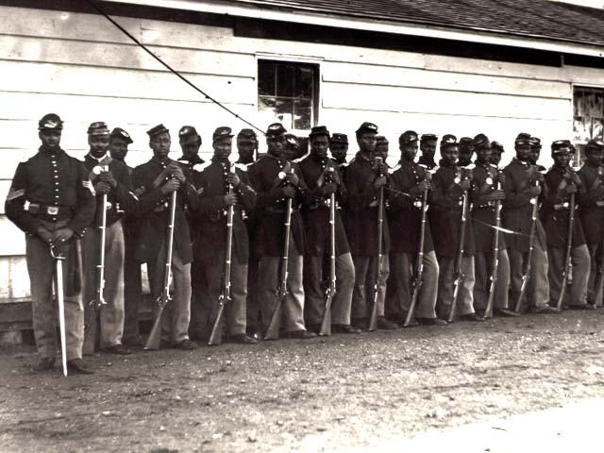
_____________________________________________________________________________________________

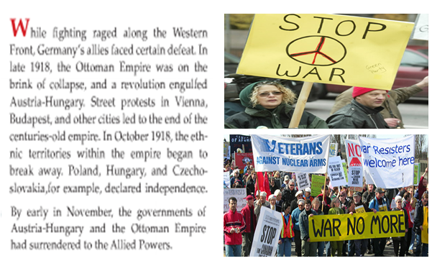
10) Why do you think there were many protests in Europe in late-1918?
__________________________________
__________________________________
__________________________________
__________________________________
__________________________________
__________________________________
__________________________________
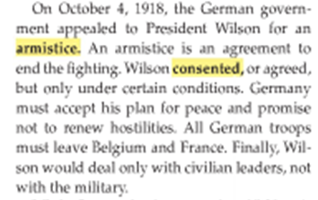
11) Why do you think the German government went to President Wilson for an armistice rather than to the British or the French?
____________________________________________
____________________________________________
____________________________________________
____________________________________________
____________________________________________
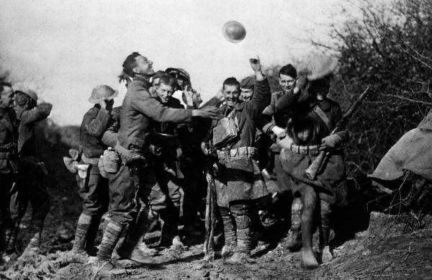
12) What do you think would have happened in Europe had America not joined World War I?
____________________________________________
____________________________________________
____________________________________________
____________________________________________
____________________________________________
____________________________________________
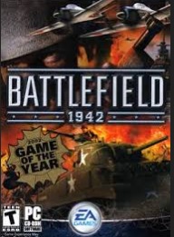
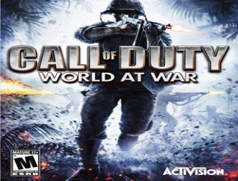
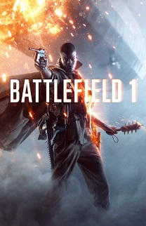
13) Why do you think World War II gets more attention in books, movies, video games, etc. than World War I?
_____________________________________________
_____________________________________________
_____________________________________________
_____________________________________________
14 - 38) Directions: You work for a company that sells short history graphic novels. The illustrator has created the pictures already. Now, it is time for you to fill in the captions for the novel, which is titled “The Loss of Innocence.”

THE END

