Small Group Discussion: “V-23.3A: “Americans Join The Allies”
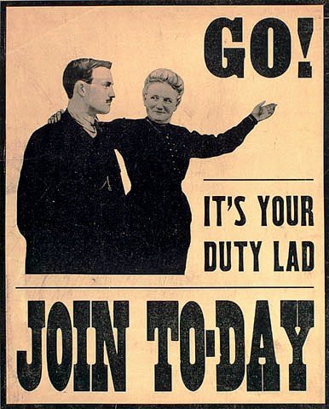
01) What propaganda is being used in this poster? Explain.

02) What did the “doughboy” mean when he said “I have often wondered if that company did not have a pack of silent liars?”
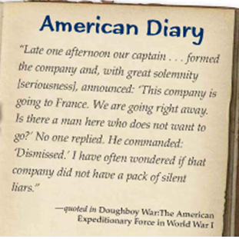

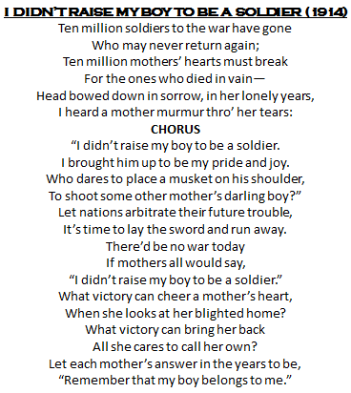
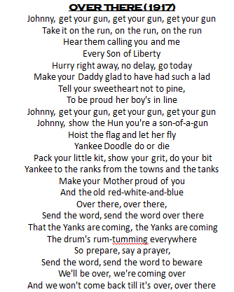

03) What is the author’s purpose in “I Didn’t Raise My Boy to be a Soldier”? Explain.
04) Cite a lyric and explain what propaganda technique is used in “I Didn’t Raise My Boy to be a Soldier”.
05) What is the author’s purpose in “Over There”? Explain.
06) Cite a lyric and explain what propaganda technique is used in “Over There.”
07) Which song did you think did a better job of promoting the goal of its propaganda? Explain.

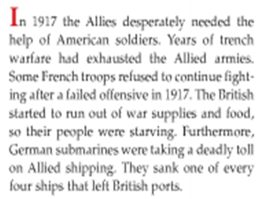
08) Let’s use the analogy of World War I as a basketball game. The year 1917 is the end of the third quarter. Who is winning the game? Explain.

09) Let’s use the analogy of World War I as a basketball game. Who does America represent? Explain.

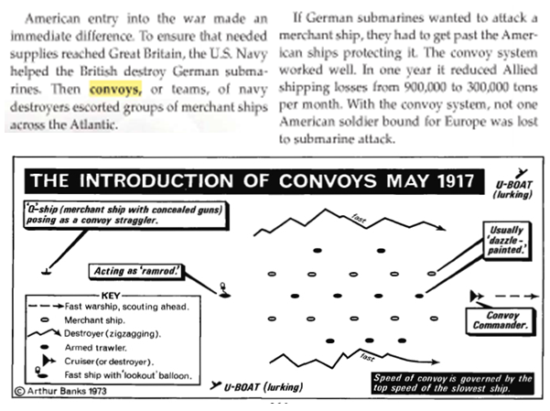
10) Let’s use the analogy of World War I as a football game. What does the navy destroyers’ “convoy system” represent? Explain.

11) Let’s use the analogy of World War I as a football game. What does the overthrow of the Czar Nicholas II represent? Explain.

12) Why do you think the Russian people overthrew Czar Nicholas II?

13) Why did the Russian democratic revolution of March of 1917 fail?

14) What two goals did Lenin have when he and the Bolsheviks took control of Russia in November of 1917?

15) When the Bolsheviks took over, they renamed “Russia” into the “Soviet Union”. Their official flag is the one shown here. What do you think the symbolism represents?

16) Why would Lenin think the Treaty of Brest-Litovsk was a win for the Soviet Union (Russia)?
17) Why would Germany think the Treaty of Brest-Litovsk was a win for Germany?
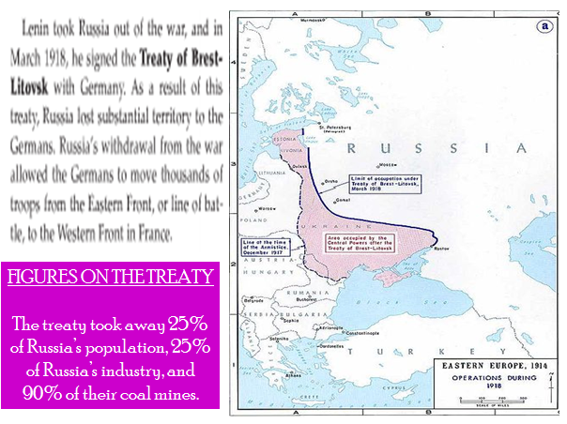
18) Why would the Allies (France, Great Britain, Belgium, & United States) think the Treaty of Brest-Litovsk was a horrible treaty?

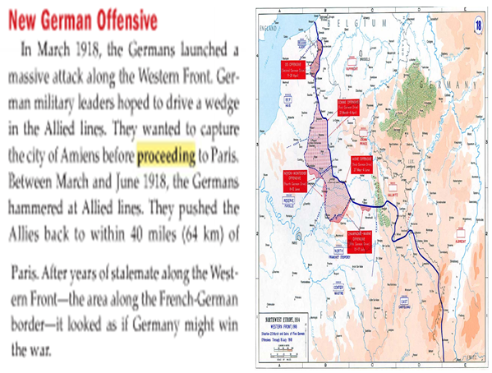
19) Let’s use the analogy of World War I as a basketball game. What does the “German massive attack” of March 1918 represent? Explain.

20) What do you think was the main idea of this “Primary Source?”
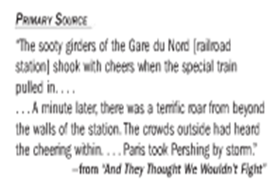

21) What advantage would the AEF troops have over their French and British counterparts?
22) What disadvantage would the AEF troops have over their French and British counterparts?
23) Why do you think General Pershing wanted to keep the American troops separated from the British and French troops?
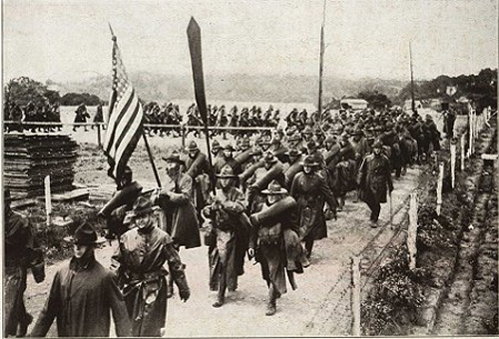
24) How do you think the French troops and civilians treated the AEF troops when they arrived in France?

