Small Group Discussion: “V-24.2A: “Warren G. Harding”
01) What do you think was meant by the title of this section?

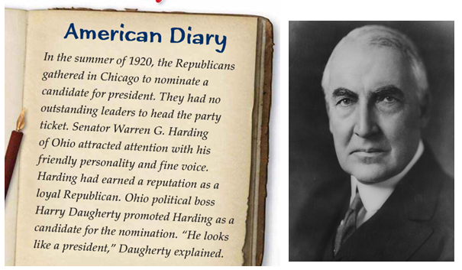
02) What do you think was the main idea of the “American Diary”?

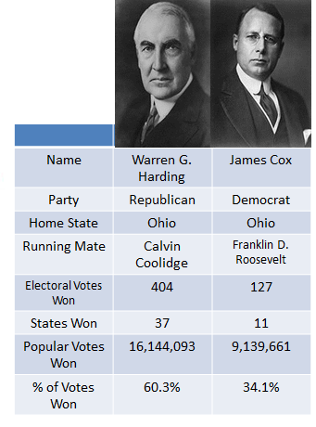
03) What did you find to be the most interesting part of this breakdown of the Presidential Election of 1920?

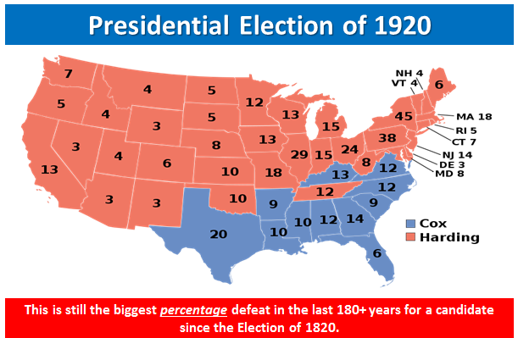
04) Why do you think the Republican, Warren G. Harding, won such a large victory over the Democrat, James Cox?

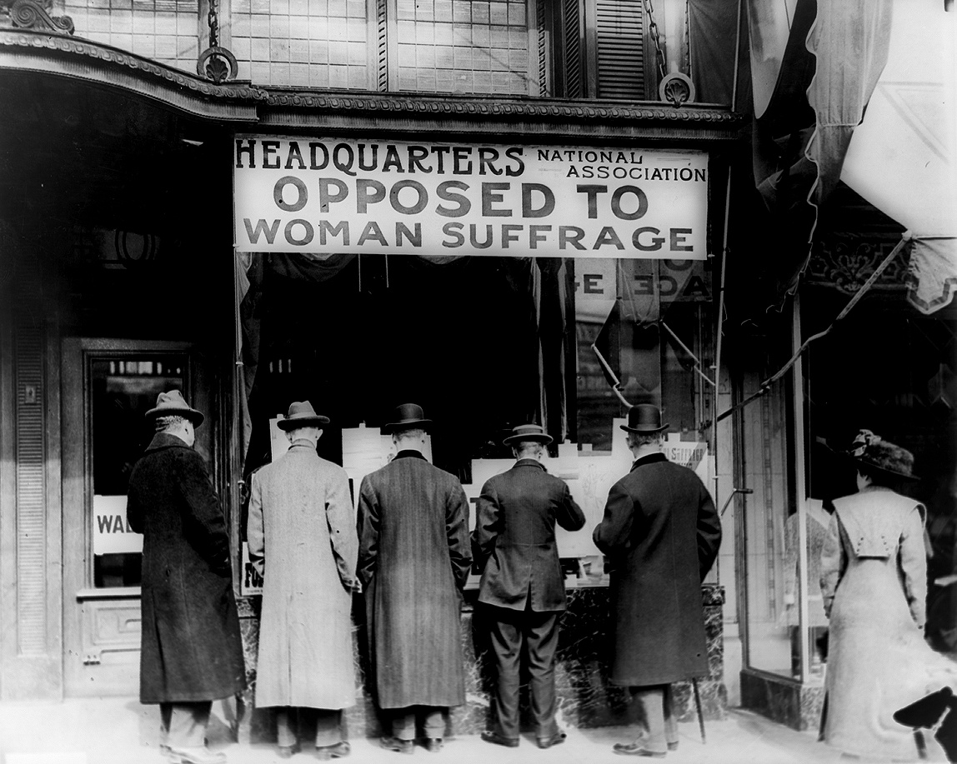
05) The year 1920 was the first year that women could vote in a Presidential election. How do you think that changed modern Presidential elections?

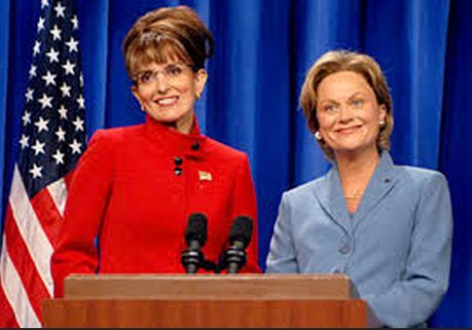
06) The year 1920 was the first year that women could vote in a Presidential election. List three issues that you believe women might care more about than men in a modern Presidential election. Explain why you feel this way.

07) Why do you think it is important for any President of the United States to select talented people to serve in their Cabinet?
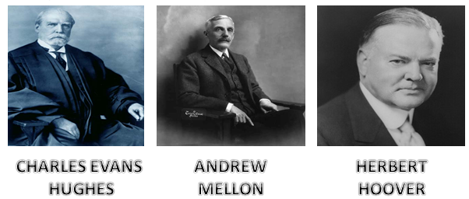

08) In 8th Grade terms, describe what the word “corrupt” means.

09) Google defines corrupt as “having or showing a willingness to act dishonestly in return for money or personal gain”. Give an example of how a trusted person in society could be guilty of corruption.

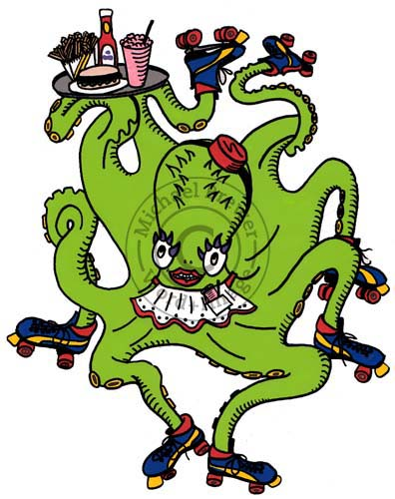
10) What do you think is the main point of this quote by H. Jackson Brown, Jr.?
“Talent without discipline is like an octopus on roller skates. There's plenty of movement, but you never know if it's going to be forward, backwards, or sideways. “
H. Jackson Brown, Jr.

11) How does the previous octopus quote relate to the Presidency of Warren G. Harding?
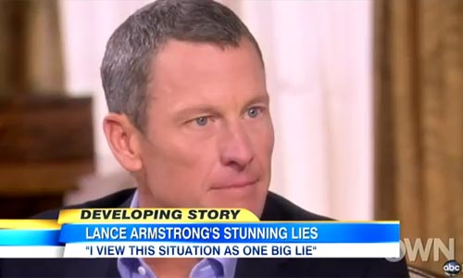
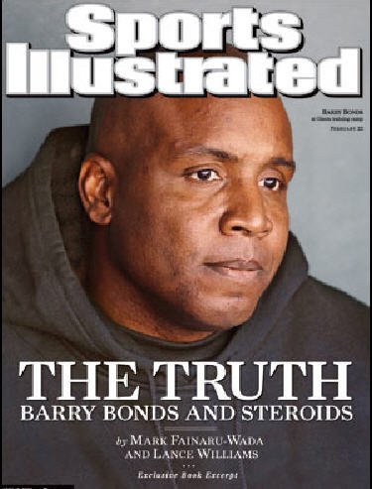
12) This section talked a great deal about “scandals.” Describe a modern day scandal in the area of sports.

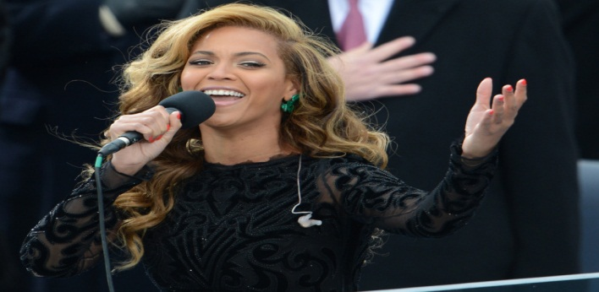
13) This section talked a great deal about “scandals.” Describe a modern day scandal in the area of “pop culture”.

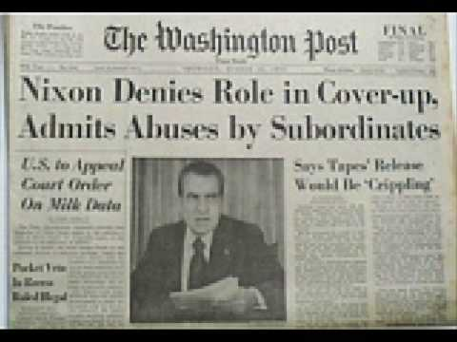
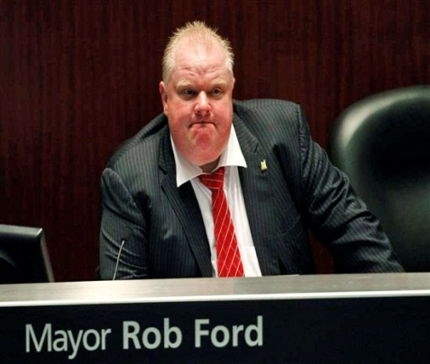
14) This section talked a great deal about “scandals.” Describe a modern day scandal in the area of politics.

15) Explain the “Teapot Dome Scandal” in 8th grade terms that could be understood by all.

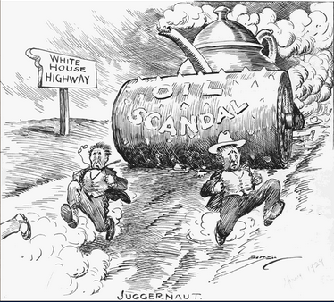
16) What do you think is the main idea of this political cartoon?

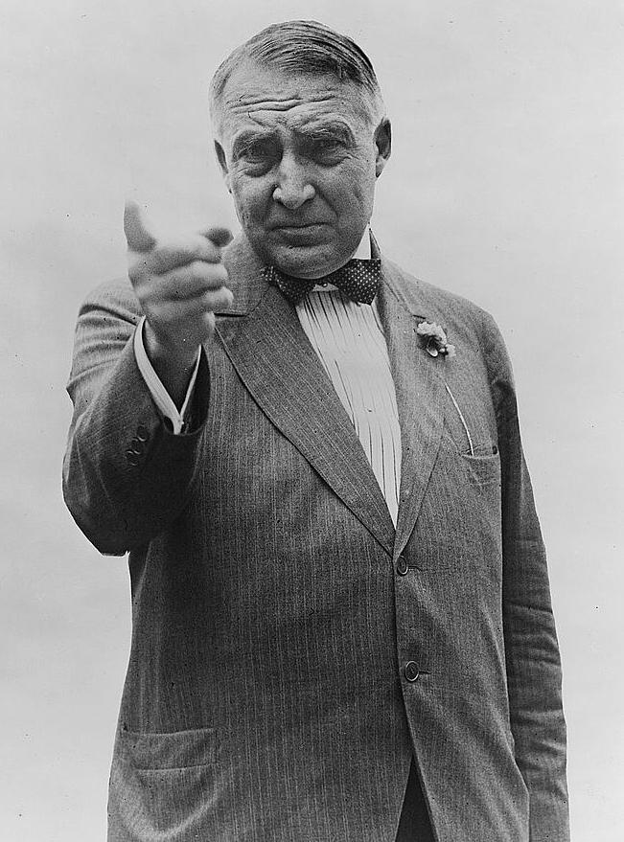
17) What did President Harding mean in this quote?
"I have no trouble with my enemies, but my d&*# friends, they're the ones that keep me walking the floor at nights!"

