Class Discussion: “V-24.3A: “A Booming Economy” Name________________________
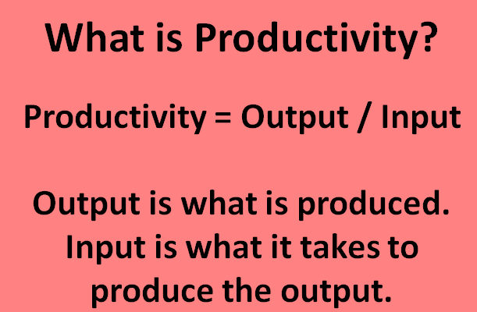
01) Which factory below has the best productivity? Be able to explain and show your work.

FACTORY NAME | # OF WORKERS IN FACTORY | # OF SHOES PRODUCED DAILY | PRODUCTIVITY
SOLE MEN  CO. | 10 | 1300
QUITE A FEET CO. | 25 | 3450
GET A LEG UP CO. | 50 | 6700

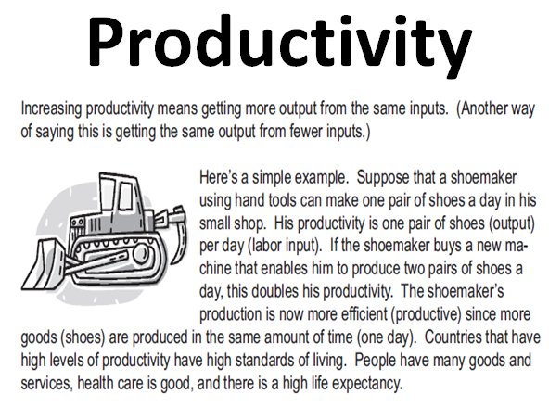

02) If a new machine could double the productivity of a worker, what are the economic reasons why the factory’s boss might want to invest in the machine?
_____________________________________________________________________________________________
_____________________________________________________________________________________________
03) If a new machine could double the productivity of a worker, what could be an economic reason why the factory’s boss might NOT want to invest in the machine?
_____________________________________________________________________________________________
04) In the above passage, it stated “Countries that have high levels of productivity have high standards of living.” What do you think the phrase “standard of living” means?
_____________________________________________________________________________________________
_____________________________________________________________________________________________
05) In the above passage, it stated “Countries that have high levels of productivity have high standards of living.” Why do you think that is true?
_____________________________________________________________________________________________
_____________________________________________________________________________________________
06) Brainstorm two REALISTIC ways that River Bend Middle School could improve student productivity.
_____________________________________________________________________________________________
_____________________________________________________________________________________________
07) What was one of the biggest influences that caused productivity to increase in the 1920’s?
_____________________________________________________________________________________________
In your group, discuss #08 - #12. Then, come to a consensus on the group’s answer for either “True” or “False”. Support your answer.
08 | “When one country becomes  wealthier, another country must become poorer.” | True or False
09 | “Countries are poor mainly because they lack natural resources.” | True or False
10 | “A large population causes a country to be poor.” | True or False
11 | “Income Results Primarily From Production.” | True or False
12 | “To become proficient at  producing valuable goods and services, countries  must increase their productivity.” | True or False

13) The next slide has two maps. The top map is a color-coded map of the world’s countries as they are ranked by G.D.P. (Gross Domestic Product.) GDP is very closely related to G.N.P. (Gross National Product.) Both measure the total value of goods and services produced.
The bottom map is a color-coded map of the world’s countries as they are ranked by the “Education Index.” The Education Index is a ranking based on a country’s adult literacy and on the percentage of their eligible population that is enrolled in school.
After analyzing the maps, I want your group to be able to tell me the main idea of the slides.
_____________________________________________________________________________________________
_____________________________________________________________________________________________
_____________________________________________________________________________________________
_____________________________________________________________________________________________
_____________________________________________________________________________________________
_____________________________________________________________________________________________
Productivity Mystery
Next, we are going to look at a mystery. We will read the story together. Then, we will look at some clues. Some clues are valuable, while other clues are extraneous (not important or necessary.) Your group needs to figure out which two clues are the most relevant and circle them. Finally, use those two clues to help you try to solve the mystery.
Scientists are constantly looking for ways to improve our lives. They have little time to waste on nonsense. Yet a Texas A&M agricultural engineer has spent some of his time inventing a contact lens for chickens. Other scientists have experimented with playing classical music to barnyard animals.
Are these the stereotypical mad scientists? Why would scientists waste their time on contact lenses and Mozart for animals when so much really important work needs to be done?
6 Ideas To Remember Before You Look At The Clues
1. People choose.
2. People’s choices involve costs.
3. People respond to incentives in predictable ways.
4. People create economic systems that influence individual choices and incentives.
5. People gain when they trade voluntarily.
6. People’s choices have consequences that lie in the future.
The Clues
1. Scientists receive billions of dollars to do agricultural research.
2. The U.S. government has a variety of programs to keep the price of some agricultural goods artificially high.
3. There is a scarcity of dollars to do scientific research.
4. Finding ways to lower the costs of agricultural production enables producers to earn higher profits while lowering prices for consumers.
5. American chickens produce millions of eggs each year.
6. The # of farms in the U.S. has been declining for several years—from 6.8 million in 1935 to less than 2 million today.
7. Satellites assist some farmers in providing information about the condition of their crops.
8. Farmers who are able to increase their efficiency and earn more profits benefit because they may keep most of what they earn by their efficiency.
Answer To The Mystery
_____________________________________________________________________________________________
_____________________________________________________________________________________________

