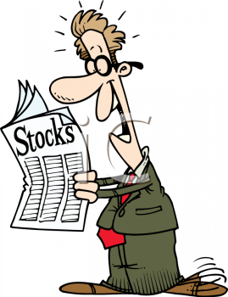
Stock Market Simulation Activity

Schedule
- Take attendance [1 minute]
- Go over Agenda [5 minutes]
- Update Leaderboard [2 minutes]
- Hand out & discuss Stock Market WS #1 [5 minutes]
- Hand out & discuss Stock Market Simulation Activity [10 minutes]
- Determine Stock Brokers #1, #2, #3 & #4 [1 minute]
- Distribute money & shares to Stock Brokers [2 minutes]
- Determine Stock Holders (rest of class) [1 minute]
- Distribute money to Stock Holders [2 minutes]
- Reviewing Stock Prospectus [5 minutes]
- Round #1: Purchasing Round [5 minutes]
- Round #2: 1920 Events & Buying/Selling [5 minutes]
- Recording Stocks & Money Leftover [1 minute]
- Returning Stocks & Money to Brokers [2 minutes]
- Closing Thoughts & Homework Reminder [1 minute]
Tomorrow
- Take Attendance [1 minute]
- Redistribute Stocks & Money to Stock Brokers & Investors [4 minutes]
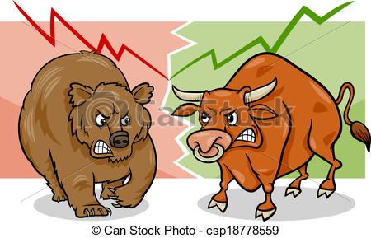
- Round #3: 1922 Events & Buying/Selling [5 minutes]
- Round #4: 1923 Events & Buying/Selling [5 minutes]
- Round #5: 1925 Events & Buying/Selling [5 minutes]
- Round #6: 1927 Events & Buying/Selling [5 minutes]
- Round #7: 1928 Events & Buying/Selling [5 minutes]
- Round #8: 1929 Events & Buying/Selling [5 minutes]
- Debrief [Remaining time]
- Homework – Stock Market WS #1 – Due Tomorrow
Summary
Four students will be playing the role of stockbrokers (guy in suit circled) in this activity. They will be:
Broker #1: ___________ Broker #2: ___________ Broker #3: ___________ Broker #4: ___________.
Each broker will be selling two different stocks (which are in alphabetical order).
The rest of the class will play the roles of stockholders. Each stockholder will be given $500.00 to invest. Half of the investors (guy with stock newspaper circled) will be investors investing their own money. Half of the investors (guy with pockets out circled) will be investors who want to get in on the stock boom and have gone to the back to borrow $500.00 to invest. After the stockholders have had a chance to go over the stock prospectus on each stock, we will begin Round #1. In Round #1, all stock certificates will have an “opening price” of $10.00. Each stock certificate represents 10 shares. Therefore, any purchase you make in Round #1 will cost $100.00. You can spread your money out, or spend all $500.00 on five stock certificates of the same stock. The choice is yours. At the end of Round #1, Mr. Mo will sound the alarm that all trading is done. Students will be required to return to their seats. We will record our transactions on this form (WHICH YOU NEED TO BRING TO CLASS TOMORROW IN ORDER TO GET MONEY AND STOCK CERTIFICATES!!!)
Tomorrow, we will play each subsequent round and find out the news (which will affect the prices of each stock). We will repeat the process of buying/selling stocks and finding out new information over the course of several rounds. At the end of the activity, we will debrief and see how the stockholders did.
DAY #1 TRANSACTION RECORDER
DURANT MOTORS | GOTHAM NATIONAL BANK | K & P RAILROAD | KROGER FOODS
MAMMOTH OIL | MIDLAND POWER | RADIO CORPORATION | TEL-TONE
MONEY SAVED

STOCK PROSPECTUS
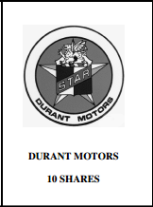 | This corporation was founded by a well-to-do carriage maker in Flint, Michigan. Durant took over several companies and brought together 12 auto producers, including Oakland Motors. Rapid expansion has left the company badly undercapitalized. Management fears that Durant Motors may be taken over by the banks. The company is attempting to produce a low cost car and has hired Charles “Boss” Kettering to manage a number of plants. Kettering plans to produce a car with a “self starter.” Durant Motors presently produces the Locomobile, the Durant-Four and the Flint. His long range plans are to develop a giant combination of automobile manufacturers. At this time, investment in Durant Motors is risky due to a lack of capital.
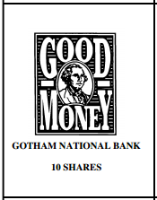 | This bank is one of the oldest, wealthiest, and most conservative financial houses in the country. The owner is proud of saying that his bank still operates on the same principles first established by Alexander Hamilton in 1790. This stock is so stable that when it once dropped two points in a week, back in 1893, it set off a small-scale recession. This bank has paid an annual dividend for 130 years!
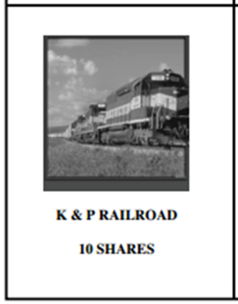 | The K & P has been in existence for over 60 years. Their assets are many and diversified. In the past, they have shown to be a stable company with small but regular dividends. While many railroads are faced with declining profits, the K & P shows a steady increase. They are presently expanding into the Southwest and plan to extend their holdings into Mexico.
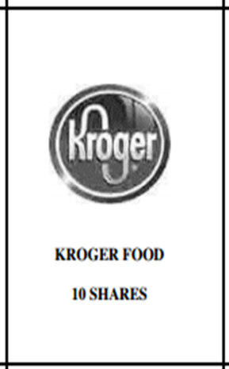 | Kroger Foods is a newly established regional food processing company. It has canneries in five of the major West Coast cities and deals basically in fruit and tomato products. It has recently offered share to the public and it has been listed on the exchange for just one week. Market experts view this entry as rather speculative and are unwilling to venture any opinions on investment opportunities with Kroger Foods. At present, Kroger Foods hopes to purchase five other regional food processors. If successful, Kroger Foods could be an excellent money maker with national markets. Of course, food industries always depend on agricultural prosperity and good crops; this year may be questionable. A good crop and successful merger could make many stockholders very wealthy.
STOCK PROSPECTUS
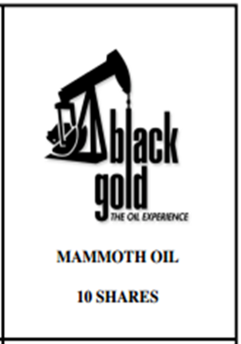 | Mammoth Oil is owned and operated by Harry Sinclair. Mammoth has oil leases in Elk Hills in California. The newly opened field, which geologists feel may be the largest oil field in the United States, has 25 wells producing oil at the present time. Sinclair is rumored to have the backing of influential government employees. Mammoth has borrowed large sums of money to explore for oil in California and Wyoming and to develop Elk Hills. Secretary of the Interior Fall is reported to be a large stockholder. Sinclair’s company has not paid dividend in the past 5 years of operation. The value of Mammoth Oil stock has fluctuated between 20 cents and $5.00 a share for the past two years.
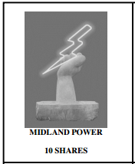 | Midland Power is owned and operated by the financial genius, Samuel Insull. Midland is part of a billion-dollar corporation operating in 32 states. Several of the most powerful banks and brokerage houses are a part of this corporation. Midland produces electricity for central Chicago and is expanding into the suburbs. Midland has developed and is using giant steam turbines to generate power. Insull’s financial abilities and the mass marketing of Midland’s stock has made Midland one of the most powerful corporations in the Midwest.
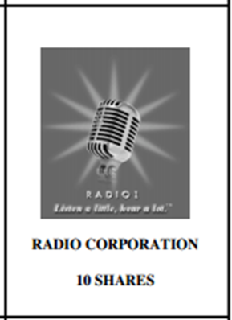 | This company has long been considered one of the better buys in the field of electronics. This corporation seems to have a bright future. Market experts see this corporation as a good, long term investment, which is safe and could continue to grow slowly. The future of Radio Corporation will depend on its new production models and if they are competitively priced.
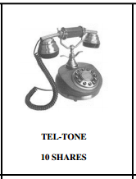 | This telephone company is just being capitalized. This is their first public offering of stock. They presently plan to raise 12 million dollars and manufacture a dial-telephone. This process reportedly will revolutionize the use of the telephone. Their management is young and inexperienced. Any capital invested should be considered a high risk. But currently, their stock is one of the hottest on the stock exchange. It has tripled in value since it was placed on the market less than two months ago.

